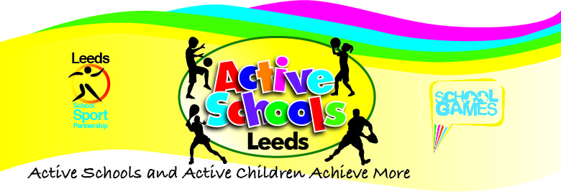**Benefits of 0-19 Active Schools Programme**

* Consistent city wide approach to Physical Activity, PE and Sport
* Support in meeting accountability for PE and Sport Premium Funding
* A comprehensive Professional Development Programme based on the needs of schools/settings
* Increased participation opportunities for children and young people
* One central point of contact for up to date advice, guidance and support
* Value for money – economies of scale – reduced costs/priority places from a comprehensive list of partners
* A programme that supports, challenges and provides opportunities through collaboration and partnership working
* An efficient, accountable, sustainable system that enables “joining dots” and coherent work which utilises resources to best effect
* Ability and time to keep abreast of national, county and city picture
* An opportunity to influence national strategy and deliver appropriately at a local level
* Representation of children, young people, staff and school views at city, county and national level
* Building on what works and designing a Leeds model based on feedback from schools
* Equality of opportunity to all Leeds children and young people
* Centralised overview and opportunity to highlight and share good practice
* A comprehensive Offer to Schools and Settings as detailed in SLA’s
* Health and Safety advice
* Access to city initiatives and Innovation projects such as Triathlon Event/Maths of the Day
* Consistent, enhanced, city wide SGO offer
* Facilitation of locality working
* Creation, development and implementation of city wide competitions, events and festivals at a local and city level
* Regular updates
* Access to resources to support PE, Sport and Physical Activity
* Flexible, bespoke support from a knowledgeable team
* Links to networks and facilitation of networks
* Annual Conference
* Access to and guidance/support on funding opportunities such as Change4Life/Awards for All
* Membership of Associations such as YST/LSSA/AfPE
* Access to and reduced rates at the Outdoor Activity Store
* Links to coaches and companies supporting PE, Sport and Physical Activity