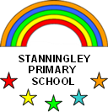

**Child Friendly Anti-Bullying Policy**

Stanningley Primary School is a place where everyone has the right to be themselves. It’s a place where everyone can feel safe, be happy and learn. Everyone at our school is equal and acts with respect and kindness towards each other. Our school is a bully-free place and the staff at Stanningley will always treat bullying as a serious matter and take positive action to address it.

**What is bullying?**

Bullying is when a person is hurtful or unkind to someone else, on purpose and more than once. Bullying can be done by one person or by a group of people and can be towards one person or a group of people. A useful way to remember bullying is

**S**EVERAL **T**IMES **O**N **P**URPOSE

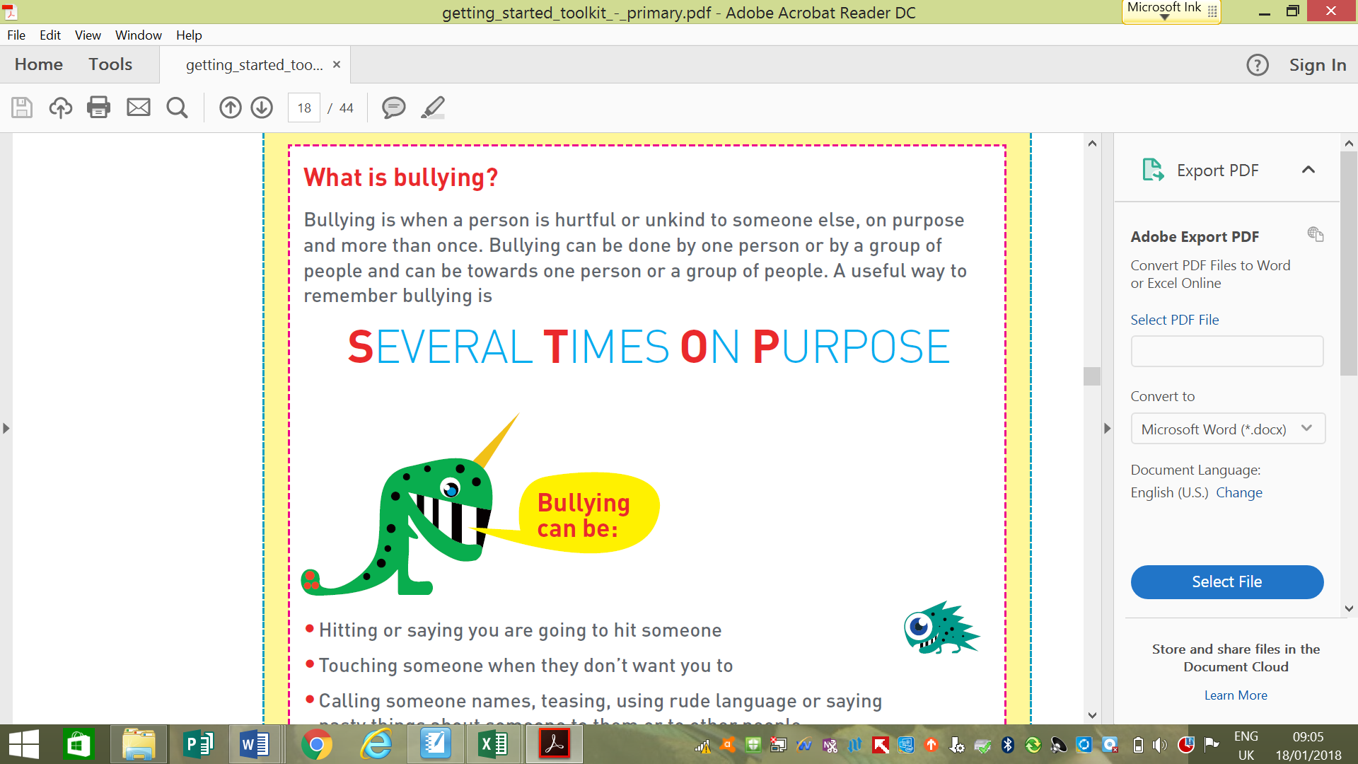

**•**Hitting or saying you are going to hit someone

•Touching someone when they don’t want you to

•Calling someone names, teasing, using rude language or saying nasty things about someone to them or to other people

•Stealing or damaging someone else’s belongings

•Ignoring someone on purpose or leaving them out

•Sending hurtful or unkind texts, emails or online messages to someone or about someone

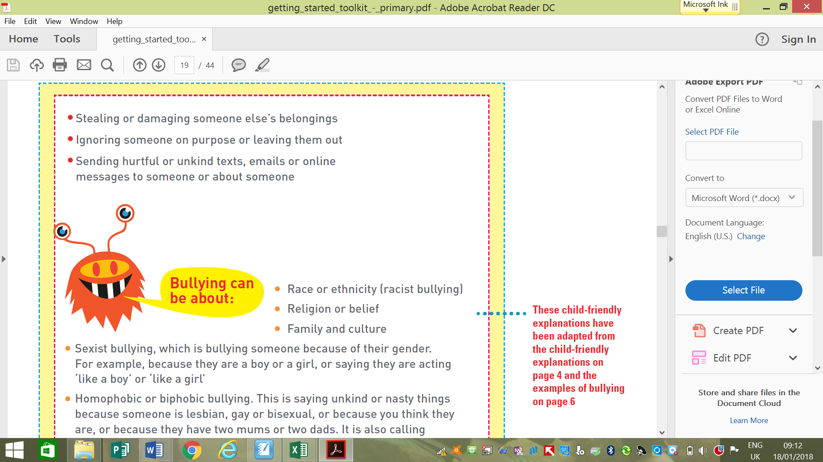

• Race or ethnicity (racist bullying)

• Religion or belief

• Family and culture

• Sexist bullying, which is bullying someone because of their gender.

For example, because they are a boy or a girl, or saying they are acting

‘like a boy’ or ‘like a girl’

• Homophobic or biphobic bullying. This is saying unkind or nasty things because someone is lesbian, gay or bisexual, or because you think they are, or because they have two mums or two dads. It is also calling someone lesbian, gay or bisexual on purpose to be unkind or nasty to

them, for example ‘you’re so gay!’

• Special educational needs or disability

• What someone looks like

• Where someone lives

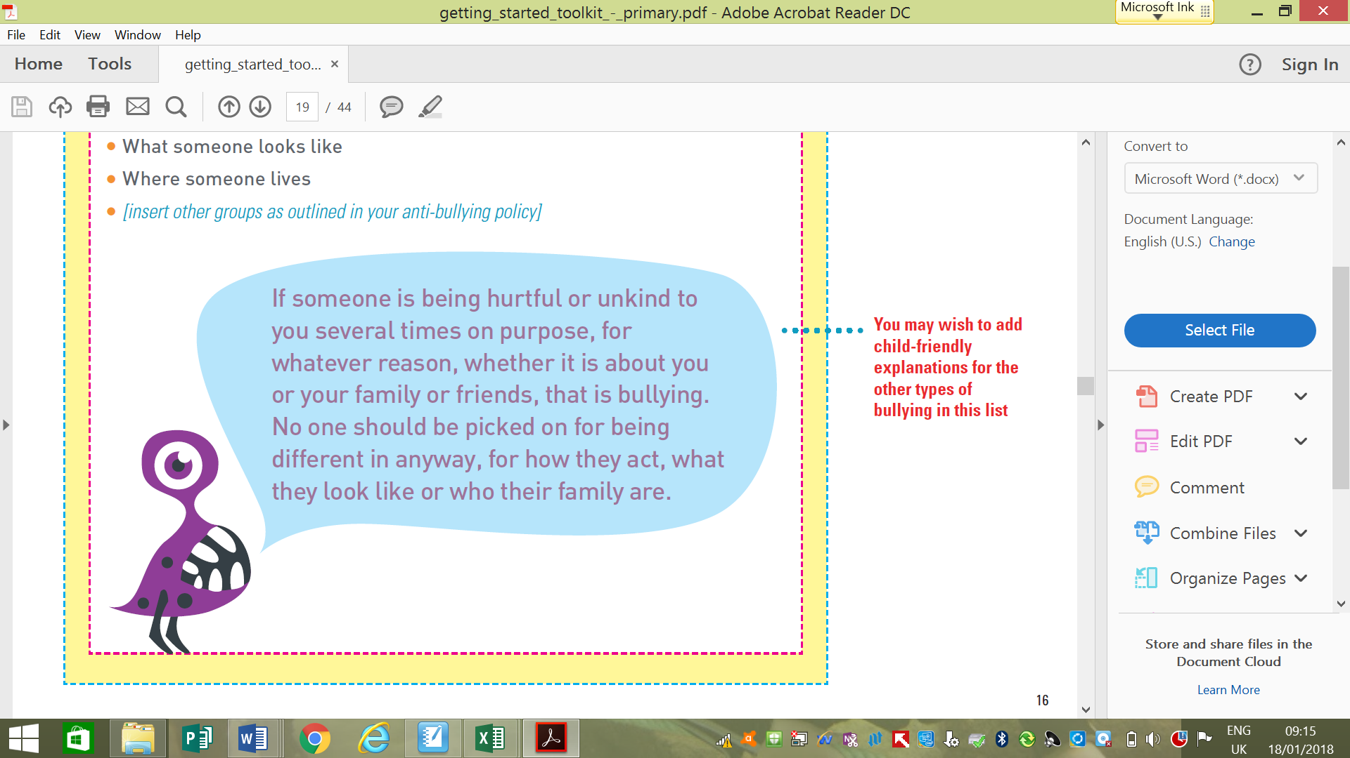

**Why does bullying happen?**

Although bullying doesn't happen very much at this school it might happen.

Bullies can be older or younger than you, bigger or smaller than you. Bullies pick on people who may be different in some way and try to make them feel worse about themselves. If you are being bullied remember that it is never your fault.

**Where does bullying happen?**

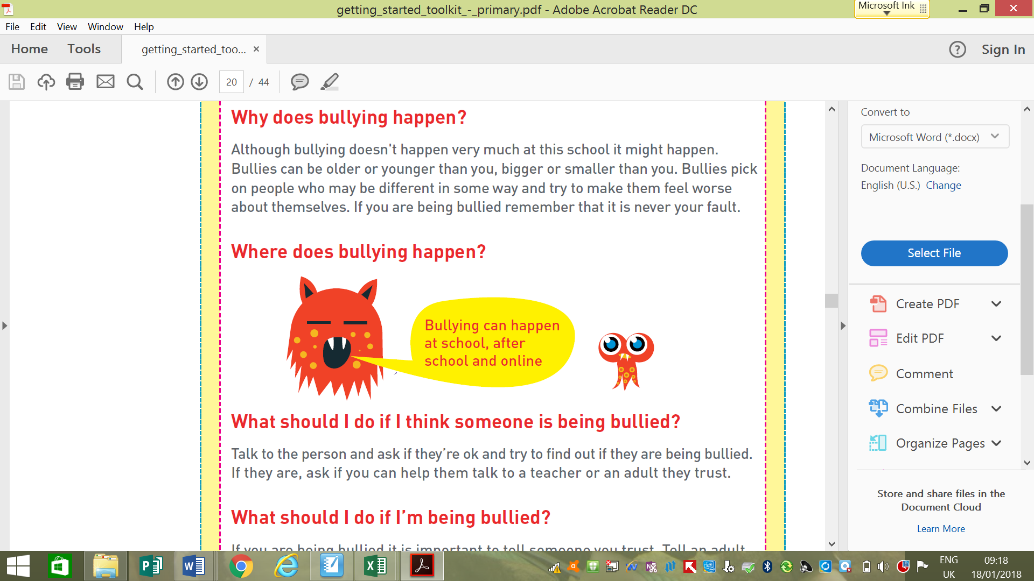

**What should I do if I think someone is being bullied?**

Talk to the person and ask if they’re ok and try to find out if they are being bullied. If they are, ask if you can help them talk to a teacher or an adult they trust.

**What should I do if I’m being bullied?**

If you are being bullied it is important to tell someone you trust. Tell an adult or friends, either at school or at home. If you have already told an adult about bullying you can still tell them again. You can:

**•Tell any adult in school**

**•Tell a playground problem solver****who will be able to help you**

**•Tell an adult at home**

**•You can also write a note about the bullying in the class worry box**

**•You can also call ChildLine at any time for free on 0800 1111. They will not tell anyone else about what you have said.**

