
Class 5 Newsletter

Spring Two

Welcome Back!
Welcome back! I hope you have all had a good week off and feeling ready for the next half term! We have lots to look forward to starting with Book Week in the second week back. This includes World Book Day which is on Thursday 6th March. This will be a fun day of book related activities and maybe a chance to dress up as our favourite story characters and then dance away into the evening at the Book Day Disco! Our annual science competition, the S Factor, is in the following week with class heats happening, followed by the Live Final the week after. In week four, we have our second round of parents evenings. This is an ideal opportunity to find out how your child is getting on and to discuss their progress. We look forward to seeing you all then. In the meantime, as always, please do feel free to get in touch if you have any questions or concerns. Kind regards. Mr Harington & Mrs White.

Our Topics

After the excitement of visiting the Alps last half term, we focus on history this half term but with no letup in the intensity as we are introduced to the vicious Vikings! A fearsome, dangerous and frequently violent part of British history, we will be finding out more about these often-misrepresented settlers who left a lasting mark on our lives. Maybe you could find out some ferocious facts to share with the class? We will be continuing our chemistry topic in science which is a big topic with lots of fun practical experiments to do. This is a big part of year 5 science curriculum and will continue into next term too. This term aslo sees the exciting return of our annual science competition – The S Factor! The heats will be held the third week back so I hope you’ve been practising your experiments! In our computing lessons we will be exploring the exciting world of game creating and in DT we will be looking at creating our own Viking bags. In the penultimate week we have Healthy Week which ties in nicely with our PSHE this term which looks at the dangers of smoking and vaping and helping the children make informed healthy choices.
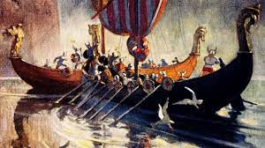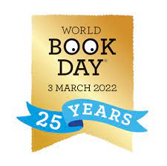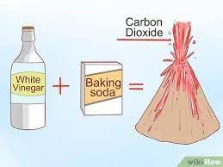

English

This term sees us becoming reporters and looking at the genre of newspaper writing. We will be looking at what makes a good headline and how to provide interesting factual writing. It will also provide plenty of scope to practise the skills we have looked at so far while working on making our writing more cohesive and fit together even better. Please continue to encourage your children to practise these vital writing skills within their weekly homework. It really does help them to become more proficient.
Maths

This term we journey back into the exciting world of fractions! We have started to multiply them and soon will be looking at the link between decimals, fractions and percentages. We will, as always, have a big focus on times tables which link directly with understanding fractions. Children should know all their times tables by now so it’s all about practice to help them to be as quick and confident as possible when recalling these essential facts. The Times Tables Rockstars app is the perfect way for them to practise. Please do encourage them, and help them to keep practising their times tables. TTRS is not the only way but it is perfect for it! Thanks.
HOMEWORK 

Your child will receive homework each Friday. The task will be inside their homework books. This year we have two different homework books, one for a spelling writing task and one for maths. Spellings will be sent home every Friday. The children will have a week to learn them. The children need to write a sentence using each spelling word to show their understanding. The children will also be given a specific focus for the sentences. All work is pitched so that it can be completed independently. However, children may need help to understand some of the words. We use dictionaries in school so if they have access to one at home this would help.
Learn by Hearts homework will come home on a TUESDAY. These are essential maths facts that must be learnt in preparation for a test the following TUESDAY. The children will then get a second week to consolidate the facts before receiving the next set.

Homework should be handed in on a Tuesday. If any child is unable to manage this, they will be expected to complete their work during break/lunchtimes.

All children should also continue to read regularly at home [we suggest a minimum of 3 x per week] to an adult and record this in their reading record. Please feel free to leave a comment on how they have got on.
Please do feel free to contact us if you have any queries or would like any advice on helping your children further.

 PE
PE this half term will be on MONDAYS AND TUESDAYS. Please make sure your child comes to school in their PE kits on these days.
If they are in an after-school club on non-pe days, then they need to wear school uniform on these days and bring their PE kit to change into after school.
Our school PE kit consists of plain black shorts or leggings/tracksuit bottoms with a plain white t-shirt and appropriate footwear (trainers must be worn outdoors, especially when it is wet!) Children should wear their normal school jumper / cardigan on PE days. We will try to be outside as much as possible so please dress according to the day’s weather prediction. We will provide a school hooded top for children to use in the lesson. This will be their own personal top for the year but does need to kept in school.
Children must not wear earrings during PE lessons for safety reasons. Please make sure they leave them at home or are able to take them out themselves.
As well as being good for your child’s health, PE is statutory; therefore, all children must participate in each lesson unless there is a medical reason to suggest otherwise.

If you have any queries, questions or concerns please do not hesitate to make an appointment [via the school office] with either of us in Class 5, before 8:40 am or after school. We are also available at the end of the ramp for a quick chat at 8:40am.

Many thanks,
This term’s value is kindness
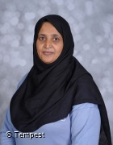
Mr Harington Alice Whiteley Mrs Hussain
Diary Dates

WB 3rd March – Book Week  Thursday 6th Mar – World Book Day  Thursday 7th Mar – Book Day Disco  Wed 12th March – S Factor Heats  Wednesday 19th March – S Factor Final | Mar – Parents Evenings ?????  Friday 21st March – Comic Relief/Red Nose day  Wednesday 2nd April– Easter Service  Friday 4th April – Start of Easter Holidays

