AUTUMN  N.C Objectives in bold | SPRING  N.C Objectives in bold | SUMMER  N.C Objectives in bold
(This term, as well; as the two named units, we will ensure all children are very secure in the use of Google Docs, Slides, Sheets, Classroom and Drive to support their work across the curriculum this year and set them up well for Y7.)  AUTUMN 1: Online safety and computer networks.  NB: The principles learned in this unit will be regularly revisited throughout the year)  - USE TECHNOLOGY SAFELY, RESPECTFULLY AND RESPONSIBLY; RECOGNISE ACCEPTABLE/UNACCEPTABLE BEHAVIOUR; IDENTIFY A RANGE OF WAYS TO REPORT CONCERNS ABOUT CONTENT AND CONTACT  - understand computer networks, including the internet; how they can provide multiple services, such as the World Wide Web, and the opportunities they offer for communication and collaboration  AUTUMN 2: Spreadsheets  - select, use and combine a variety of software (including internet services) on a range of digital devices to design and create a range of programs, systems and content that accomplish given goals, including collecting, analysing, evaluating and presenting data and information | This term, we will be using our NEW Microbits for the first time. Alongside this, we will be writing blogs to record and share our experiences and promote collaboration.  SPRING 1 and 2: Coding with Microbits  - design, write, and debug programs that accomplish specific goals, including controlling or simulating physical systems; solve problems by decomposing them into smaller parts  - USE SEQUENCE, SELECTION, AND REPETITION IN PROGRAMS; WORK WITH VARIABLES AND VARIOUS FORMS OF INPUT AND OUTPUT  - use logical reasoning to explain how some simple algorithms work and to detect and correct errors in algorithms and programs | This term, we will focus on creative work with cross-curricular links. Probable topics are in brackets.  SUMMER 1: Film-Making(The Battle of Marathon)  - select, use and combine a variety of software (including internet services) on a range of digital devices to design and create a range of programs, systems and content that accomplish given goals, including collecting, analysing, evaluating and presenting data and information  SUMMER 2:  - Create a Multi-media text based story (Kensuke’s Kingdom/ desert islands)  - Plan and record a podcast (Moving on to secondary school)  - select, use and combine a variety of software (including internet services) on a range of digital devices to design and create a range of programs, systems and content that accomplish given goals, including collecting, analysing, evaluating and presenting data and information  - use search technologies effectively, appreciate how results are selected and ranked, and be discerning in evaluating digital content
AUTUMN 1: Online safety and computer networks.  Online safety (review from previous years):  - To know the meaning of a digital footprint and know how information online can persist.  - To have a clear idea of appropriate online behaviour.  - To identify benefits and risks of mobile devices broadcasting the location of the user/device.  - To identify secure sites by looking for privacy seals of approval.  - To identify the benefits and risks of giving personal information.  Computer networks:  - To explain the importance of Internet addresses  - To recognise how data is transferred across the internet  - To explain how sharing information online can help people to work together  - To evaluate different ways of working together online  - To recognise how we communicate using technology  - To evaluate different methods of online communication  Google classroom:  To independently log on to Google classroom and  - Respond to work set  - Create a Google doc and a Google slide.  - Find previously saved work in Google Drive.  - Organise work in Google drive into folders.  Autumn 2: Spreadsheets (Making surveys with an online safety theme).  - To create a data set in a spreadsheet  - To explain that formulas can be used to produce calculated data  - To apply formulas to data  - To create a spreadsheet to plan an event  - To choose suitable ways to present data  Online safety theme for the spreadsheeet and survey:  - To understand the importance of balancing game and screen time with other parts of their lives.  - To identify the positive and negative influences of technology on health and the environment. | SPRING 1 and 2: Introduction to microbits, while blogging about it  Sessions1 – Name Badge  Sessions 2- Beating Heart Animation  Session 3- Emotion Badge  Session 4- Step Counter  Session 5- Night Light  Session 6 – Rock, Paper, Scissors  Choose, plan, implement and evaluate own microbit project (working with a partner) Record in a blog.  Coding objectives  - To explain what the buttons and sensors on the micro:bit do  - To program sensors and buttons using the MakeCode editor  - To store data with variables using the MakeCode editor  - To ‘flash’ code from the chromebook to the Microbit  - To analyse problems in computational terms  - To have repeated practical experience of writing computer programs in order to solve such problems  - To use the microbit to collect data and download it to the chromebook before presenting it.  - To evaluate and apply information technology, including new or unfamiliar technologies, analytically to solve problems  - To be responsible, competent, confident and creative users of information and communication technology  Blogging  - To contribute thoughtfully to the content of a blog.  - To comment appropriately on the content of other blog users. | Film Making  - To know the features of a filmed news feature,  - To develop knowledge of camera angles and types of camera shots  - To plan a short news film, using storyboarding.  - To create and edit short film clips.  To use music, credits and clips to create a short film.  - To convert a movie-editing project into a finished movie file.  - To review film against a given criteria  - To use feedback to make changes  - To evaluate the film-making process.  Text Adventure  - To plan a text adventure story with a non-sequential narrative.  - To use appropriate search criteria to efficiently find appropriate images, (and possibly sounds) understanding the origins and copyright of found images.  - To cite images accurately.  - To create a non-sequential text adventure using hyperlinks.  Podcasting  - To know the features of a radio magazine show.  - To plan a short podcast, using storyboarding.  - To create and edit sound clips  To use (copyright free or original) music, and sound clips to create a class podcast.  - To review podcast against a given criteria  - To use feedback to make changes  - To evaluate the podcasting process.

KNOWLEDGE TO BE LEARNED BY THE END OF EACH UNIT (WHAT DO WE WANT THE CHILDREN TO KNOW AND REMEMBER?)
AUTUMN TERM | SPRING TERM | SUMMER TERM
Computer Networks  - Computers or computer controlled devices that can connect to the server are called clients.  - The process of changing a message so it cannot be read by anyone except who it is sent too is called encryption.  - A protocol is a set of rules that say how information and data should be sent. Router. An Internet Protocol ( IP) address identifies each computer using the Internet Protocol to communicate over a network  - Routers are small computers that communicate between the Internet and devices that connect to the Internet. They keep the packets in a network moving to their destination as smoothly and quickly as possible. server  - A server is a piece of hardware that has a large memory drive where lots of files and resources are stored. It also responds to requests across a computer network.  - Streaming is a method that allows people to transmit or receive data. This happens when people listen to music or watch videos over a computer network. People can stream whenever they like as long as they are connected to the Internet.  - A device that has lots of connection ports for lots of other devices to connect to a computer network is called a switch .  - Topology is a term used to define the layout of a network and can tell us how different devices are connected. There are different types of topology, such as: star, bus, mesh, ring and hybrid.  Internet vs World Wide Web Many people believe that the Internet and the World Wide Web are the same. In fact, they are two separate concepts. One is a network and the other is a file system. The Internet is a network of computers connected to each other all around the world. The World Wide Web is a global filing system that runs on the Internet. Many entries in the World Wide Web’s filing system are websites which consist of many web pages. | The micro:bit helps you understand how computers work. When you type on your laptop or touch the screen on your phone, you’re using an input device. Inputs allow computers to sense things happening in the real world, so they can act on this and make something happen, usually on an output like a screen or headphones.  In between the input and the output, there is the processor. This takes information from inputs like buttons, and makes something happen on outputs, like playing a song in your headphones.  Abstraction- Identifying and focusing on the most important information  Accelerometer- A sensor that can be used to measure if the micro:bit is moving, in which direction it is moving and how fast it is moving  Algorithm-s A set of instructions or rules written for a human to follow.  Bug-An error in a computing program which results in an incorrect output  Debugging- Finding and fixing bugs in a computer program. Decomposition- Breaking a problem down into smaller tasks  Execute- When the computer reads the program and carries out the instructions  Input devices - used to send data to the computer  LEDs- Stands for light-emitting diode.  Logical reasoning- Using what you already know when solving a problem  Physical systems A computer that responds to changes in the environment and has a real-world output  Count-controlled loops- A form of repetition where the instructions are repeated a given number of times.  Infinite loops- A form of repetition where the instructions are repeated endlessly  Selection- Telling the computer to only carry out a set of instructions if a certain condition is met.  Variables A variable is data stored within a computer program. This data be changed, recalled or used. | Summer 1&2  Film-making  - Shot: Single uninterrupted recording of action.  - Angle: Viewpoint from which camera captures.  - Edit: Combine shots to create final film.  Text Adventure  - Hyperlink: Interactive link to different story parts.  - Choice: Decision point affecting story progression.  - Outcome: Result based on player's choices.  - Navigate: Move through the adventure's paths.  - Copyright: Legal protection for original creations.  - Fair Use: Limited use of copyrighted material.  - Cite: Acknowledge source, giving credit when referencing.  Podcasting  - Podcast: Digital audio show available online.  - Episode: Individual installment of podcast content.  - Host: Person leading and presenting podcast.  - RSS Feed: Mechanism to distribute podcast episodes.  - Subscribe: Follow podcast updates automatically.
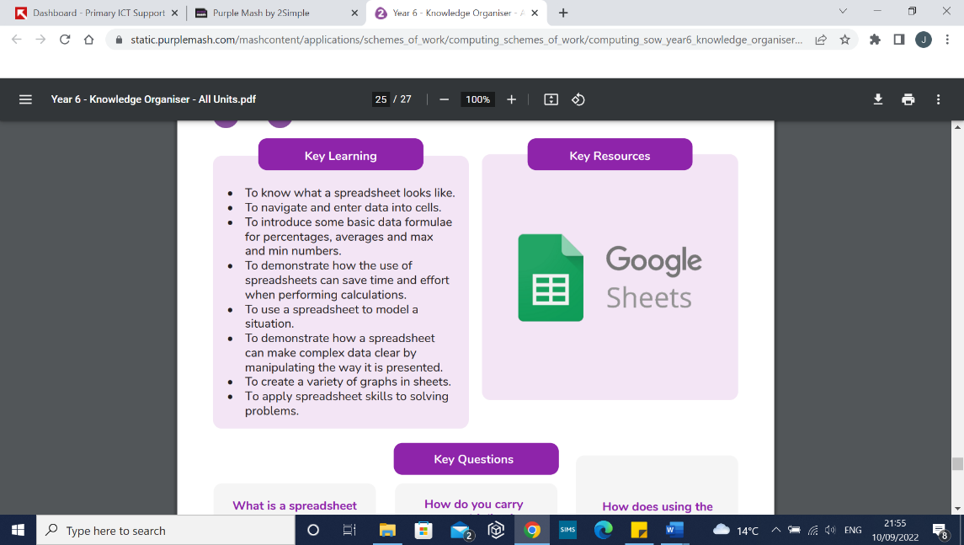  Sheets (Spreadsheets)  - Spreadsheets are used to display, organise and interpret information.  - They are easy to manipulate and carry out useful calculations quickly.  - Data is a collection of information, especially facts or numbers, obtained by observation, questions or measurement to be analysed and used to help decision-making.  - A cell is an individual section of a spreadsheet grid. It contains data or calculations.  - A column is a vertical, lettered reference points for the cells in a spreadsheet.  - The formula bar is an area of the spreadsheet into which formulae can be entered using the ‘=’ sign to open the formula.  - Formula (e) is a group of letters, numbers, or other symbols which represent a mathematical rule. It allows a spreadsheet to carry out calculations.  - Range is a collection of selected cells: all the numbers you want to appear in a calculation. For example, A1:A12 includes all the cells from A1 to A12.  Online safety  - The term digital footprint is used to describe the traces that people leave behind when they have visited a website or used social media. Your digital footprint is unique to you.  - Using a screen can help you surf the Internet or enjoy computer games but you need to be careful how much time you spend using a screen.  - Using a screen at night can damage your sleep patterns.  - Secure websites have particular privacy features to look out for such as a padlock or https.  - Location sharing is a way of sharing with others your device’s location; these can be switched off for added security.  - PEGI rating show the age that digital content is suitable for and the type of content that it contains.  - Phishing is the practice of sending email pretending to be from reputable companies in order to persuade individuals to reveal personal information. | Blogging  - A blog, (short for web-log) is a website or webpage that is regularly updated by the author .Vlogs, or video logs, are similar.  - A blog also allows the reader to post comments or opinion based on what is written.

