

Food Served at Our Breakfast Club

[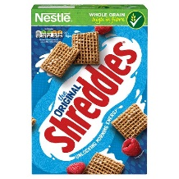](https://www.google.co.uk/url?sa=i&rct=j&q=&esrc=s&source=images&cd=&ved=2ahUKEwiQ7OSjx83iAhVPPBoKHa8oDmkQjRx6BAgBEAU&url=https://www.britishcornershop.co.uk/nestle-shreddies&psig=AOvVaw0FnxQ78DP5GtQ2zbGQDEMQ&ust=1559659692834970)[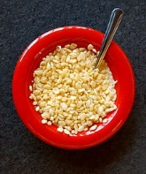](https://www.google.co.uk/url?sa=i&rct=j&q=&esrc=s&source=images&cd=&ved=2ahUKEwi1p6LSx83iAhVNdhoKHdPTCOsQjRx6BAgBEAU&url=https://en.wikipedia.org/wiki/Rice_Krispies&psig=AOvVaw2oJVPGsj0qJjgCuH3LHqQK&ust=1559659783207477)We have a range of different cereals daily, these include Shreddies, Multi Grain Hoops, Cornflakes & Rice krispies.

[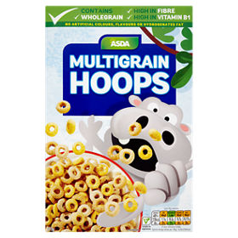](https://www.google.co.uk/url?sa=i&rct=j&q=&esrc=s&source=images&cd=&ved=2ahUKEwiAwOfxx83iAhUmzIUKHRJ9D4IQjRx6BAgBEAU&url=https://groceries.asda.com/product/high-in-fibre/asda-multigrain-hoops/910002026009&psig=AOvVaw0ED_98wG4-GFUlWP61mhJY&ust=1559659850415074)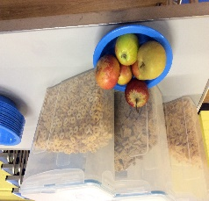[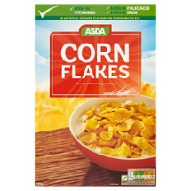](https://www.google.co.uk/url?sa=i&rct=j&q=&esrc=s&source=images&cd=&ved=2ahUKEwiTn-qoy83iAhWpxoUKHbxiBRAQjRx6BAgBEAU&url=https://groceries.asda.com/product/cornflakes-crunchy-nut/asda-corn-flakes/910002922274&psig=AOvVaw3X8evxlD24VuJ-U9-83_Yb&ust=1559660769677831)

[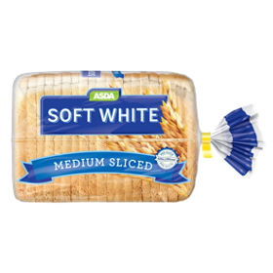](https://www.google.co.uk/url?sa=i&rct=j&q=&esrc=s&source=images&cd=&ved=2ahUKEwiej8iDys3iAhUyyoUKHQ5KBIoQjRx6BAgBEAU&url=https://groceries.asda.com/product/white-bread/asda-square-cut-medium-white-bread/910002989320&psig=AOvVaw0TdQLrcJlKDhmeyKP5LRzm&ust=1559660430319340)[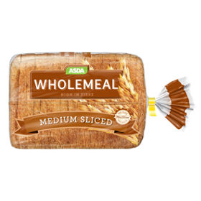](https://www.google.co.uk/url?sa=i&rct=j&q=&esrc=s&source=images&cd=&ved=2ahUKEwiX0Obhyc3iAhUPmRoKHVfNDPkQjRx6BAgBEAU&url=https://groceries.asda.com/product/wholemeal-bread/asda-square-cut-medium-wholemeal-bread/910002989489&psig=AOvVaw12DvPvw8fFByA2gtKo6VwC&ust=1559660355990552)Toast – Children can have up to 3 slices of toast a day or 2 slices if they have had cereal. We serve wholemeal & white bread. Children are served one slice of each.

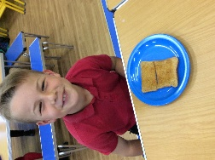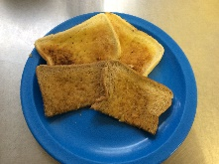

[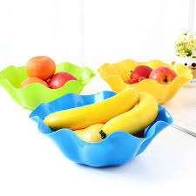](https://www.google.co.uk/url?sa=i&rct=j&q=&esrc=s&source=images&cd=&ved=2ahUKEwiyupXzzc3iAhWOsBQKHeU1ASsQjRx6BAgBEAU&url=https://m.kikuu.ug/product/1467255&psig=AOvVaw1uwkshTW99D6u-sjTC9--d&ust=1559661434271441)[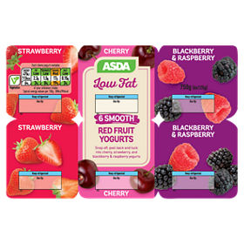](http://www.google.co.uk/url?sa=i&rct=j&q=&esrc=s&source=images&cd=&cad=rja&uact=8&ved=2ahUKEwi64sSKzc3iAhWN1eAKHZgqDsUQjRx6BAgBEAU&url=/url?sa%3Di%26rct%3Dj%26q%3D%26esrc%3Ds%26source%3Dimages%26cd%3D%26ved%3D%26url%3Dhttps%3A%2F%2Fgroceries.asda.com%2Fproduct%2Ffat-free-low-fat%2Fasda-6-low-fat-red-fruit-yogurts%2F910002962908%26psig%3DAOvVaw26zmVI7pu7Ia_J6C0NYoSs%26ust%3D1559661090845578&psig=AOvVaw26zmVI7pu7Ia_J6C0NYoSs&ust=1559661090845578)As well as the cereals & toast that we offer, we also have a selection of fruit & yoghurts.

We serve water, milk & fruit juice.

[](http://www.google.co.uk/url?sa=i&rct=j&q=&esrc=s&source=images&cd=&ved=2ahUKEwjc77iD0M3iAhWJ34UKHfDiAIQQjRx6BAgBEAU&url=http://foodviva.com/juice-recipes/orange-pineapple-juice-recipe/&psig=AOvVaw3uT7TBsjlWvL97fD4_Jl65&ust=1559662017510453)[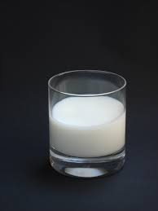](https://www.google.co.uk/url?sa=i&rct=j&q=&esrc=s&source=images&cd=&cad=rja&uact=8&ved=&url=https://ahmongwoman.com/2011/09/12/top-3-parenting-tips-for-fairly-new-parents/&psig=AOvVaw0u0JW4R9EUDN3NZLYQBe4M&ust=1559661776894827)[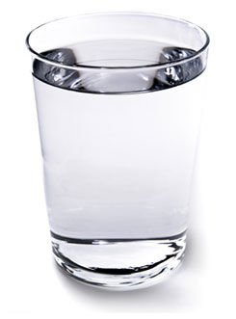](https://www.google.co.uk/url?sa=i&rct=j&q=&esrc=s&source=images&cd=&ved=2ahUKEwiglIah0M3iAhWnxoUKHYKgDaoQjRx6BAgBEAU&url=https://www.instructables.com/id/How-to-fill-a-cup-with-water/&psig=AOvVaw3LH8c2y_oIZ7nlyS9_hnZl&ust=1559662099743377)