**Stanningley Primary School**



**Healthy Packed Lunch Policy**

[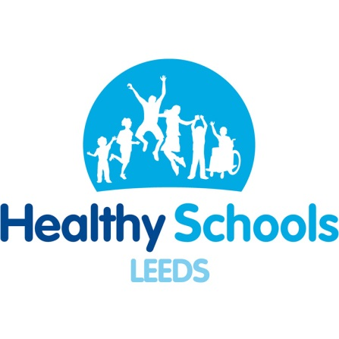](http://www.google.co.uk/url?sa=i&rct=j&q=&esrc=s&source=images&cd=&cad=rja&uact=8&ved=2ahUKEwjp6rGF7cPaAhWGPBQKHeo1BlYQjRx6BAgAEAU&url=http://www.stjosephspudsey.org/our-awards/&psig=AOvVaw3fwb9UfjWzQIRPUyPenLNM&ust=1524141862361017)[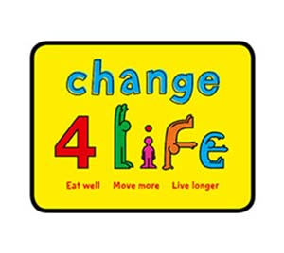](https://www.google.co.uk/url?sa=i&rct=j&q=&esrc=s&source=images&cd=&cad=rja&uact=8&ved=2ahUKEwjas87A7cPaAhWKbhQKHdXpCG8QjRx6BAgAEAU&url=https://www.royalmail.com/corporate/marketing-data/trends-innovation/case-studies/change-4-life&psig=AOvVaw26iAFljlQyfjhpC__nxRhB&ust=1524141975825763)

At Stanningley Primary School we are committed to educating our children in making healthy lifestyle choices. This policy supports our aims in this.

**The aim of our policy is:**

To ensure all packed lunches brought from home and consumed in school (or on school trips) provide our pupils with a healthy, nutritious, balanced lunch, that is similar to food served in schools, which is regulated by The National Foods Standards.

**Why the policy was formulated:**

The government has placed a duty on schools to ensure that every child is healthy and has invested hugely in improved school meals, with free fruit for schools and ***The School Food Trust*** which encourages healthy eating. The trust recommends we have a policy and this one is based on their model. This policy has been written following consultation with parents, pupils, staff and governors.

Eating healthily is important because it will help children to:

* Be fitter and healthier now and later in life.
* Learn more efficiently quickly and support behave better.

School meals conform to government nutritional guidelines with less sugar, fat and salt and more fresh fruit and vegetables. School lunches also provide a good balance of “complex carbohydrates” such as pasta, rice, bread or potatoes with dairy and other protein foods. There is no reason why a packed lunch cannot provide the same nutrition as a cooked meal.

Full details of the National Food Standards can be found at [www.schoolfoodplan.com](http://www.schoolfoodplan.com)

[www.change4life.co.uk/](http://www.change4life.co.uk/)

**Where, when and who the policy applies to:**

The policy applies to all pupils, parents/carers or any staff member providing a packed lunch to be eaten at school or on a school trip during normal school hours beginning from June 2018

**The policy:**

* We will try to ensure that children who bring a packed lunch and children who have a school dinner are able to sit and eat together, sitting in their year group on one table together.
* Both children who bring a packed lunch & those who have a school meal will sit together in their year groups to eat their lunches.
* We will provide a clean appropriate dining room facility where pupils can eat their lunch.
* Fresh, cooled drinking water is available at all times of the day and is provided on tables for children at lunchtime. **Drinks should not be provided in lunch boxes** (unless on a school trip, when bottled water or only a non-fizzy drink may be included.)
* As a fridge space is not available for packed lunch boxes within school, during particularly hot weather pupils are advised to bring lunches in insulated bags with freezer blocks to stop food going off.
* Children must only eat their own food and are not permitted to swap items.
* Although they can be healthy **Nuts or nut products are not permitted in lunchboxes due to the danger of allergies to other children.**

**Special Diets/ Allergies:**

We understand that sometimes, some pupils may have a special diet, so that may not always allow for them to be able to fully meet the government food standards. In this situation we would urge any parents/carers to be responsible in ensuring that packed lunches are as healthy as possible. We would ask parents / carers to provide a letter from a doctor / dietician outlining their child’s special dietary requirements.

**For this reason pupils are**

* **not permitted to swap food items.**
* **not permitted to bring in any nuts or nut products in packed lunchboxes.**

**Guidance- what a healthy lunchbox should include**

Packed lunches **should** include:

Following published guidance it is recommended that packed lunches contain one food from each of these groups every day:

|  |  |
| --- | --- |
| A **starchy food** (such as bread, pasta, rice, noodles and potatoes). |  |
| At least 1 portion of **fruit** and/or **vegetables**. |  |
| Meat, fish (e.g. a ham or tuna sandwich) or another source of non – dairy **protein** (such as lentils, hummus and kidney beans) |  |
| A **dairy food** (such as milk, cheese, yogurt, fromage frais, custard ) |  |
| **Water** will be provided by school. Drinks do not need bringing into school with packed lunches. |  |



Packed lunches **could** include these items, only as part of a balanced diet but not every day.

* buns
* plain biscuits
* cereal bars/ rice cakes
* savoury crackers or bread sticks
* Children are encouraged to bring crisps **only on a Friday**
* All children will be reminded of this regularly.

Packed lunches **should not** include:

* chocolate covered confectionary, bars, i.e. mars bar/ milky way, kinder bar (if these items are mistakenly included, staff will encourage children to save them for after school)

We do allow chocolate covered biscuits such as penguins, club biscuit ect.

* sweets of any kind
* drinks of any kind (water is provided by school)
* chocolate spread or jam
* meat and pasty products such as pork pie, sausage rolls or pasty
* any nuts or nut products
* Crisps on any day except Friday

**Monitoring of lunch boxes**

Packed lunches are reviewed by lunchtime staff as part of their supervision of the children & polite reminder notes will be given to children if they persistently bring items which are deemed not to comply with the policy (**Pupils with special diets will be given due consideration).**

We rely on parents/carers to encourage & support this policy and work with the school to ensure that their children are provided with a balanced, healthy lunchbox.

**If a child regularly brings a packed lunch that does not conform to the policy then the school will contact the parents to discuss this & parents may be asked to make alternative lunchtime arrangements ??)**

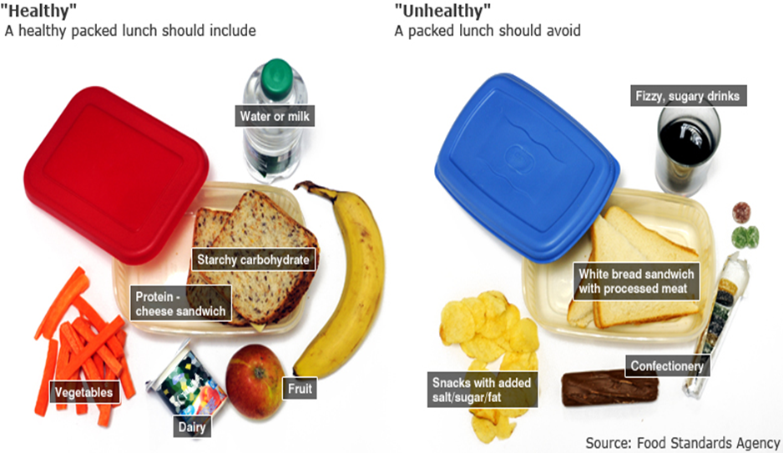

This Healthy Packed Lunch Policy was reviewed by Stanningley Primary School in May 2022

Review date: May 2024

Head Teacher, Mrs J. Brewer 

Chair of Governors, Mrs Louise Travis-Jones 