

MUSIC POLICY
INTRODUCTION Music is a powerful, unique form of communication that can change the way pupils feel, think and act. It enables personal expression, reflection and emotional development. As an integral part of culture, past and present, it helps pupils understand themselves and relate to others, forging important links between the home, school and the wider world. The teaching of music develops the pupils’ ability to listen and appreciate a wide variety of music and to make judgements about musical quality. It encourages active involvement in different forms of music-making, both individual and communal, thereby developing a sense of group identity and togetherness. It also increases self-discipline and creativity, aesthetic awareness, sensitivity and fulfilment.
AIMS: Music in Stanningley Primary school aims to:
- foster pupils’ sensitivity, understanding and enjoyment of music, through an active involvement in listening, performing, composing and appraising.
- enable all children to realise their individual creative potential by encouraging them to express themselves through music.
- enable children to acquire and develop the musical skills involved when performing, composing, listening and appraising.
- extend and develop the children’s awareness and understanding of traditions by giving them the experience of a range of musical styles from a variety of cultures, times and places.
- use music as a medium to develop the pupils’ skills, which will compliment and contribute to learning across the curriculum.

GUIDELINES :

All classes are to have a timetabled session with specialist music teacher, Mrs Claire Rivers. Children will experience at least twenty minutes of high quality music learning on a weekly basis as per the following timetable. Class teachers are expected to attend and be involved in all sessions and observe teaching, to enable skills and resources to be taken back to the classroom, so that Music does not only take place in Music lessons, but is an integral part of school life. 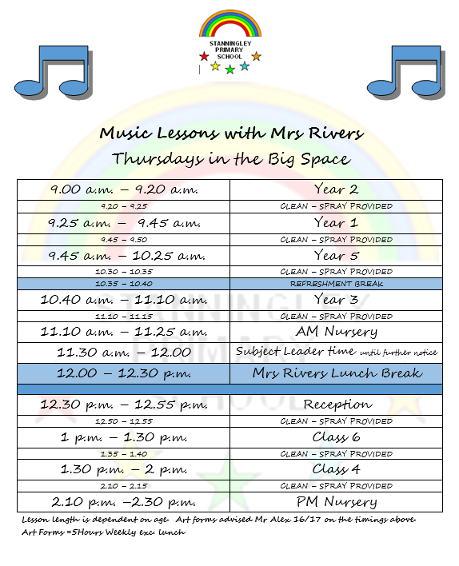

Music lessons follow the new model music curriculum introduced by the government in March 2021. This guidance is a practical framework setting out a model of how the curriculum can be taught.

In addition to the above, weekly singing assemblies will take place on Thursdays with Mrs Rivers and Mrs Hayward. Key Stage One and Two will join together to learn songs from a range of backgrounds and cultures. Songs will be learnt to celebrate key events throughout the school year. Thursday assemblies provide the essential rehearsal time needed for Easter, Christmas and Harvest services.

Sessions and performances will be recorded regularly in lessons using the ‘music ipad’. A session will be recorded at the beginning and the end of each unit to assess progression for that class. This will also show progression across year groups and it will show how the interrelated dimensions of music are taught as the children move through the school.

Stanningley School Choir will be open to all key stage two children, with an invite to Year Two children in the summer term. Rehearsals will take place weekly on Thursday lunchtimes with Mrs Hayward and Mrs Rivers. The children will learn more complex songs from a wide range of backgrounds. Stanningley Choir will be encouraged to perform at whole school events such as Christmas concerts and the Christmas and Summer Fair. The choir will also be encouraged to perform in and around the local community, in events such as the St Johns Luncheon Club Christmas Lunch and carol singing in the local area.

Visiting performers will be invited into school to assist in the enrichment of the childrens’ experience of music. The music co-ordinator will make an annual application to the LMEP Innovate Funding. This will provide the necessary means to invite professional musicians with a range of specialities to work with the children to experience, perform and enrich their musical experience which may include African drumming and Samba workshops.

Guitar lessons are offered to a number of children from year 4 – year 6. Children will register their interests and the places will be allocated on a first come first serve basis. Lessons will be delivered by a specialist guitar teacher employed through the Artforms contract. Lessons will be approximately 20 minutes long. The children will have the opportunity to use their own instruments or loan then from school upon the completion of a signed agreement. Parents and carers will pay approximately £4 per week for the lessons depending on the number of children in each lesson (arrangements will be made for PP children).
For Children and Families Wanting instrumental or Vocal Lessons
The school will happily signpost families to the weekend provision at Horsforth Music Centre. Operating at Horsforth High School, Lee Lane East, Horsforth, LS18 5RF during term time, the centre offers lessons in many instruments and also has ensembles and choir running throughout Saturday mornings. Open to adults as well as children, Horsforth Music Centre is run by ArtForms, part of Leeds City Council. Members from the Music Centre will be invited in to showcase the centre and introduce the children to the opportunities available to them.

Stanningley Primary School will ensure it has leaflets available to families and will seek to invite the centre in to speak to the children where possible. The music co-ordinator will keep these and distribute accordingly. The Head of centre, Mark Sturdy can be contacted via mark.sturdy2@leeds.gov.uk

RESOURCES : A range of tuned and untuned percussion instruments are available for use in music lessons and are kept in the Big Space and Zig Zag Area. Singing resources and CDs are stored in the music cupboard and in the ‘Big Space’. Further whole school music is stored on the school ipod. The projector and hall laptop are used to assist the children in learning words.

CONCLUSION : We need to monitor and review the success of this policy and its effectiveness. The children need to feel safe to express themselves musically in many different forms and contexts. A range of experiences need to be offered to the children to extend their knowledge, skills and understanding of music.
This Policy was reviewed and adopted by Stanningley Primary School in January 2025
Head

Teacher: Mr Ben Farrar Chair of Governors:
Review date : January 2028

