SPRING ONE
AREAS OF DEVELOPMENT |  | WEEK 1 | WEEK 2 |  | WEEK 3 |  | WEEK 4 | WEEK 5 |  | WEEK 6
Personal Social and Emotional | Making relationships  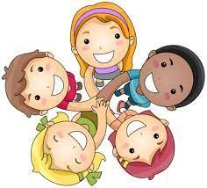 | Settling in new children. Learning names. |  | Settling in new children. Learning names. |  | Settling in new children. Learning names. | Settling in new children. Learning names. | Settling in new children. Learning names. | Settling in new children. Learning names.
 |   Managing self | Remembering our routines and the pattern of the day. |  | Helping new friends to tidy up and learn where things belong. |  | Helping new friends to tidy up and learn where things belong | Helping new friends to tidy up and learn where things belong | Helping new friends to tidy up and learn where things belong | Helping new friends to tidy up and learn where things belong
 |   Self regulation | Encourage and support children in finding solutions to conflict and rivalry. |  | Encourage and support children in finding solutions to conflict and rivalry. |  | Encourage and support children in finding solutions to conflict and rivalry. | Encourage and support children in finding solutions to conflict and rivalry. | Encourage and support children in finding solutions to conflict and rivalry. | Encourage and support children in finding solutions to conflict and rivalry.
Communication and Language | Listening and attention  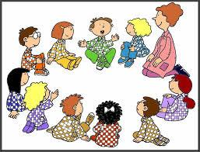 | Begin to listen to longer stories and recall more of what has happened. |  | Begin to listen to longer stories and recall more of what has happened. |  | Begin to listen to longer stories and recall more of what has happened. | Begin to listen to longer stories and recall more of what has happened. | Begin to listen to longer stories and recall more of what has happened. | Begin to listen to longer stories and recall more of what has happened.
 | Understanding  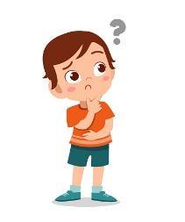 | Understand a question or instruction that has two parts, such as “Get your coat and wait at the door”. Understand ‘why’ questions, like: “Why do you think the puddle turned into ice?” |  | Understand a question or instruction that has two parts, such as “Get your coat and wait at the door”. Understand ‘why’ questions, like: “Why do you think the puddle turned into ice?” |  | Understand a question or instruction that has two parts, such as “Get your coat and wait at the door”. Understand ‘why’ questions, like: “Why do you think the puddle turned into ice?” | Understand a question or instruction that has two parts, such as “Get your coat and wait at the door”. Understand ‘why’ questions, like: “Why do you think the puddle turned into ice?” | Understand a question or instruction that has two parts, such as “Get your coat and wait at the door”. Understand ‘why’ questions, like: “Why do you think the puddle turned into ice?” | Understand a question or instruction that has two parts, such as “Get your coat and wait at the door”. Understand ‘why’ questions, like: “Why do you think the puddle turned into ice?”
 | Speaking   | Talk about home experiences and the things that they notice in their environment using longer sentences and a wider range of vocabulary.  Compare different experiences of Christmas holiday |  | Talk about home experiences and the things that they notice in their environment using longer sentences and a wider range of vocabulary.  Compare winter with autumn |  | Talk about home experiences and the things that they notice in their environment using longer sentences and a wider range of vocabulary.  Compare winter with autumn | Talk about home experiences and the things that they notice in their environment using longer sentences and a wider range of vocabulary.  Compare winter with autumn | Talk about home experiences and the things that they notice in their environment using longer sentences and a wider range of vocabulary. | Talk about home experiences and the things that they notice in their environment using longer sentences and a wider range of vocabulary.
Physical Development | Moving and Handling  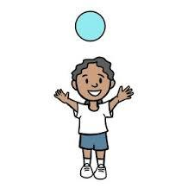 | Real PE Foundations –  Static balance, seated – Jungle |  | Real PE Foundations – Static balance, one leg -Pirates |  | Real PE Foundations –  Dynamic balance On a line - Trains | Real PE Foundations –  Dynamic balance to Agility Jumping and landing-Space | Real PE Foundations –  Dynamic balance to Agility Jumping and landing-Space | Real PE Foundations –  Counter balance – with a partner -Seaside
 |  | Handling tools-  Using tweezers to transport small objects. |  | Handling tools-  Using tweezers to transport small objects. |  | Handling tools-  Using chop sticks to have a go at eating noodles. | Handling tools- focus on cutting skills and use of split pins | Handling tools-  focus on cutting skills and use of split pins | Handling tools- making pancakes, stirring mixture and flipping pancakes.
 | Health and Self Care  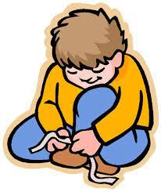 | Continue to monitor use of snack table.  Monitor and support washing of hands and use of blue paper towel when using the bathroom. |  | Continue to monitor use of snack table.  Monitor and support washing of hands and use of blue paper towel when using the bathroom. |  | Continue to monitor use of snack table.  Monitor and support washing of hands and use of blue paper towel when using the bathroom. | Continue to monitor use of snack table.  Monitor and support washing of hands and use of blue paper towel when using the bathroom. | Continue to monitor use of snack table.  Monitor and support washing of hands and use of blue paper towel when using the bathroom. | Continue to monitor use of snack table.  Monitor and support washing of hands and use of blue paper towel when using the bathroom.  Discuss the importance of washing hands when making pancakes and keeping hands away from hot cookers.
Literacy | Reading  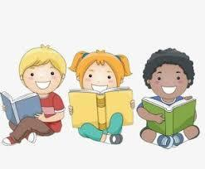 | Book Focus  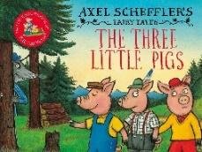 |  | Book Focus  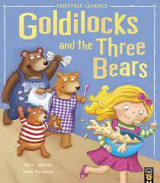 |  | . Book Focus  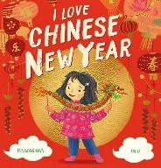 | 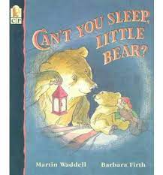  Book Focus  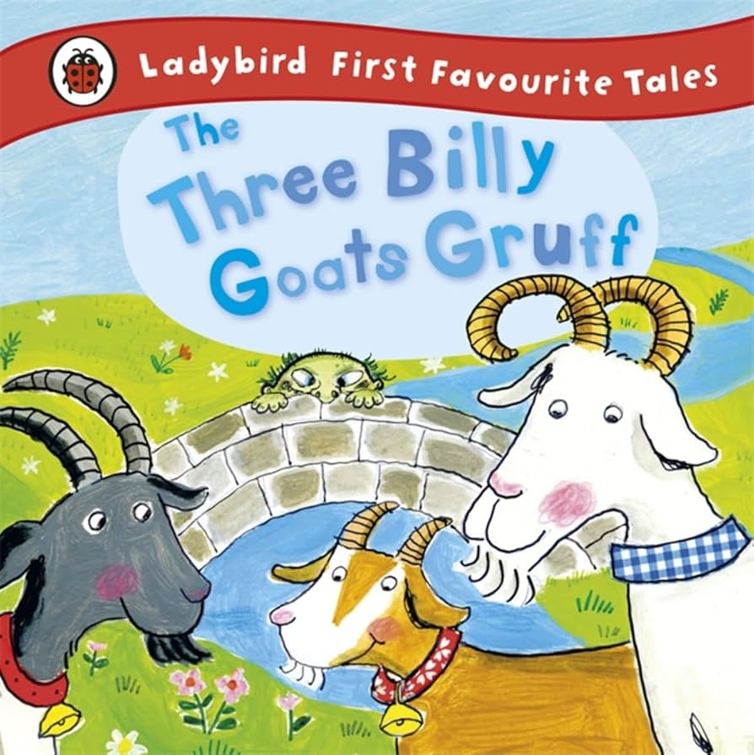 |   Book Focus  Snowman | Book Focus  
 | Writing  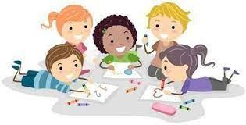 | Introduce helicopter stories –adults scribe short stories for children. |  | Introduce helicopter stories –adults scribe short stories for children. |  | Introduce helicopter stories –adults scribe short stories for children. | Introduce helicopter stories –adults scribe short stories for children. | Introduce helicopter stories –adults scribe short stories for children. | . Introduce helicopter stories –adults scribe short stories for children.
 | Phonics  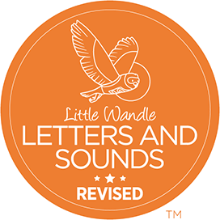 | Sounds d  NR= Hey Diddle  Hickory, Dickory  Phonemic awareness focus  Teach chn to hear the same initial sound.  Oral blending  Recognising their name  Teach chn to hear the initial sound of their name. |  | Sounds g  NR= Goldilocks went  Goats came a marching  Phonemic awareness focus  Teach chn to hear the same initial sound.  Oral blending  Recognising their name  Teach chn to hear the initial sound of their name. |  | Sounds o  NR= Oranges and Lemons  Phonemic awareness focus  Teach chn to hear the same initial sound.  Oral blending  Recognising their name  Teach chn to hear the initial sound of their name. | Sounds c  NR= Cobbler mend my shoe.  Clap, clap hands 12,3  Phonemic awareness focus  Teach chn to identify initial sound.  Oral blending  Recognising their name  Teach chn to hear the initial sound of their name. | Sounds k  NR= Old King Cole  Phonemic awareness focus  Teach chn to identify initial sound.  Oral blending  Recognising their name  Teach chn to hear the initial sound of their name. | Sounds e  NR= One elephant  Phonemic awareness focus  Teach chn to identify initial sound.  Oral blending  Recognising their name  Teach chn to hear the initial sound of their name.
MATHS |  | Books to Read  Three Little Pigs  Three Billy Goats Gruff  Goldilocks and three Bears  Roald Dahl’s 1,2,3  It’s not easy being Number Three (Drew Dernavich)  Number song:  “Three Blind Mice”  Number 3 Subitising and numeral recognition  Dice patterns  Different patterns  Different sizes and patterns | Books to Read  Three Little Pigs  Three Billy Goats Gruff  Goldilocks and three Bears  Roald Dahl’s 1,2,3  It’s not easy being Number Three (Drew Dernavich)  Number song  “Three little Kittens”  Number 3  1:1 counting  Numeral recognition  Composition of 3  Triangles  Triangle patterns |  | Books to Read  Pete the Cat and his four groovy buttons  Number  “Four Little Snowmen”  Number 4  1:1 counting  Numeral recognition  Squares and rectangles  Shape hunt  Making shapes  Piet Mondrian’s painting  Shape prints |  | Books to Read  Anno’s Counting Book  Number song:  “Four Little Teddy Bears”  Number 4 Composition of 4  Frogs & log  Ladybird & spots  Skittles & ball | Books to Read  Anno’s Counting Book  Spots and Dots.  Number song:  “Five fingers”  Number 5  1:1 counting  Numeral recognition  Pentagons  Shape hunt  Making shapes  Shape prints |  | Books to Read  Anno’s Counting Book  Spots and Dots.  Number song:  “Alice the Camel”  Number 5  Composition of 5  Sammy the Snail  Numicon Houses  Spots & Dots
Understanding of the World | People, Culture and communities   | Talk about how our families celebrate Christmas. What’s the same and what’s different. | Discuss who works in our communities to build houses. What other things do builders do in our community? Create building area in outdoor area using bricks and tools. Sand and water in builders tray. |  | Chinese New Year To have a greater understanding of and respect for other cultures and traditions. To compare and notice similarities and differences between cultures and traditions. |  | Chinese New Year To have a greater understanding of and respect for other cultures and traditions. To compare and notice similarities and differences between cultures and traditions.
 | 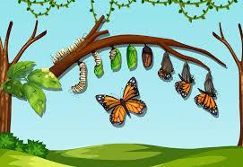  The natural world | Winter – observe weather freezing and melting, read stories about animals that hibernate in the winter. Introduce cycle of seasons. | Winter – observe weather freezing and melting, read stories about animals that hibernate in the winter. Introduce cycle of seasons. |  | Winter – observe weather freezing and melting, read stories about animals that hibernate in the winter. Introduce cycle of seasons. |  | Winter – observe weather freezing and melting, read stories about animals that hibernate in the winter. Introduce cycle of seasons. | Winter – observe weather freezing and melting, read stories about animals that hibernate in the winter. Introduce cycle of seasons. |  | Winter – observe weather freezing and melting, read stories about animals that hibernate in the winter. Introduce cycle of seasons.
 | Past and present  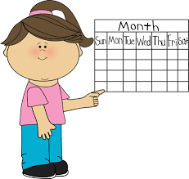 | Recall of what the children did over Christmas. Talk about how people celebrate. Look at similarities and differences. |  |  |  |  | Recalling the Chinese New Year Story |  |  | Recall the different traditional stories from the half term. Look at the differences and similarities
 | Technology   | Use Ipad to access photos on Tapestry ENCOURAGE PARENTS TO PARTICIPATE MORE IN UPLOADING TO TAPESTRY | Use Ipad to access photos on Tapestry  ENCOURAGE PARENTS TO PARTICIPATE MORE IN UPLOADING TO TAPESTRY |  | Use Ipad to access photos on Tapestry  ENCOURAGE PARENTS TO PARTICIPATE MORE IN UPLOADING TO TAPESTRY |  | Use Ipad to access photos on Tapestry  ENCOURAGE PARENTS TO PARTICIPATE MORE IN UPLOADING TO TAPESTRY | Use Ipad to access photos on Tapestry  ENCOURAGE PARENTS TO PARTICIPATE MORE IN UPLOADING TO TAPESTRY |  | Use Ipad to access photos on Tapestry  ENCOURAGE PARENTS TO PARTICIPATE MORE IN UPLOADING TO TAPESTRY
Expressive  Art and Design | Creating with materials  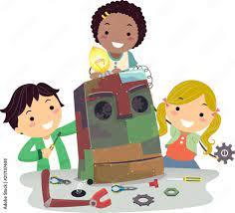 | Learn how to use powder paints and palettes | Learn how to use powder paints and palettes |  | Create and design the dragon for the dragon dance  Learn how to use split pins/tie string  Play movement and listening games that use different sounds for different movements.  Replicate a dance for Chinese New Year |  | Create and design the dragon for the dragon dance  Cut around a shape.  Learn how to use split pins/tie string  Play movement and listening games that use different sounds for different movements.  Replicate a dance for Chinese New Year | Create and design different sized lanterns associated with the story Can’t you sleep Little Bear.  Create and design different sized bridges associated with the story Three Billy Goats Gruff |  | Create and design different sized lanterns associated with the story Can’t you sleep Little Bear.  Create and design different sized bridges associated with the story Three Billy Goats Gruff
 | Being expressive and imaginative  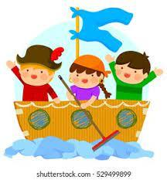 | Music: ‘Love is Here to Stay’ – Frank Sinatra 1956  EYFS  Keep the beat, copy and tap body parts to the music. | Music: ‘La Vida es un Carnaval’ – Celia Cruz 1998  EYFS  Keep the beat, copy and tap body parts to the music. |  | Music: ‘You Really Got Me’ The Kinks 1964  EYFS  Keep the beat, use a tambourine to tap.  Lunar New Year – The Dragon song with percussion accompaniment  Leeds College of music community project. |  | Music: Horn Concerto No 4, 3rd Movement by Mozart 1783  EYFS  Keep the beat, copy and tap body parts to the music.  Lunar New Year – The Dragon song with percussion accompaniment  Leeds College of music community project. | Music: ‘He’s the greatest Dancer’ Sister Sledge 1979  EYFS  Keep the beat and dance to the music.  Leeds College of music community project. |  | Music:  Create a beat /rhythm for goats trotting over the bridges.  Leeds College of music community project.
Characteristic of effective learning |  | Problem solving | Problem solving |  | Problem solving |  | Problem solving | Problem solving |  | Problem solving

