[](https://www.google.co.uk/url?sa=i&rct=j&q=&esrc=s&source=images&cd=&cad=rja&uact=8&ved=2ahUKEwjVjefCvtzfAhVOThoKHVh5DVQQjRx6BAgBEAU&url=https://kirkstile.com/news/snowdrops-loweswater&psig=AOvVaw3JNY4q_zvhdt9ZUFSKItkS&ust=1546978533615219) Nursery Newsletter Spring 1

Welcome back to a new year and the start of our Spring Term. We hope you have all had a lovely Christmas and wish you all the best for the upcoming year. We look forward to chatting to the children about the things they have been doing over Christmas. We would like to get as many families as possible to add photos of their Christmas to Tapestry. This term we will be reacquainting the children with our nursery routines and we will also be welcoming more new children and their families into nursery.

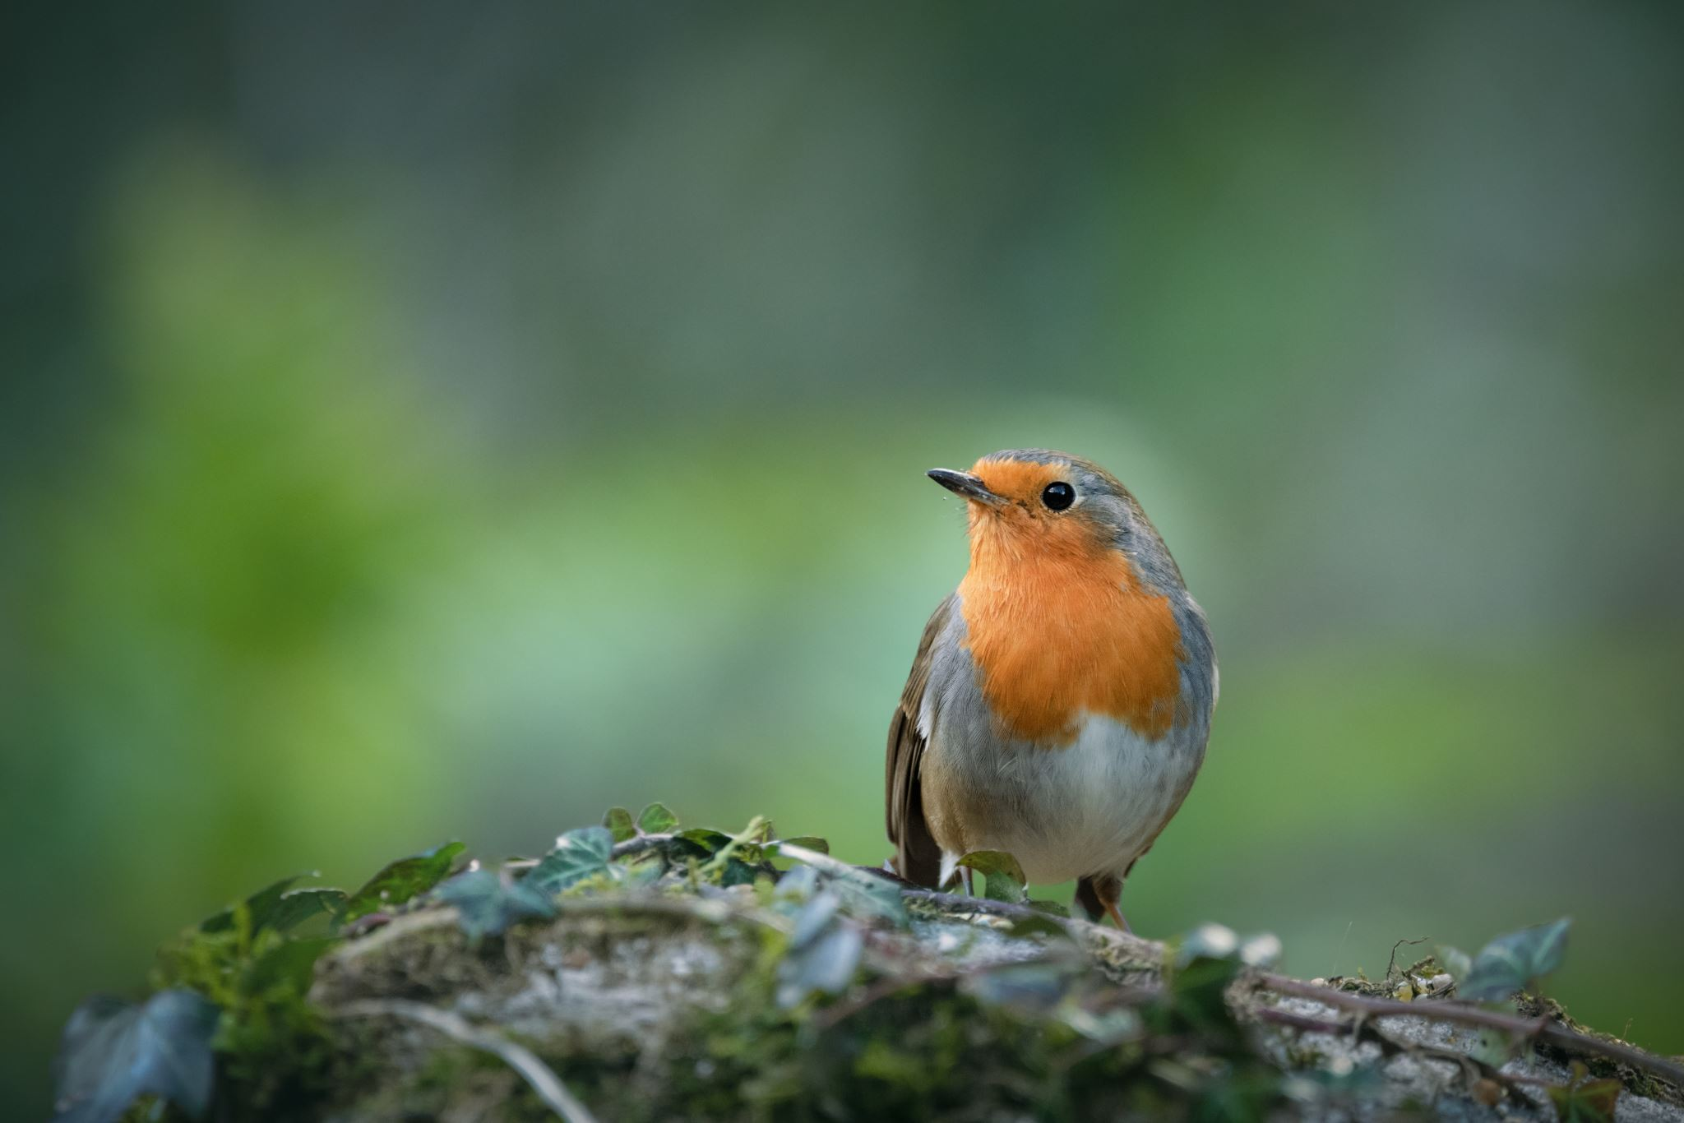

***Mrs Pritchatt, Mrs Whiteley and Miss Holgate***



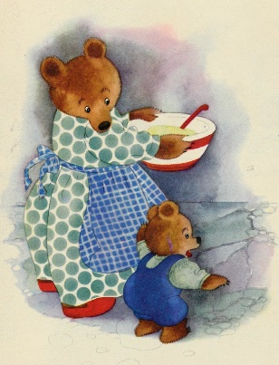**Traditional Tales** This half term we will be developing our understanding of the value of number up to 5. In the first few weeks there will be a particular focus on the number three. We will be looking at a range of traditional stories that feature the number three including *The Three Little Pigs*, *The Three Billy Goats Gruff* and *Goldilocks and the Three Bears*. When we look at Goldilocks and the 3 Bears it will also give us the opportunity to explore the concept of size and develop associated vocabulary e.g. small, tiny, huge, and gigantic. You can help your child at home by collecting sets of objects such as spoons, balls or pencils and then compare them according to size. Introduce your child to language such as, bigger than, biggest, smaller than and smallest. To challenge them further you could encourage them to place them in order of size.



**Developing a sense of rhythm and rhyme**

Research has found that when a child knows eight or more nursery rhymes by heart, at the age of 4, that they are usually one of the best at reading and spelling in their class by the age of 8! As well as tuning into the different sounds that make up words, developing a sense of rhythm and rhyme, is a very important pre-reading skill. Last half term we introduced our Poetry Basket and have already learnt to recite 2 or 3 poems. This half term we will be learning to recite more poems and adding them to our basket. Singing nursery rhymes and simple songs with your children at home will also help them to develop their rhyming skills. See how many rhyming stories you can find to read at bedtime. You could also visit the library to find new rhyming stories. Julia Donaldson books are very good for developing a sense of rhythm and rhyme.



**Chinese New Year**

On 29th January it will be Chinese New Year or Luna New Year as it is now more usually named. We will be introducing the children to the story of how Chinese New Year began and how each New Year was named after a different animal following the Great Race. This year will be the year of the Dragon. We will be watching videos of dragon dances and will work together to create our very own dragon to dance with. This always proves very popular with our children.

**Can’t you Sleep Little Bear**

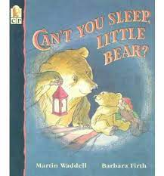As we are now in winter, we will be observing and talking about how the season has changed. We will also be investigating light and dark. The story Can’t You Sleep Little Bear? introduces this theme perfectly.



[](https://www.google.co.uk/url?sa=i&rct=j&q=&esrc=s&source=images&cd=&cad=rja&uact=8&ved=2ahUKEwjd7JK0xtzfAhUGzIUKHcH_CLsQjRx6BAgBEAU&url=https://www.thedj.co.uk/music/&psig=AOvVaw1R5M6zpRA9YgZFnJWiN84V&ust=1546980616881945)**Leeds College of Music**

We are very fortunate in that our children have been given the opportunity to take part in a music project which will be led by third year graduate students from the Leeds College of Music.

Stay and Play

[](https://www.google.co.uk/imgres?imgurl=https://www.rbkc.gov.uk/images/stay_and_play_v_Variation_2.png&imgrefurl=https://www.rbkc.gov.uk/subsites/citylivinglocallife/gogolborne/play/stayandplay.aspx&docid=W6-5-dDIXhZtiM&tbnid=fIfp3TBGw-9n8M:&vet=10ahUKEwjx7JqRxdzfAhUCRxUIHc1QD5oQMwhKKA0wDQ..i&w=672&h=285&bih=498&biw=1097&q=stay%20and%20play&ved=0ahUKEwjx7JqRxdzfAhUCRxUIHc1QD5oQMwhKKA0wDQ&iact=mrc&uact=8)You are all invited to our Stay and Play session on Monday 20th January

from 2.00pm – 3.00pm



**Wet weather.**

[](https://www.google.co.uk/url?sa=i&rct=j&q=&esrc=s&source=images&cd=&cad=rja&uact=8&ved=2ahUKEwi1z_Kvx9zfAhXvx4UKHVgiAX8QjRx6BAgBEAU&url=https://www.cyclingabout.com/seven-really-important-touring-tips/wet-weather-460_995731c/&psig=AOvVaw3yd9gw8BZXEWHQHQpchZCc&ust=1546980930048166)At this time of year, we tend to get lots of wet and even snowy weather. Outdoor play is very important to development at this age and we will therefore continue to use the outdoor area during wet days. Your child would therefore benefit from wearing waterproof coat and wellies. Can we also remind you that your child will need to bring in a spare set of clothes.





* **Mond 20th Jan –** Stay and Play
* **Wed 22nd Jan –** Mindmate Parents Workshop
* **Tue 11th Feb –** Safer Internet Day
* **Fri 14th Feb** School closes.