

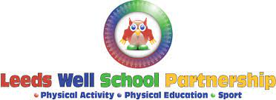

**STANNINGLEY PRIMARY SCHOOL**

**PHYSICAL EDUCATION POLICY**

**School Vision for PE**

The vision for PE at Stanningley Primary School was discussed and compiled by the children, staff, parents/carers and governors. It is a culmination of thoughts and ideas in a joint effort to improve physical and health education in lessons, around school and during extra-curricular activities for our children.

Working in collaboration with real PE, the Physical Education programme at Stanningley Primary School is so much more than teaching physical skills and sports. It is also about helping pupils understand their body (Health and Fitness) and the development of the whole child through PE, covering Physical, Personal, Social and Creative skills and how to apply them and transfer them to different life situations.

At Stanningley Primary School we have adopted a curriculum that is ambitious and designed to give all pupils… ‘The knowledge and cultural capital they need to succeed in life.’ The curriculum provides opportunities for the pupils to meet both the physical and personal development outcomes.

**Personal Development** ‘The curriculum and the school’s wider work support pupils to develop resilience, confidence and independence and lead a healthy and active lifestyle, helping them to know how to keep physically and mentally healthy.’

**Behaviours & Attitudes** ‘We believe that the pupils at Stanningley Primary School consistently have highly positive attitudes...’ And ‘They are committed to their learning, know how to study effectively, are resilient to setbacks and take pride in their achievements.’

***Healthy & Active Lifestyles***

We aim to educate both adults and children to develop a greater understanding of the benefits of healthy living. Children need to practise skills on a daily basis to show commitment to keeping their bodies healthy. This will promote long term healthy, active lifestyle choices. We will build knowledge, improve skills and deepen social wellbeing within a fruitful partnership between home, school and the community.

***Competitive Opportunity***

Our aim is to nurture confident, resilient children who strive to achieve their potential through a wealth of competitive experiences. We will encourage a positive attitude towards winning and an accepting approach towards losing within a wide range of sports. This way everyone can celebrate varying sports, skills and success in themselves and others in school.

We will provide***, ‘opportunities for children to compete in a wide range of sports and other activities in order to build character and help to embed values such as fairness and respect.’***

***National Curriculum 2014***

***Physical Education***

We will ensure that;

***‘pupils develop fundamental movement skills, become increasingly competent and confident and access a broad range of opportunities to extend their agility, balance and***

***co-ordination, individually and with others.’* As pupils move into KS2 they will *‘continue to apply and develop a broader range of skills, learning how to use them in different ways and to link them to actions and sequences of movement.’*** At Stanningley Primary School we will support the children in, ***‘developing an understanding of how to improve physical activities and sports and learn how to evaluate and recognise their own success.’***

***National Curriculum 2014***

We will offer a wide range of sports and physical activities that will encourage children to enjoy exercise now and also throughout their whole life. This will promote high self-esteem and confidence when faced with challenges in all areas of life at school, at home and in the community. Overall potential must be enhanced by celebrating success in all that our children strive to do academically and physically. Healthy minds and bodies support present and future learning and wellbeing.

**Sport Premium Funding**

In March 2013 the government announced that they would introduce a dedicated primary PE and Sport Premium that would go directly to primary school head teachers so that they could decide how best to use it to provide sporting activities for pupils.

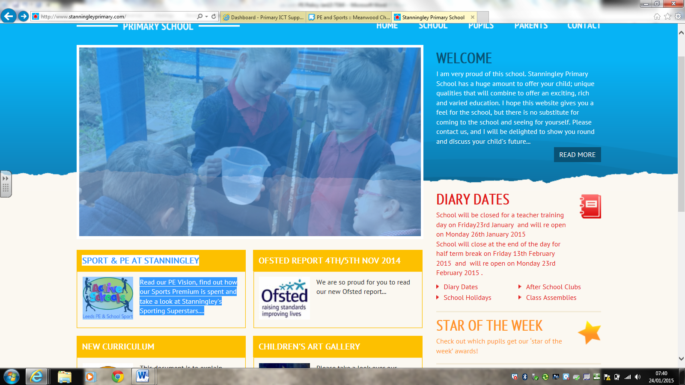Since September 2013, Ofsted inspections have reported on PE and sport provision and on how schools spend their additional funding. Schools are accountable and are required to publish details of how they spend (or will spend) their PE and sport grant on their websites.

Details of how the Sport Premium Funding is spent at Stanningley Primary School are found on the school website which can be accessed by searching <http://www.stanningleyprimary.com/> The main home page will show a link to Sport and PE at Stanningley. Once in the Sport and PE area a link to the Sport Premium Spending can be found.

**Rationale and Ethos**

This policy was reviewed in February 2023 in consultation with children, staff and governors. It recognises how Physical Education (PE) is an integral part of the process of education and plays an important role in the total development of each pupil. PE, along with sport and physical activity, can bring about whole school improvement by impacting positively on attendance, behaviour and pupil attainment.

At Stanningley Primary School we believe that physical education, experienced in a safe and supportive environment, is vital and unique in its contribution to a pupil’s physical and emotional development and health. The physical education curriculum aims to provide for pupils’ increasing self- confidence through an ability to manage themselves successfully in a variety of situations. A balance of individual, team, co-operative and competitive activities aims to cater for individual pupil’s needs and abilities. The scheme of work is based on progressive learning objectives which, combined with varied and flexible teaching styles, endeavour to provide appropriate, stimulating, challenging and enjoyable learning situations for all pupils. The scheme aims to promote an understanding of the many benefits of exercise, through a balanced range of relevant activities. Physical education is considered to be a vehicle that facilitates access to cross-curricular themes, skills and dimensions, rather than a subject concerned exclusively with the acquisition of motor skills and techniques.

**Aims of PE**

Physical Education, physical activity and school sport all have a high profile at Stanningley Primary School. We believe that these areas importantly contribute to the holistic development of our young people. Through providing a high quality PE curriculum at Stanningley we aim to;

* Provide learning situations in which all pupils will be able to develop their physical ability to the full.
* Provide opportunities for children to acquire and develop skills, performing with increasing physical competence and confidence in a range of physical activities and contexts.
* Provide stimulating and challenging opportunities that help to promote physical development such as cardio-vascular health, flexibility, muscular strength and endurance.
* Enable pupils to understand the importance of Physical Education in respect of a healthy lifestyle. (Knowledge and understanding of fitness and health).
* Develop positive attitudes in the children towards participation in physical activity.
* Provide a safe learning environment for physical activity and an understanding of the need for safety.
* Provide pupils with opportunities to become aware and conform to the principles of fair play, demonstrating good sporting behaviour.
* Enable pupils to actively participate in a wide range of activities with confidence, developing self-esteem through achievement.
* Promote equal opportunities for all and value the contribution of other irrespective of gender, ability, social/cultural background.
* To develop links between Physical Education and other aspects of the curriculum.
* Solve problems and find alternative solutions to physical challenges on their own and with others.
* Learn how to select and apply skills, tactics and compositional ideas to suit activities that need different approaches and ways of thinking.
* Develop their ideas in a creative way.
* Set targets for themselves and compete against others, individually and as members of a team.
* Understand how (and be able) to persevere, succeed and acknowledge others' success.
* Take initiative, lead activity and focus on improving aspects of their own performance.
* Discover their own aptitudes and preferences for different activities.
* Make informed decisions about the importance (and value) of exercise in their lives.
* Be given a firm foundation for life-long participation in sporting activity.

**Outcomes**

|  |  |  |
| --- | --- | --- |
| **Intended outcomes that we deem to be desirable from the PE programme include:** | | |
| Skill acquisition | Skill application | Movement appreciation |
| Movement observation memory | Knowledge | Understanding |
| Health/fitness principle | Awareness of safety | Competition |
| Rules how to officiate | Leadership | Challenges |
| Enjoyment | Creativity | Problem solving |
| Self-control | Tolerance | Respect |
| Honesty | Self-esteem | Responsibility |
| Sense of achievement/well being | Communication skills | Language terminology |
| Recreation in society |  |  |

**Entitlement and Progression**

In **foundation stage** the prime areas of learning are:

* communication and language
* physical development
* personal, social and emotional development

The specific areas of learning are:

* literacy
* mathematics
* understanding the world
* expressive arts and design

Teaching is often done through play, where the child learns about subjects and other people through games.

In **Key Stage 1** pupils should develop fundamental movement skills, become increasingly competent and confident and access a broad range of opportunities to extend agility, balance and coordination, individually and with others. They should be able to engage in competitive (both against self and against others) and cooperative physical activities, in a range of increasingly challenging situations.

Pupils should be taught to:

* master basic movements such as running, jumping, throwing, catching, as well as developing balance, agility and coordination, and begin to apply these in a range of activities
* participate in team games developing simple tactics for attacking and defending
* perform dances using simple movement patterns

In **Key Stage 2** pupils should continue to implement and develop a broader range of skills, learning how to use them in different ways and to link them to make actions and sequences of movement. They should enjoy communicating, collaborating and competing with each other. They should develop an understanding of how to improve in different physical activities and sports and learn how to evaluate and recognise their own success.

Pupils should be taught to:

* Use running, jumping, catching and throwing in isolation and in combination.
* Play competitive games, modified, where appropriate, such as badminton, basketball, cricket, football, hockey, netball, rounders, tennis and apply basic principles suitable for attacking and defending.
* Develop flexibility, strength, technique, control and balance, for example through athletics and gymnastics.
* Perform dances using a range of movement patterns.
* Take part in outdoor and adventurous activity challenges both individually and within a team
* Compare their performances with previous ones and demonstrate improvement to achieve their personal best.

**Swimming and Water Safety**

At Stanningley Primary School the children have historically had access to swimming instruction in Y3 & Y4. However, due to budget restraints this was reviewed and from September 2019, it is now Y3 that access swimming sessions. The swimming sessions at Stanningley Primary School are held at Bramley Baths where staff are supported by two trained swimming teachers and one lifeguard. The children in Year 3 are transported by bus/coach (Hunters Coaches Ltd [0113 255 2617](https://www.google.com/search?q=hunters+travel+leeds&safe=active&rlz=1C1GCEA_enGB1041GB1042&ei=h60MZKaIN8aS8gLphb_ABA&ved=0ahUKEwjm5_uWp9T9AhVGiVwKHenCD0gQ4dUDCA8&uact=5&oq=hunters+travel+leeds&gs_lcp=Cgxnd3Mtd2l6LXNlcnAQAzIGCAAQFhAeMgUIABCGAzIFCAAQhgMyBQgAEIYDMgUIABCGAzoKCAAQRxDWBBCwAzoFCAAQgAQ6CAgAEBYQHhAKSgQIQRgAUPoBWJ4LYLcMaAFwAXgAgAGRAYgBngSSAQMyLjOYAQCgAQHIAQjAAQE&sclient=gws-wiz-serp)) to Bramley Baths in order to meet the National Curriculum swimming requirements.

**National Curriculum Swimming states that pupils should be taught to:**

* Swim competently, confidently and proficiently over a distance of at least 25 metres.
* Use a range of strokes effectively such as front crawl, backstroke and breast stroke.
* Perform safe self-rescue in different water based situations.

**Physical Education at Stanningley Primary School, including Time Allocation (in minutes)**

At Stanningley Primary School, with the exception of Reception Class, the children are timetabled for two hours of high quality PE.

|  |  |  |  |  |  |  |
| --- | --- | --- | --- | --- | --- | --- |
| KS1 | | | KS2 | | | |
| REC | Y1 | Y2 | Y3 | Y4 | Y5 | Y6 |
| 90  **Ongoing in provision** | 120 | 120 | 120 | 120 | 120 | 120 |
| For relevant year groups the times above include swimming sessions. | | | | | | |

* Teachers have a long-term PE curriculum map that has been provided by the DHT/PE leader. Working in collaboration with Create Development, the long-term plan at Stanningley, in the main, follows the REAL PE Scheme of work.
* At Stanningley Primary School we are proud to employ a Physical Education Coach from Bradford City, Gareth Davis. Gareth is very much part of our staffing team at Stanningley and works very closely with the PE lead. He supports the delivery of our PE curriculum and spends time in each class either leading or supporting one of the PE sessions.

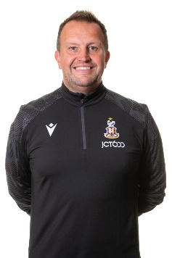

* PE sessions are matched to the main hall timetable. Dependent on the activity, the staff will decide whether the session will be taught inside or outdoors. Whenever possible the staff will try to take the children outside. This allows them a greater access to more space. Using monies provided by the Sport Premium grant every child in school is provided with a school hoody to keep them warm during outdoor use. Each child is allocated a numbered hoody at the beginning of the academic year.

**Out of school hours learning (OSHL)**

OSHL activities are an important part of Stanningley Primary School and are planned to enhance curriculum PE, allowing pupils the opportunity to broaden their experience and to take part in competitive sport. We have an excellent history of participation in events and competitions in the local area. Pupils are provided with information about local clubs and exit routes through the club links section, found in the PE area of school website. The club links area of the website provides a medium for local clubs to advertise through school, enhancing the link between the school and the club. At Stanningley Primary School we celebrate our sporting achievements during our celebration assembly on a Friday, on monthly newsletters and by also posting information on the school website.

The children have access to a wide variety of sports throughout the academic year as either a lunch time or an after school club. The focus is on participation with all children encouraged to attend practices. These competitive sporting events are generally offered to Key Stage 2 children. However at various points during the year, specific events are organised for Key Stage 1 children to attend. Staff running extra-curricular activities keep a register of attendance.

The school participates in a variety of sporting events both within and out of school hours led by the Community Sports Officer at LWA (Matthew Downing), Leeds Well School Partnership and members of our school team. Our Leeds Well Schools Partnership Strategic Lead for West and NW Leeds (Matthew Herschell-Smith) and other area Well School leads promote numerous competitions/festivals throughout the academic year that we attend on a regular basis.

**Please also refer to the schools Physical Activity Policy – Last updated February 2023.**

**Safe Practice**

In all areas of PE safety guidelines should be strictly adhered to, in order to promote safe practice and fulfil the safety requirements of the National Curriculum. At Stanningley Primary School we follow the safety guidelines **‘Safe Practice in PE and School Sport**’ guidance provided by the Association for Physical Education.

Health and safety is an integral part of pupils’ learning in PE and they are taught to recognise and take some level of responsibility for their own safety. They are taught to recognise and be aware of hazards that are present from an early age.

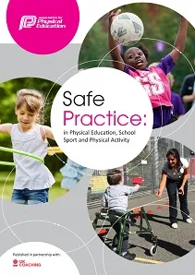

Staff must all be aware of safety guidelines for PE that can be found in the book, **‘Safe Practice in PE and School Sport.**’ **A COPY OF THIS DOCUMENT IS KEPT IN THE SCHOOL OFFICE.**

On review of this policy, February 2023, it is important to note that the current edition is the 2020 publication. A new version is published every four years so we will be expecting the 2024 edition before this policy is next reviewed.

**PE Changing**

Following the COVID19 pandemic, pupils are now advised to wear PE kit to school, on the days that PE is timetabled. Where children need to change for PE in school, for example, After School Club or Sports Competition/Event then the NSPCC Factsheet for schools**: best practice for PE changing rooms should be adhered to.**

**School PE Kit**

In the interest of health and safety appropriate kit should be worn for P.E. activities. Acceptable kit is that which presents no risk of injury to the wearer or other children and details of our policy are outlined below.

**Indoor clothing =** plain white round necked T-shirt, black shorts and school pumps. Children must have bare feet for gymnastics unless they have medical reasons not to.

**Outdoor clothing =** plain white round necked t-shirt, plain black leggings or tracksuit bottoms and trainers. Trainers must be worn outside. Indoor pumps are not suitable as the grip is insubstantial

* A school hoody will be provided by the school for outdoor use at the discretion of the teacher. A hoody number will be allocated to all children at the start of a new school year.
* In warmer months the children can substitute leggings/joggers for shorts.

**Additional PE Kit information**

All teachers must ensure that children tie long hair back with a suitably soft item; finger nails are appropriately short to prevent injury to themselves or others and personal effects including jewellery have been removed.

Stanningley Primary School adopts a policy where taping is utilised to enable participation. Parents of children unable to remove earrings should be required to make them safe by taping, front and back, which may offer a measure of protection. The taping should be sufficient to prevent the stud post penetrating the bone behind the ear should an unintentional blow be received (e.g., from someone or from equipment such as a ball).

**Refer to Safe Practice: in Physical Education School Sport and Physical Activity (2.14.9**)

This taping should be done at home. **Staff are not required to remove or tape earrings for students.**

**Stanningley Primary School advise that all children remove personal effects. Therefore, if**

**a parent is choosing to tape their child’s ears then they are accepting full responsibility in the event of an accident.**

**Failure to produce appropriate kit**

The reluctance of some children to bring appropriate kit should be avoided if the child understands the necessity of changing for PE lessons and is familiar with the timetable. Staff will encourage and support all children to meet the requirements. If PE kit is forgotten then a spare kit (regularly cleaned) will be provided. The use of spare kit is monitored by staff and any regular occurrence will be forwarded to the head teacher. If a pupil is not actively taking part in the lesson, due to illness or injury, then a letter is required from home.

**Staff Dress**

It is expected that teachers change for PE lessons or come to school dressed appropriately, for the safe delivery of a PE lesson. This should include suitable footwear. If possible jewellery should be removed to set a good example.

**Accident Procedure**

For school based activities staff should follow the guidelines in the Health and Safety Policy.

For offsite activities, staff must familiarise themselves with the individual facility procedures. Risk assessments must be in place for any off site visits. For swimming sessions, all staff should familiarise themselves with pool procedures, e.g. the fire and drown alarm. They must know the location of rescue and survival equipment and have the ability to use emergency drill. There should be frequent practices involving the children.

As a school we ensure the safety of all pupils and staff through the following codes of practice:

* Safe storage of all equipment – all equipment to be stored safely and tidily in its appropriate place after use, so easy access and availability are ready for the next group. PE equipment is stored in a variety of places including, the hall, outside storage and the PE garage. These areas will be monitored by members of the PE team.
* The school office will arrange for an annual safety equipment check (gym equipment) by a recommended maintenance contractor.
* Children are taught to manage and use apparatus safely and effectively.
* Equipment will be checked at the beginning and end of use. All unsafe, damaged or lost equipment to be reported to a member of the PE team.
* Staff are aware of First Aiders within the School and there are several members of staff first aid trained across school.
* Staff have knowledge of the environment in which learning is taking place. They must check areas for hazards before any activity takes place.

**Handling Apparatus**

* Apparatus should be stored consistently and always returned to the same place.
* Apparatus needs to be easily accessible for all children.
* Children are taught how to lift apparatus correctly. They should know:
* never to touch apparatus unless instructed to do so by the teacher
* how many children should be holding it
* where they have to grip the apparatus
* To carry apparatus – never drag it across the floor
* to have knees bent, back straight and head up ready to lift. They must walk when carrying the apparatus
* only to lift when everyone is ready. When ready lead child to say ‘one, two, three lift’ and when it is in place ‘one, two, three down’
* when the apparatus has been positioned, children must sit on the floor to await instructions
* Always have plenty of children lifting the apparatus.
* Avoid walking backwards when carrying the apparatus. The apparatus should be pointed in the direction of its destination and children should carry it facing in the same direction.
* Mats should be put out last and put away first; this will avoid children tripping over the mats as they carry the apparatus.
* As a general guideline, children should only use apparatus which they can move themselves.

**Equal Opportunities and Inclusion**

Working towards equal opportunities requires that teachers should treat all children as individuals with their own abilities, difficulties and attitudes, as stated in the school inclusion policy. Children will have their own individual gifts to contribute, which can be used to enrich the experience of others. The overriding aim should always be to create an environment in which, from the earliest age, children and their teachers learn to respect each other. The P.E. curriculum should enable all children to benefit. There will be no barriers to access or opportunity based on race, sex, religion, ethnic group, culture or ability. Consideration will be given to those with special educational needs, whether they have disabilities or a particular talent. The action necessary to respond to an individual's requirements for curriculum access will be met through greater differentiation of tasks and materials.

**Facilities, Equipment and Resources**

Stanningley Primary School has a school hall, which is equipped with portable and fixed apparatus for gymnastics and a music centre and a large projector to support the teaching of dance. For the teaching of games, there is a large playground, with multi-purpose markings and locked gate access to Stanningley Park. In the summer of 2014, Stanningley Primary School secured £30,000 of lottery funding to further develop the outdoor space. The installation of additional posts, markings and bouldering equipment etc. compliment the schools trim and tyre trails.

The PE team are responsible for purchasing and maintaining equipment in school. All classes are provided with all the resources required to teach the REAL PE Scheme of work.

The RE PE Scheme is now available through an ONLINE platform (JASMINE). All teachers have a personal log in to access the scheme. Further paper resources, such as Val Sabin, can be found in the Big Space resource wardrobes.

**The Learning Environment**

An outdoor Sainsbury’s Competition noticeboard is used to display information regarding current competitions. After school club letters are given out to children half-termly. In the school playground a chalk board if used to display learning objectives. The main school hall is used for breakfast club and lunchtimes therefore the floor is appropriately cleaned before school begins and after lunch to ensure it is safe for PE lessons to take place.

**Sports Day**

The PE team organises the annual Sports Day in which all children compete in a variety of traditional races. Weather permitting, the event takes place on Stanningley Park, where the school works with LCC Parks and Countryside to mark out race lanes.

**Staffing / Staff Development**

All staff should take part in professional development to ensure secure subject knowledge, awareness of health and safety procedures and up to date knowledge. Staff should be comfortable and competent in the area of activity being taught. Staff should indicate where they feel they need support so that appropriate support can be given by either the subject leader, the PE Adviser or through INSET. Any staff member who attends a CPD course must provide feedback/ disseminate the information.

**Adults Supporting Learning**

Staff members are supported by the PE team which includes the school PE coach. Members of the PE team accompany and transport children to competitions. Support assistants assist with the delivery of PE as they would any other subject.

**Cross Curricular**

Where relevant, links will be made to cross curricular themes and used as a means to develop cross curricular skills. For example:

**Maths.** In athletics it is hoped that pupils will reinforce skills in measuring and timing. In other activities, basic numeracy skills will be developed by the understanding of scoring systems.

In the dance scheme teachers have access to numeracy based concepts which can be taught through dance.

**Problem Solving**. Through an open-ended approach in OAA and team games, pupils will develop their ability to find ways of answering questions.

**Literacy and Communication Skills** will be developed by discussion in lessons and in problem solving, and by communicating ideas through movement. There are links to Literacy in the dance scheme of work.

**Personal and Social**. Pupils interacting with each other and in a group situation will promote personal and social skills. They will also be promoted by cooperation, tolerance, respect of the individual and group, self-respect and self-discipline.

**Preparation for Citizenship**. By giving information on and introduction to clubs and associations, pupils are made aware of agencies and groups outside the school and home environments.

**Computing.** Use of smart board technology, CDROMs, videos, cross curricular science – physical changes in the body, to enhance learning.

**Leadership and Management Roles**

At Stanningley Primary School we have a PE leadership team. The team has proved to be highly effective and has been used as a model of good practice.

* 1. ***“The inspirational and highly dedicated team that lead on PE and Physical Activity (including a dedicated sports coach employed by the school) has raised the profile of the subject and inspires confidence in both staff and children.”***

*(A quote from* Helen Smithies, Healthy Schools/PSHE Consultant, Health and Wellbeing Service)

* 1. **“I didn’t used to be as good at PE but now our Deputy Head is in charge of it and she’s more into it so it’s better and I am improving. She is looking all the time for new sports.”**

(Pupil Quote from Healthy Schools Visit)

* 1. ***“An effective model of leadership in which the sports coach is an integral member of the team and works closely with all teachers across the school. He has attended a number of staff professional learning programmes and has a growing understanding of the school’s ethos.”***

(A quote from Amanda Thornton Jones, School Improvement Consultant)

**Meet the team**

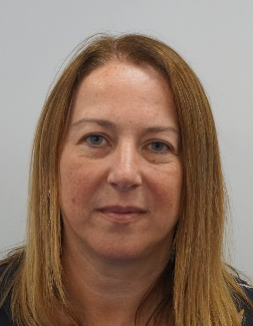 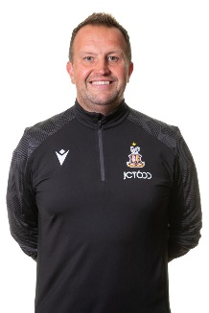

Mrs T. Stott-Moore Gareth Davis

Deputy Headteacher School PE Coach - PE Team

PE Lead.

The Governors at Stanningley Primary School know about current and projected expenditure of the Sport Premium funding on school website and will regularly scrutinise current and projected expenditure with the HT and understand the impact the grant is expected to make.

The Head teacher will actively support and encourage staff by praising good practice and supporting staff development and resources, including extra-curricular activities. She will:

* Regularly share current and projected expenditure with governors and discuss the impact the grant is expected to make
* Aim for high teaching competency across the school
* Designate a member of staff to lead the subject

The PE team that is led by the School Deputy will:

* Monitor the teaching and learning of PE within the school
* Keep up to date with new developments and inform staff
* Produce a flexible scheme of work, with lesson ideas to support colleagues in all aspects of the curriculum. (REAL PE)
* Audit staff performance to determine appropriate and targeted training
* Aim for excellent teaching competency across the school
* Ensure that PE resources are available and appropriate to the needs of the staff
* Audit resources regularly and take overall responsibility for equipment and resources
* Ensure that all pupils have the opportunity to become involved in extra–curricular clubs to further develop skills and talents and will monitor attendance at OSHL to ensure there is an inclusive offer which is accessible to all pupils
* Ensure that PE maintains a high profile within the school, through displays etc.
* Assist with recording keeping and assessment of the subject.
* Present information detailing the current and projected expenditure and impact of the Sport Premium monies published on the school website
* Regularly share current and projected outcomes with pupils, parents, staff and senior leaders including governors
* Have a formal, long term strategy for PE, sport and physical activity. This should be aligned with the SDP and have been informed by pupil and staff feedback
* Ensure all coaching staff delivering PE and OSHL on the school site are quality assured
* Establish a Sports Council where pupils can discuss and plan PE, sport and pa activities
* Informally observe PE lessons to compile a picture of teaching competency across the school
* Perform annual / termly planning scrutiny
* Contact local sports clubs to establish new community links with the school

Teachers should:

* communicate high expectations, enthusiasm and passion about PE to pupils and challenge their thinking and act as a good role model.
* have a high level of confidence and expertise both in terms of their up to date specialist knowledge and their understanding of effective learning in PE. As a result, they should employ a very wide range of resources and teaching strategies to stimulate pupils' active participation in their learning. This enables pupils to explain their ideas and concepts clearly and apply them with confidence.
* plan for opportunities for pupils to develop and demonstrate their initiative and independence and take responsibility for their learning. Lessons should be thoughtfully planned and secure outstanding progress across all aspects of PE.

The Class Teacher will be responsible for the planning and teaching of PE as set out in this Policy. The Teaching Assistant (TA), when available during PE lessons, will support the class teacher in delivering PE and in particular, support those children with Special Educational Needs where timetabled to do so and collect resources if requested to do so by the class teacher.

**Assessment and Recording**

Class teachers will assess and record pupil’s progress using the materials available from the REAL PE scheme of work.

At Stanningley Primary School, the pupils are assessed within PE each half term, based on the 12 cogs of the assessment wheel using the Real PE assessment programme. The easy-to-use **real PE** Assessment Wheel supports teachers to quickly assess pupil progress, store evidence, report and inform planning.

The class teachers are responsible for creating an updated wheel each half-term.

**Review**

**This Physical Education Policy was formally adopted by Stanningley Primary School in March 2023.**

**Chair of Governors:**

**(Louise T. Jones)**

**Headteacher:** 

**(Mrs J. Brewer)**

This policy is to be reviewed every three years and modified as necessary.

**Review Date: February 2026**

**This School is committed to safeguarding and promoting the wellbeing of all children, and expects our staff and volunteers to share this commitment.**

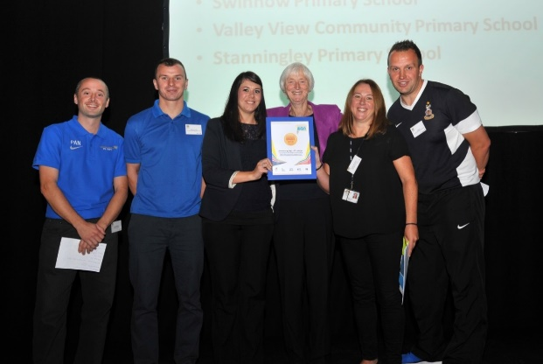

**SPS PE team (including Paul Anderson – Community Sports Officer) receiving the Gold Mark form Baroness Sue Campbell**

**Stanningley Primary School is now PLATINUM**