

**Stanningley Primary School**

**Physical Activity Policy**

1. **Introduction**

Physical activity is essential for good health and contributes to positive well-being. Many of the leading causes of disease in today’s society are associated with *physical inactivity*. Physical activity during the early years and childhood are strong indicators of future behaviours including educational attainment, health and happiness. Simple games during early childhood help to improve confidence and instil a sense of achievement. Sedentary behaviour can lead to an increase in social and emotional health concerns.

The Chief Medical Officers Physical Activity Guidelines published September 2019,

***‘Since 2011, the evidence to support the health benefits of regular physical activity for all groups has become more compelling. In children and young people, regular physical activity is associated with improved learning and attainment, better mental health and cardiovascular fitness, also contributing to healthy weight status.’***

**Summary of Guidelines for Children and Young People (5 to 18 years):**

* ***‘Children and young people should engage in moderate-to-vigorous intensity physical activity for an average of at least 60 minutes per day across the week.***

***This can include all forms of activity such as physical education, active travel, after-school activities, play and sports.’***

* *‘****Children and young people should engage in a variety of types and intensities of physical activity across the week to develop movement skills, muscular fitness, and bone strength.’***
* ***‘Children and young people should aim to minimise the amount of time spent being sedentary, and when physically possible should break up long periods of not moving with at least light physical activity.’***

**Pre-schoolers (3-4 years):**

* ***‘Pre-schoolers should spend at least 180 minutes (3 hours) per day in a variety of physical activities spread throughout the day, including active and outdoor play. More is better; the 180 minutes should include at least 60 minutes of moderate-to-vigorous intensity physical activity.’***

**2.0 School Rational & Ethos**

Stanningley Primary School is committed to promoting the health and well-being of its pupils and staff through physical activity. This policy outlines the organisation, teaching and management of physical activity at Stanningley and is overseen by the Deputy Headteacher and school physical activity policy co-ordinator, Mrs Stott-Moore.

The policy was formulated through consultation with members of staff, governors, parents, pupils, and developed in partnership with the Leeds School Health and Wellbeing Service.

Stanningley Primary School strives to maximise opportunities for children, young people and all associated with the school to be physically active by promoting all avenues for activity.

This includes the curriculum, environment and the wider community.

The Physical Activity Policy also relates to the following key documents;

* Physical Education Policy
* PE Vision
* School Travel Plan
* Leeds Well School Partnership
* Health and Wellbeing Service

**3.0 Aims**

At Stanningley Primary School we aim to ensure that all aspects of physical activity in school are promoted for the health and well-being of pupils, staff and visitors.

We will aim to increase the activity levels of the whole school through the provision of a supportive environment conducive to the promotion of physical activity.

**4.0 Objectives**

Our specific objectives are as follows:

* To provide the consistent messages in school about physical activity both within and outside the taught curriculum
* To increase pupils’ knowledge, understanding, experience and attitudes towards physical activity.
* To improve self-esteem, confidence and resilience among pupils and provide opportunities for them to work together.
* To provide and promote opportunities for staff and pupils to be physically active throughout and beyond the school day
* Out of School Hours Clubs offering a range of activities
* Groups that target specific individuals, for example, groups that help develop confidence or tackle obesity
* Children and staff to feel enjoyment and success through physical activity
* To increase physical activity levels of pupils in line with national targets

**5.0 Equal Opportunities and Inclusion**

All physical activity opportunities offered at Stanningley Primary School are designed to be inclusive, and cater for different ability levels. The staff work to ensure that the physical activity provision in school reflects the cultural and medical needs of pupils.

**6.0 Facility, Equipment & Resources**

Stanningley Primary School has a school hall, which is equipped with portable and fixed apparatus for gymnastics and a music centre and a large projector to support the teaching of physical education and dance. For the teaching of games, there is a large playground, with multi-purpose markings and locked gate access to Stanningley Park.

In the summer of 2014, Stanningley Primary School secured £30,000 of lottery funding to further develop the outdoor space. The installation of additional posts, markings and bouldering equipment etc compliment the schools trim and tyre trails. The school playground also houses the toy shed where a range of additional resources can be found to make recreational times more active.

At Stanningley Primary School we work very closely with the community to form good links that allow us to access opportunities that would not otherwise be readily available. For example, we work in collaboration with the local academy and have access to the climbing wall and table tennis facilities. Children in Year 3 visit the local swimming pool (Bramley Baths) which allows them to participate in weekly swimming sessions as well as experiencing local history from visiting this Edwardian Swimming Baths which was originally built in 1904.

An annual audit of all physical education equipment is conducted by the PE team in order to prioritise any necessary expenditure for the year. Resources for games, dance and outdoor activities can be found in the PE shed and outdoor storage, and planning resources can be found in the PE Co-ordinator’s area in the Big Space.

**7.0 Out of School Hours Learning OSHL**

***Break times / lunch times***

Markings are added to the playground in order to stimulate children at playtimes. Children are encouraged to throw, skip, catch, jump and send and receive at play. All classes have access to playground equipment, weather permitting, at recreational times. When the smiley face is displayed from the school staff room the children are permitted to access the trail facilities on the grassed area where they can climb and balance on the resources provided. In addition, children have access to a range of lunch time activities that are available such as Netball, Football, and Cross Country.

Key Stage 1 children have access to play / game activities that are delivered by Upper Key Stage 2 Play Leaders. The staff at Stanningley Primary School encourage active break and lunchtimes. Mrs Lofthouse (Lunch time Supervisor) and Gareth Davis (Sports Coach) work together to plan for active lunch times and the use of Play Leaders to support and promote.

**Encouraging the 1 Hour a Day Physical Activity Target**

In working towards increasing the physical activity levels of pupils in line with national targets, Stanningley Primary School are committed to offering The Daily Mile. In June 2019, Stanningley won the Yorkshire Sport Daily Mile school competition and received a wireless outdoor speaker for use in Physical Education and Activity.

Working in partnership with our local community, the school promotes the Bramley Junior Park Run. This is A free, fun, and friendly weekly 2k event for juniors (4- to 14-year-olds). It is held every Sunday at 9:00am. The event takes place in Bramley Park, Westover Road, Leeds, West Yorkshire LS13 3PG.

***After school clubs***

We aim to encourage all Key Stage 2 pupils to take part in a range clubs, and involve them in deciding the clubs we put on offer. Registers of clubs are kept to identify those who do not take part in (extra) regular exercise. Football, rugby, tennis and cross country clubs are put on offer each year to prepare children for competitions however many clubs are offered in order to give children a range of experience. Stanningley Primary School actively promotes inclusive sports and offers children access to activities such as New Age Curling, Boccia and Tri-Golf.

***Competition***

Pupils take place in a range of intra-school and inter-school competitions organised through the School Sport Partnership. The school works in very close partnership with the Community Sports Coordinator based at Leeds West Academy and regularly attend events and tournaments. At Stanningley Primary School we regularly update our sporting success using the competition page on the school’s website. For up-to-date information visit; [**http://www.stanningleyprimary.com**](http://www.stanningleyprimary.com)

The teaching staff at Stanningley Primary School ensure that the young person's motivation, competence and confidence are at the centre of the competition. When attending a competiton and representing Stanningley Primary the School Games **PRINCIPLES OF COMPETITION** are followed.

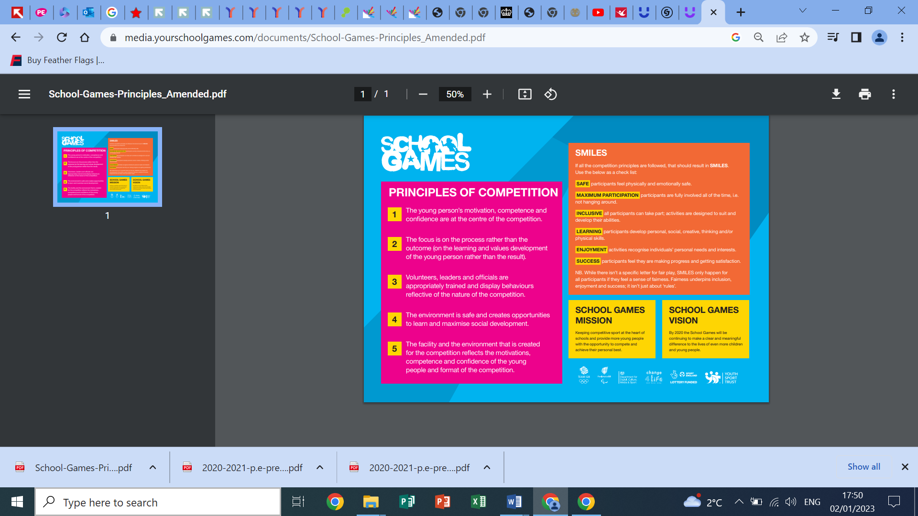

**8.0 Curriculum provision**

***Organisation:***

The Physical Activity Policy links very closely to our Physical Education and School Sport Policy. The staff at Stanningley commit to the delivery of two hours of high-quality PE.

***Planning:***

In September 2014 all teaching staff were first trained in the delivery of the REAL PE Scheme of Work. Twilight refresher training was then completed in the Autumn Term of 2016 and the updated resources were purchased. Excitingly, in September 2018, staff were trained in the use of the REAL PE Online Platform = Jasmine. More recently, Autumn Term 2022, the full staff team received refresher training in order to reinvigorate the relationship with real PE.

***Links to Wider Curriculum:***

Whilst retaining its unique contribution to a pupil’s movement education, physical activity also has considerable potential to contribute to much wider areas of learning. At Stanningley Primary School we are committed to developing an understanding of the health benefits of physical activity. This links to learning in other areas of the curriculum such as science, PSHE and SEMH (MindMate). During our annual, ‘Healthy Week,’ the children enjoy the additional time allowed for physical activity.

At Stanningley, we are proud of the links that we have with Cycle North. We provide a wide range of cycling opportunities that are arranged on an annual basis with the Cycle North School Liaison Administrator (Angela Gaunt)

Opportunities range from Balance Ability, Learn to Ride, Scooting and Bikeability. All stakeholders are encouraged to Cycle to School. We do have a small amount of cycle storage available in school.



***Assessment:***

Teachers use the real PE Assessment Wheel to track the pupils progress at Stanningley Primary School.

**9.0 School Staff/Adults Supported Learning/Leader Development**

At Stanningley Primary School we are very proud of the team approach that we take to the development of Physical Education and Activity. The strategic lead to the team is the school Deputy Headteacher, Mrs T. Stott-Moore. However, all members of the staff team as well as the lunchtime supervisor, Mrs L. Lofthouse take responsibility for developing, improving and monitoring the policy.

**Training;**

* *All school teaching staff received training on the real PE Scheme of Work*
* *Teachers received training on the real PE assessment tool*
* *All of the PE team attend cluster training sessions*
* *Mrs Stott-Moore regularly reviews the training that is offered locally and allocates depending on school and personal need.*

**10.0 Staff Physical Activity Engagement**

Adults at Stanningley Primary School aspire to be positive role models for our children. We aim to take part in physical activity whenever possible, for e.g. racing with the children at sports day. Staff often play games with children at playtime and demonstrate physical activity during PE lessons.

**11.0 Partnerships**

The Community Sports Co-ordinator (Mr Matthew Downing) and the Partnership Lead for West Leeds organise activities/competitions for our pupils to attend. Mrs Stott-Moore and Mrs Di Greenwood (Family Support Worker) liaise closely with community and city contacts including those from Active Schools in order to communicate any relevant information regarding holiday clubs etc.

At Stanningley we have also established links with a number of local clubs and we display these on our club links page on our website.

**12.0 Family engagement**

At Stanningley Primary School we share information about physical activity with families on our school website. We also use events such consultation evenings to gain information and opinion from our families. Occasionally we are asked to distribute leaflets from members of the community and this is done at the discretion of the Senior Leadership Team.

**13.0 Evaluation**

The physical activity policy co-ordinator supported by the PE team will have the responsibility for the monitoring of physical activity in the school. A range of measures will be used to evaluate impact of the policy in line with the above objectives including participation data collected as part of the Sainsbury’s School Games requirement.

**This Physical Activity Policy was formally reviewed and adopted by Stanningley Primary School in January 2023.**

**Chair of Governors:** **(Mrs Travis Jones)**

**Headteacher:**  **(Mrs J. Brewer)**

**To be reviewed: January 2026**