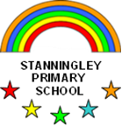Reception Newsletter Autumn 1

Welcome to Reception

It was great to meet all of your lovely children during our play sessions, last term and we are now very much looking forward to welcoming them into school for the start of their first year at Stanningley Primary School! We have been doing lots of planning to help the children settle into their new classroom and build relationships with everyone as soon as possible. In the first few week’s staff will spend lots of time working with children and chatting to them as they engage in self-chosen activities in order to develop relationships. We will be establishing Reception class routines and learning about tidying up and taking care of our early year’s environment which will help the children to become more independent. Encouraging them to put on their own coats and footwear as well as manage their own personal hygiene is something that we will be doing alongside this inorder to help them develop their independence even further.

You will find some other things that we have also planned below and you can find more detailed plans on the website [www.stanningleyprimaryschool.com](http://www.stanningleyprimaryschool.com)

If you have any worries about the way your child is settling into school please do not hesitate to come and arrange a time to speak to us either at the door when you are dropping off or via our school email [school.office@stanningleyprimary.com](mailto:school.office@stanningleyprimary.com)

***What we have planned for the upcoming half term.***

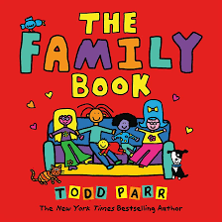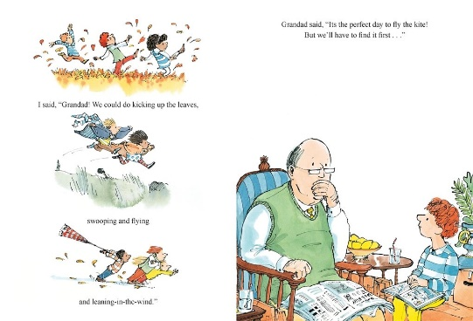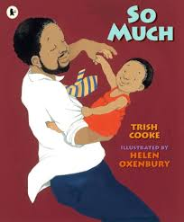Lots of time will also be spent getting to know each other, talking about our families and where we live in order to develop our sense of belonging. We would like to ask you to bring in a photo of your child’s family for them to share with us and display in the classroom. We will be looking at the Family Book by Todd Parr which introduces the children to a diverse range of family settings and the story So Much which is about a family getting together to celebrate dad’s birthday. We will also be looking at our extended family and talking about our grandma’s, grandads, aunties and uncles. Storm is another book that we will be looking at which explores a little boy and his grandad sharing memories as they search for a kite to go and fly in the autumn wind.

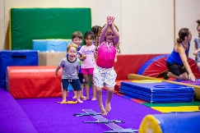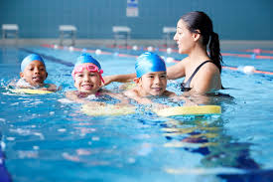As well as our families we will also be talking about other groups that the children might belong to. Our school, class, community, swimming class, football class, gym class or places of worship. If your child belongs to any groups outside of school we would be great to hear about them. It would be lovely if your child brings in photo’s to share or certificates to show to their friends.

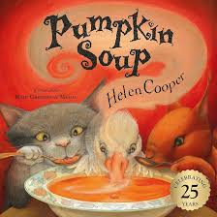We will be observing the seasonal changes around us as the Summer slowly turns into Autumn. Particularly thinking about the leaves on the trees and discussing how they are changing as well as harvesting some of the apples and pears from the trees around school. Towards the end of the half term, we will be looking at the story Pumpkin Soup. It is a great story for us to introduce the idea of sharing and taking turns as well as fitting in with the theme of autumn. We will also be cutting up our pumpkins to make into soup.

In **Literacy** as well as listening to the stories mentioned above the children will be working towards independently writing their names. For some children that will mean beginning to recognise their name and put the letters in the correct order before moving on to writing them. For other children that can already recognise and write their names will be learning to form each letter correctly. If you are writing with your children at home, it is important that they use lower case letters NOT CAPITAL LETTERS (apart from the initial letter of their name)

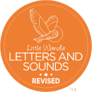 In **Phonics** the children will start by playing simple games for the first few weeks whilst they are settling in. We will then be starting our school phonics scheme ‘***Little Wandle’*** where children will be taught a new phoneme (letter sound) each day, which they will then learn to blend together to read simple 2 and 3 letter words. If you are not sure what phonics is then please don’t worry will be holding a meeting to tell you all about our scheme and will let you know how you can help your child at home. This meeting will be held on Monday 16th October at 5 pm.

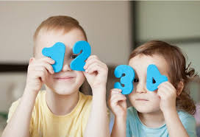In **Maths** we will be counting and playing with numbers to 5. We will be singing number songs such as ‘Five Little Speckled Frogs’ using props which will help the children to order numbers and secure their understanding of the value of number. The children will also learn lots about maths through our daily routines and we will be following a maths scheme which will introduce the children to matching, comparing, sorting and creating repeating patterns all very important maths skills.

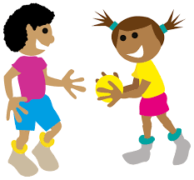**P.E. –** The children will take part in 2 PE sessions a week which will take place on Wednesday and Friday. Please ensure your child is dressed in their P.E. kit on these days -plain black shorts/joggers (no logos), white round necked t-shirt and trainers please. It is school policy NOT to wear jewellery. However small studs may be worn in ears but **MUST** be removed for P.E days and long hair must be tied up.

**Baseline Assessment**

Schools are required to carry out a baseline assessment as set out by the Government within the first 6 weeks of pupils starting reception. No numerical score is shared and the data will only be used at the end of year 6 to assess how much progress the children have made throughout their time in school . However, school will receive a series of short, narrative statements that tell us how the children have performed in the assessment. These can be used to inform teaching within the first term. These assessments will be carried out by Ms Read. If you have any queries please speak to a member of staff.

* Monday 16th September 5 pm - **Phonics Meeting**
* Wednesday 2nd October- **School Photo**
* McMillan Coffee Morning – TBC
* Friday 25th October -**School closes for half term**.