

Reception Newsletter Autumn 2

We hope everyone has had a lovely holiday and would like to welcome you all back. Last half term was spent settling the children into their new environment, establishing routines and getting to know our rules and routines. We are pleased that the children have settled back into school well after their short break and look forward to the very busy and exciting weeks ahead. If you have any queries or concerns, please do not hesitate to speak to us. We may not be able to talk to you at the door when seeing the children in but can arrange a time to meet after school. You can also contact us by sending an email to the school office which will then be forwarded to us by the office staff. [school.office@stanningleyprimary.com](mailto:school.office@stanningleyprimary.com)

***Ms Read, Miss Currie***

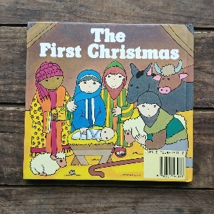**Which stories and themes will we be looking at this half term?**

This half term we will be learning about the different festivals that are celebrated by different religions around this time of year. We are also planning to take the children on a visit to our local church.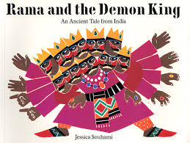 We will be looking at the story of Rama and Sita and will introduce the children to the Celebration of **Diwali** which was celebrated by Hindu and Sikh communities at the end of last week. Next month we will be putting up our decorations and telling the children about the story behind Christmas. We will also be putting together our Nativity Performance, a lovely Christmas tradition that I am sure will bring a tear to your eye. Don’t forget to put the date in your diary! All the children will have a part to play in our performance and some children will have a few words to say. We will be sending home these words and ask that you help your child to learn them. *The performance will be on* ***Monday 17th December, time 10 9.15 am***

***See website for more detailed planning.***

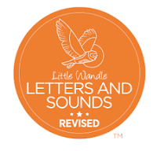We would like to thank all the parents that attended our Phonics meetings last term and those that have been supporting their child’s learning at home by helping them to complete their homework each week. It has been lovely to see so many of our children make a flying start to their phonics learning as a result of this support. If you have not yet attended one of our Phonics Meetings, I will be planning another one for this half term and would urge you to attend. Please follow the link below which will take you to the Little Wandle Parents page.

<https://www.littlewandlelettersandsounds.org.uk/resources/for-parents/>

At the end of last term your child was assessed to check the progress they are making towards learning the sounds that have so far been introduced. We will discuss this with you at the upcoming parents meeting and will let you know if your child will need extra support both in school and at home in order to help them to catch up with the rest of the class.

**Reading books**

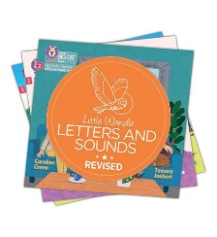If your child’s assessment shows that they have learnt the sounds that we have so far been introduced and that they have learnt to blend they will soon be starting to bring home books with words in. The level of book they receive will depend on their phonic knowledge at this stage. Children do progress at different rates and some children have only recently turned 4 so please don’t be disheartened if your child doesn’t bring home a book with words straight away. Be assured that they will be getting extra support at school and with your extra help at home their progress will start to increase. From next week reading books will be collected on a Tuesday (Please place in box outside of the the classroom) A new book will then be given out on a Wednesday. Please aim to read with your child 4 times a week. The more times they read, the quicker they will progress. Please follow this link to watch a video on the Little Wandle website about listening to your child read at home and sharing wordless books with your child. <https://www.littlewandlelettersandsounds.org.uk/resources/for-parents/#tabnametabBooksComingHome>

**Homework**

Homework should be completed by **Tuesday** and placed in the blue homework book box outside the classroom. The next weeks homework will then be handed out on a **Thursday**. Please make sure your child hands in their book even if they haven’t had the chance to complete the homework for that week so that we can stick in the following weeks homework. Completing homework each week will help your child to keep up with the rest of their class. If you are having any issues with completing homework, please let us know so that we can find a way to support you.

**PE**

Please remember to remove earrings on PE days. We also ask that children wear trainers with fastenings that they can manage by themselves. Once children start school they are taught to dress independently. Velcro fastenings are preferable as children find it very difficult to tie shoe laces at this age and they can become a tripping hazard.

**Naming Clothes**

We are aware that the loss of clothing can be very frustrating for parents and replacing them can be costly. We would therefore like to remind you to name your children’s clothes. Some children take off coats, jumpers and cardigans in the dinner hall or school playground and forget to take them back to the classroom at the end of lunch. Named clothing will eventually find its way back to the classroom but this might not be on the same day. Un named clothing however is extremely difficult to trace. Children are reminded on a daily basis to put their clothing on their peg when they take them off in the classroom and to go and get their coats etc after lunch. We would also like to make you aware that names written in biro will fade after a few washes and will need to be redone.

  
**Friday 15th Nov**, *Children in Need Day*

**Tuesday 17th Dec** Nativity

**Wednesday 18th Dec**, *Christmas Dinner*

**Thursday 19th Dec**, *Christmas Party Day*

**Friday 20th Dec**, *Break up for Christmas Holidays*

**Monday 6th Jan**, *School re-opens*