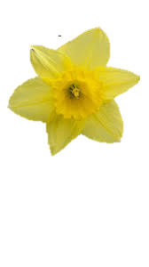

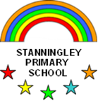 Reception Newsletter Spring 2

We hope you have all enjoyed a short break from school routines and that the children are now rearing to get back to their learning. As Spring approaches we hope to say goodbye to all the nasty bugs that were being passed aroundl last term! This half term we will be learning about our bodies and how to stay healthy.

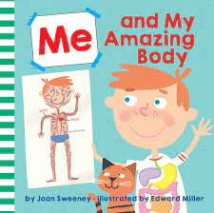**Our Bodies**

We will be looking at non-fiction books during our Literacy sessions and learning what a “fact” is. There are lots of facts that we can learn about our bodies. We will be finding out all about the different organs that are inside our body helping to keep us alive. The children will then get the chance to put their learning into action as we exercise our bodies when running during the Daily Mile and taking part in PE lessons. The children will be encouraged to think about how exercise affects their bodies as they feel their hearts beating faster and bodies getting warmer.

**Healthy Week**

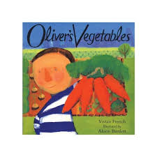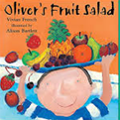The whole school will also be celebrating Healthy Week this half term. In Reception we will be reading two stories *Oliver’s Vegetable* and *Oliver’s Fruit Salad* that will help us to teach the children how important it is to eat fruits and vegetables as part of an healthy diet. Oliver doesn’t like eating vegetables, all he likes to eat is chips. When he goes to stay with his grandad he has a clever plan to encourage Oliver to eat his vegetables. During Healthy Week we will also be learning about germs and bacteria and how how important it is to keep our bodies clean by washing our hands and brushing our teeth.

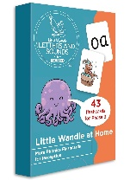**Phonics**

We have now introduced all the phonemes to be taught in Reception. However, the Phase 3 digraphs and trigraphs that we taught last half term can be difficult for the children to retain straight away so we will be revisiting them again this half term. Please continue to help your child to reinforce what they have learnt at school by helping them to complete their homework each week. We have seen great progress with the children’s reading and writing where they have been getting support at home.

Our recent assessments show that some children still need further help learning the Phase 2 sounds. These children will be getting extra support in school. I will also let you know via the homework book which Phase 2 sounds your child still needs to learn.

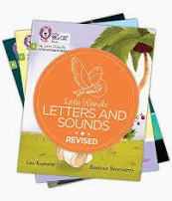**Reading**

We are pleased to see the great progress that lots of our children are making with their reading which means they will be moving up to the next level reading book! It’s lovely to see that all the support you are giving your children by reading with them regularly at home is paying off. Thank you for your support!

Please remember to return all books on a **Monday** and place in blue box. This is the day when your child’s book will be changed.

**Letter Formation**

In order for your child to achieve the Early Learning Goal for writing at the end of the year most of their letters need to be formed correctly. It is important that children learn to form their letters correctly as soon as possible so that bad habits don’t become ingrained. Every week your child his given a letter to practice in their handwriting book in school. They are then given the same letter to practice again in their homework book on the Thursday. It’s important that you practice letter formation with your child to make sure that they are forming them correctly. When left to their own devices they often trace over the letters in the wrong direction.

**Tricky words**

As well as putting a different tricky word up outside the classroom door each day I will also now be starting to pop our tricky words into your child’s reading folder for you to practice with them at home.

**Maths**

This half term we will be looking at the value of numbers from 6-7 and looking at the composition of each number e.g. 6 can be made of a 3 and 3, 2 and 4, 5 and 1 or a 2 and a 2 and a 2. We will be using counters and 10 frames to represent numbers. We will also be consolidating our knowledge of number bonds to 5 in order to be able to recall them automatically. We will continue to practice conceptual subitizing, revisit odd and even and double numbers and later in the half term we will be investigating shape.

**Festivals**

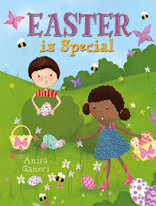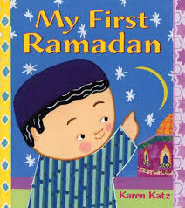We will be learning about the holy month of Ramadan which is observed by Muslims and starts on 28th February which will then be followed by the celebration of Eid. We will be making pancakes and talking about the start of Lent which is observed by Christians and learning about Easter. We will also be celebrating World Book Day on Thursday 6th March.

[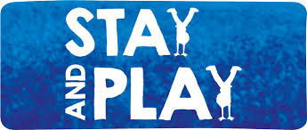](https://www.google.co.uk/imgres?imgurl=https://www.rbkc.gov.uk/images/stay_and_play_v_Variation_2.png&imgrefurl=https://www.rbkc.gov.uk/subsites/citylivinglocallife/gogolborne/play/stayandplay.aspx&docid=W6-5-dDIXhZtiM&tbnid=fIfp3TBGw-9n8M:&vet=10ahUKEwjx7JqRxdzfAhUCRxUIHc1QD5oQMwhKKA0wDQ..i&w=672&h=285&bih=498&biw=1097&q=stay%20and%20play&ved=0ahUKEwjx7JqRxdzfAhUCRxUIHc1QD5oQMwhKKA0wDQ&iact=mrc&uact=8)**Stay and Play**

This half term the session will be held on **??????????????????**time and day each half term. Younger siblings are welcome.

**PE**

PE continues to be held on a **Wednesday** and **Friday.** Please remember to remove earrings and ensure your child is wearing the correct PE kit: plain black shorts/joggers (NO LOGOs), plain white round necked t-shirt (NO LOGOS), trainers (NO LACES unless your child can tie them by themselves)

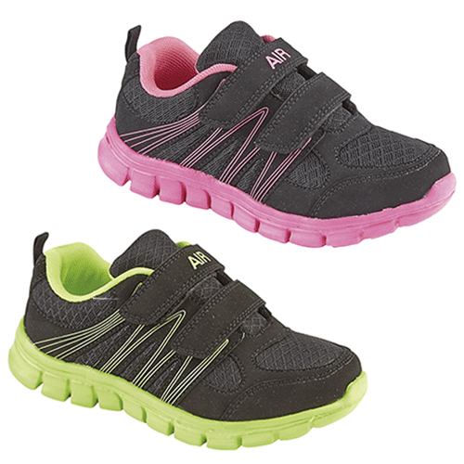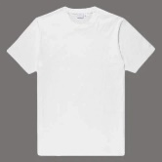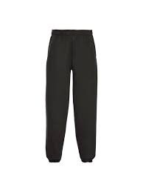

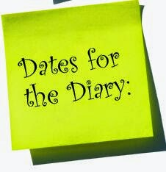 Stay and Play

**Monday 17th March** Start of Healthy Week

**Friday 4th April** School closes for Easter Holidays

**Tuesday 22nd April**  School re-open