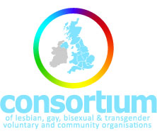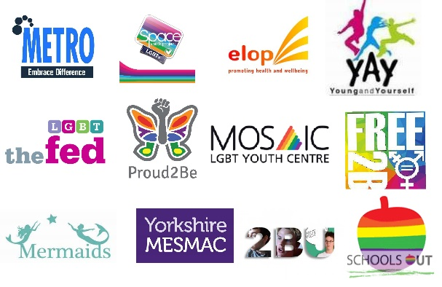

**Anti-Homophobic, Biphobic, Transphobic (HBT) Bullying Programme**

**School Development Plan**

1. Project Information and Aims

What is the Anti-HBT Bullying Programme?

The Anti-Homophobic, Biphobic and Transphobic (anti-HBT) Bullying Programme is fully funded by the Government Equalities Office to support primary and secondary schools in England who have not participated in anti-HBT work before.

The LGBT Consortium Alliance, made up of 12 LGBT (lesbian, gay, bisexual & transgender) organisations, aims to support schools to:

* Prevent HBT bullying from happening in the first place
* Effectively respond to HBT bullying when it does occur
* Create an inclusive school environment for LGBT pupils and families

Yorkshire MESMAC will facilitate these aims by ensuring:

• Teachers and non-teaching staff feel confident and supported to prevent and address HBT bullying

• Pupils report that they feel confident in reporting HBT bullying, and feel their school is inclusive towards LGBT pupils and families

• Staff, pupils, and families are engaged, empowered and motivated to reduce HBT bullying

• More schools have policies and curricula targeted at preventing and tackling HBT bullying

2. What can we expect from each other?

**What can you expect from the Anti-HBT Programme?**

Based on your survey submission, we will decide on the appropriate model of support:

**Model 1** - Whole school approach targeting school staff, teachers, students and families (completed within 6 months of scheduled start date)

**Model 2** - Targeted training for school staff only (completed within 3 months of scheduled start date)

You will also receive:

• Designated contact with Anti-HBT Programme staff at Yorkshire MESMAC

• Guidance through the Advice for Advisors helpline, both pre- and post- scheduled face-to-face support

* The opportunity to participate in our peer-to-peer partnerships programme, linking with best practice schools, experienced teachers and learning from LGBT professionals

**What will the Anti-HBT Programme expect from you?**

• To be dedicated to the aims of the programme

• Regular communication with your anti-HBT Programme lead

• Completion of a short external evaluation survey before the programme commences, and again shortly after support has ended.

To comply with the needs of the evaluators in collecting their data.

• Committing to and engaging in all planned activities

• Sharing resources to enable the anti-HBT programme to work efficiently

3. Operations

• A Yorkshire MESMAC staff member and designated senior staff member from your school will sign this document, agreeing to the terms in this development plan

• Yorkshire MESMAC will deliver activities within the allocated time frame and will monitor progress, identify blocks, assess risks and provide solutions to overcome any difficulties

• Your school will have an agreed delivery schedule, taking place over a minimum of 2 sessions:

**Date of first training session: 27/06/2018**

**Date of second training session: 03/09/2018**

1. Signatures to the development plan

We the undersigned confirm our full acceptance of the terms outlined in this development plan

1. For and on behalf of Yorkshire MESMAC

Name: Rosemary Ellingham

Role: LGB&T schools Delivery Worker

Contact email: r.ellingham@mesmac.co.uk Contact tel: 07551152665



Signature: Date: 08/02/2017

1. For and on behalf of partner school

Name: Mrs Tammy Stott-Moore

Role & School name: Deputy Headteacher Stanningley Primary School

Contact email: tammy.stott-moore@stanningleyprimary.com Contact tel: 0113 2557677

Signature: Mrs Stott-Moore Date: 22/03/2018