
Class 3 Newsletter
Welcome back to Class 3 and Happy New Year! I hope you have all had a lovely Christmas and are feeling well fed and rested.
I am very excited to be returning to Class 3 and look forward to getting to know all of the children and helping them make the progress they need to achieve their goals and meet all of their targets! I hope you will all support us in our efforts this year to ensure the children in Class 3 are achieving by supporting them with their spellings, homework and reading at home.
Thank you and, once again, Happy New Year!

Our science topic this half term is forces. We will be looking at what a force is and different kinds of force including magnetic force. Do you have any magnets at home? If so, maybe you could find out the following: What can magnets do? What happens if you put magnets together? We will be investigating the answers to these questions and much more.

This term will also have a geography focus as we use maps and compass points to locate and identify countries around the world!

We will be looking at the story `The Tin Forest` in English as well as `The lion, the witch and the wardrobe` and we will also start reading our new book for pleasure……MEGAMONSTER!!

I am sure they will love it!


 Mr Carney

Mr Carney

Mr Carney & Mrs Stott-Moore & Miss Hudson

Mr Carney Mrs Tillotson Mr Nathan
Class Teacher Support Support

It is expected that ALL children have a pair of pumps in school to wear whilst inside the building. Pumps can be bought at most supermarkets.

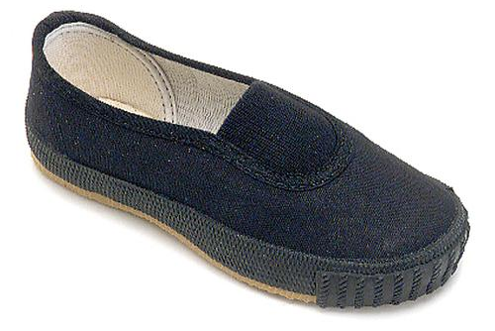

Mrs Stott-Moore Miss Hudson
This half term we will be looking at the following areas for Maths & English:

English

Maths

Story Writing
Creativity

Using and applying

Number and Place Value
Length and Perimeter

Setting Descriptions
Character Descriptions
Direct speech

Multiplication and Division

Problem Solving and Reasoning

Homework and Reading
In Year 3 we will give out homework each week on a Thursday and this will be due back in school completed by the following Tuesday. If any child is unable to manage this, they will be expected to complete their work during break/lunchtimes. Please remember to complete homework in homework books, as pieces of paper tend to get lost if they have not been glued in.

All children should also continue to read regularly at home to an adult and record this in their reading record. Children have a reading book which is colour coded to match their current reading level. I will be checking to make sure that all children have been reading at home and that this has been recorded/signed – please aim for at least 3 signatures per week.

For mental arithmetic, we will be doing an arithmetic test each week. In terms of X tables, children should know their 2’s, 5’s and 10’s by now. Please do help them to be as quick and confident as possible when recalling these essential facts. By the end of year three, they will also need to know their 3’s, 4’s and 8’s

Spellings are an essential part of Year 3 learning. In Year 3 we will send home at least 10 spellings each week for the children to learn – these will focus on the spelling rules. As well as this your child will also take home the week’s learn by heart facts ready to be tested on the following week. Please ensure your child has their `learn by heart` book in school every Thursday and Friday and that they are learning these facts throughout the week in preparation for the test.
The children also have their log in details for Lexia and TT Rockstars which they can access at home.

PE
We have our PE slot on a Thursday. Your child will need to arrive at school on this day already wearing their PE kit. Our school PE kit consists of plain black shorts or leggings with a plain white, round-necked t-shirt (NO LOGOS/STRIPES) and appropriate footwear (trainers must be worn outdoors, especially when it is wet!). Please make sure your child is wearing their kit in school on a Thursday. Children must not wear earrings during PE lessons for safety reasons. Please make sure they leave them at home or are able to take them out themselves. As well as being good for your child’s health, PE is statutory, therefore all children must participate each lesson unless there is a medical reason to suggest otherwise.
SWIMMING
Swimming will take place every Tuesday afternoon so it is important that the children arrive each Tuesday already wearing their PE kit, with their swimming kit in a bag.

We are really looking forward to this half term with Class 3. If you have any queries, questions or concerns please do not hesitate to make an appointment with me or the other adults in Class 3, before 8:40am or after school.

We are always available to see you.

Many thanks,

Mr Carney & Mrs Stott-Moore & Miss Hudson

Diary Dates

7/1/25 – Return to school

14/2/25 – Break up

