
Class 3 Newsletter
I hope you have had a good break from school and are feeling rested and ready for the next half term. We will begin the new half term by having a huge focus on reading, as World Book Day is fast approaching so please take this opportunity to focus on reading at home and please help your child on their journey to success. It is such an important skill and those children who are reading regularly at home do much better at school. Thank you to those of you who are reading at least three times a week – many of you have already moved up a reading level this year as a result.

Our Topic
This half term our whole school value is KINDNESS

Class 3 will begin a very exciting history topic on the Ancient Egyptians when we return. I wonder if they can already begin to find out some interesting facts to share with us on their return?

Our science topic this half term is one that looks at animals including humans. We will be looking at where animals get their energy from. What makes a healthy, balanced diet for humans? Also, we will be delving into whether all animals have skeletons or not and how and what the muscles do. We will be investigating the answers to these questions and much more.

This term we will also be looking at emails in our computing lessons as well as many more exciting things as we move towards Easter.




Mr Carney Mrs Stott-Moore Moss Hudson
Class Teacher Class Teacher Teaching Assistant

It is expected that ALL children have a pair of pumps in school to wear whilst inside the building. Pumps can be bought at most supermarkets. We will check in the first week that all children have pumps.

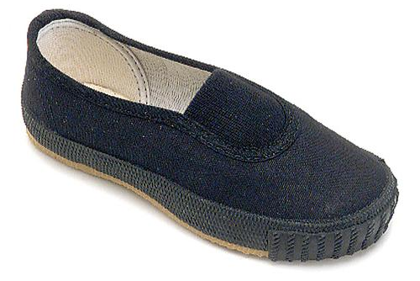

This half term we will be looking at the following areas for Maths & English:

English

Maths

Using and applying

Instructions

Length and Perimeter

Fractions and Mass
Letter Writing
Diary Writing

Multiplication and Division

Problem Solving and Reasoning

Homework and Reading
In Year 3 we will give out homework each week on a Thursday and this will be due back in school completed by the following Wednesday. If any child is unable to manage this, they will be expected to complete their work during break/lunchtimes. Please remember to complete homework in homework books, as pieces of paper tend to get lost if they have not been glued in.

All children should also continue to read regularly at home to an adult and record this in their reading record. Children have a reading book which is colour coded to match their current reading level. I will be checking to make sure that all children have been reading at home and that this has been recorded/signed – please aim for at least 3 signatures per week.

For mental arithmetic, we will be doing an arithmetic test each week. In terms of X tables, children should know their 2’s, 5’s and 10’s by now. Please do help them to be as quick and confident as possible when recalling these essential facts. By the end of year three, they will also need to know their 3’s, 4’s and 8’s

Spellings are an essential part of Year 3 learning. In Year 3 we will send home at least 10 spellings each week for the children to learn – these will focus on the spelling rules. As well as this your child will also take home the week’s learn by heart facts ready to be tested on the following week. Please ensure your child has their `learn by heart` book in school every Thursday and Friday and that they are learning these facts throughout the week in preparation for the test.
The children also have their log in details for Lexia and TT Rockstars which they can access at home.

PE
We have our PE slot on a Thursday. Your child will need to arrive at school on this day already wearing their PE kit. Our school PE kit consists of plain black shorts or leggings with a plain white, round-necked t-shirt (NO LOGOS/STRIPES) and appropriate footwear (trainers must be worn outdoors, especially when it is wet!). Please make sure your child is wearing their kit in school on a Thursday. Children must not wear earrings during PE lessons for safety reasons. Please make sure they leave them at home or are able to take them out themselves. As well as being good for your child’s health, PE is statutory, therefore all children must participate each lesson unless there is a medical reason to suggest otherwise.
SWIMMING
Swimming will take place every Tuesday afternoon so it is important that the children arrive each Tuesday already wearing their PE kit, with their swimming kit in a bag.

We are really looking forward to this half term with Class 3. If you have any queries, questions or concerns please do not hesitate to make an appointment with me or the other adults in Class 3, before 8:40am or after school.

We are always available to see you.

Many thanks,

Mr Carney & Mrs Stott-Moore & Miss Hudson

Diary Dates
24/2/25 – Return to school
3/3/25 – Book Week 6/3/25 – World Book Day and discos
12/3/25 and 13/3/25 Parents Evening
March – S Factor Final
21/3/25 -Comic Relief/Red Nose Day
WB 17/3/25: Healthy Week
2/4/25 – Easter Service in church at 1.30pm
4/4/25 – Break up

