**Substance MISUSE POLICY**



**This Substance Misuse Policy which works in partnership with the Drug Education and Incidents Policy was formally approved by Stanningley Primary School Governing Body in February 2018.**

**To be reviewed by Governors on or before Friday 28th February 2021.**

**Chair of Governors: _________________________ Mr A. Wibrew February 2018**

**Headteacher: _________________________ Mrs J. Brewer February 2018**

**Substance Misuse Policy**

**Date of policy: February 2018 Review date: February 2021**

Staff at Stanningley Primary School rarely have to deal with drug related incidents / substance misuse therefore there is a need for clear procedures should an incident occur. Stanningley Primary School is committed to the safeguarding of and promoting the welfare of pupils. We believe all staff and visitors have an important and unique role to play in child protection and safeguarding of children. This policy is designed for pupils but applies equally to any participant in principle.

1. **Policy – why a policy on substance misuse is important**

This policy is intended to outline the schools approach to education about substance misuse and our response to matters related to the misuse of substances, as this has an impact upon the wellbeing and safety of individual students and members of the school community.

The policy that replaces the, ‘Managing Drug related incidents Policy’ is in place to ensure that all pupils and staff are safeguarded and that our school fulfils its legal and statutory responsibilities.

The substance misuse policy works in close relation to the Drugs Education and Incidents policy and makes reference to this throughout.

The policy gives guidance to pupils, parents/carers and staff on:

* What substances are allowed on the schools premises and in what circumstances
* How the health and safety of the school is safeguarded
* What action we will take if an incident related to illicit or illegal substances occurs

# 2. Development process

This policy was drafted by Mrs Stott-Moore (Deputy Headteacher/PSHE Leader) and was supported by senior leadership. All school staff were offered an opportunity to respond to the policy. This policy has been approved and adopted by the head teacher, Mrs Julie Brewer and governing body, Mr Alex Wibrew. The member of staff responsible for overseeing and reviewing this policy is the Headteacher who will be supported by the PSHE Lead: Mrs T. Stott-Moore. The policy will be reviewed briefly annually and in full every 3 years. The next full review is due before the end of February 2021.

# Policy relationship to other policies

* Anti-bullying
* Assessment, Recording and Reporting
* Asthma
* Attendance
* Behaviour
* Child Protection/Safeguarding Children
* Confidentiality
* DRUG EDUCATION AND INCIDENTS (DE&I)
* Equal Opportunities
* First Aid
* Health & Safety
* Medication/medicines
* Mission/ethos statement
* Pastoral support
* PSHE
* Science
* Sex and Relationships Education
* SEN/Inclusion
* Teaching and Learning
* Visitors in School

At Stanningley Primary School we believe that:

* Our school can contribute to the prevention of substance misuse.
* All students have the right to be protected from harm.
* Pupils need support which matches their individual needs, including those who may have experienced substance misuse or misused substances.
* Pupils need to be safe and feel safe in school.

Our school will fulfil local and national responsibilities as laid out in the following documents:-

* Working Together to Safeguard Children (DfE March 2015)
* Keeping Children Safe in Education (DfE July 2015)
* Association of Chief Police Officers (ACPO) Drug Advice for Schools (DfE September 2012)
* The Misuse of Drugs Act 1971 (Amendment) Order 2015
* The Medicines Act 1968
* Leeds Safeguarding Children’s Board Procedures (2007)
* Children’s and Families Act 2014
* Children Act 1989 (as amended 2004, Section 52)
* Education Act 2011 s175/157
* Education and Inspections Act 2006
* Teachers Standards 2012
* Information Sharing – Advice for Practitioners Providing Safeguarding Services to Children, Young People, Parents and Carers (DfE March 2015

1. **Overall Aims**

The overall aims of the policy are to contribute to the prevention of substance misuse experiences in the following ways:

* Clarifying standards of behaviour for staff and pupils
* Introducing appropriate work within the curriculum
* Developing staff awareness of the causes of substance misuse
* Encouraging pupils and parental participation in awareness raising practice
* Addressing concerns at the earliest possible stage

To contribute to the protection of students and the prevention of substance misuse in the following ways:

* Including appropriate work within the curriculum
* Implementing child protection policies and procedures
* Working in partnership with pupils, parents/carers and agencies

Contributing to supporting our students in the following ways:

* Identifying individual needs where possible
* Designing plans to meet individual needs
* Developing staff awareness of the causes of substance misuse
* Addressing concerns at the earliest possible stage

# To whom and where the policy applies

The policy applies to:

* The head teacher
* All school staff
* The governing body
* Pupils
* Parents/carers
* School nurse and other health professionals
* Partner agencies working in or with the school such as d:side, Forward Leeds Platform
* Police such as the Safer Schools Police Officer (SSPO)

At Stanningley Primary School the term ‘school’ refers to:

* The buildings and grounds within the school perimeter security fence at times when pupils are authorised to be on the premises (8:00am until 5pm Monday to Friday term time only).
* Stanningley Park, when used by the school for lessons or events
* location visited by pupils as part of an organised school visit, in and outside school hours
* Anytime a child is in their school uniform acting as ambassadors for the school for example, Remembrance Day Service

# Location and dissemination

This policy document is freely available on request to the whole school community. A copy of the policy can be found on the school website. A physical copy of the policy is available from the school office.

# Definition

1. Substance misuse is the harmful use of substances (like drugs and alcohol) for non-medical purposes. The term substance misuse often refers to illegal drugs. However, legal substances can also be misused, such as alcohol, prescription medications, caffeine, nicotine, New Psychoactive Substances (NPS) and volatile substances (e.g. petrol, glue, paint).
2. Illicit drugs include illegal drugs (such as cannabis, opiates, and certain types of stimulants), pharmaceutical drugs (such as pain-killers and tranquillisers) when used for non-medical purposes, and other substances used inappropriately (such as inhalants).
3. A controlled substance is generally a drug or chemical whose manufacture, possession, or use is regulated by a government, such as illicitly used drugs or prescription medications that are designated a Controlled Drug.
4. The use of volatile substances as drugs involves breathing in gases or vapours from household and industrial products such as aerosols and lighter refills. These substances are volatile, meaning that they evaporate and can be inhaled without burning or heating them up.
5. NPS are designed to mimic the effects of illegal drugs but are structurally different to these drugs and therefore are not classified as illegal under the Misuse of Drugs Act. Despite being labelled as legal these substances are not always safe to use and can contain controlled drugs making them illegal to possess. NPS will be treated in the same respect as other controlled drugs. All NPS are prohibited, whether legal, or controlled under the Misuse of Drugs Act 1971 either as Class A, B or C drugs, or through temporary class drug order (TCDO).

# The Law and Substance Misuse

1. The Misuse of Drugs Act 1971 is intended to prevent the non-medical use of certain drugs. For this reason it controls not just medicinal drugs (which will also be in the Medicines Act) but also drugs with no current medical uses. Drugs subject to this Act are known as controlled drugs. The law defines a series of offences, including unlawful supply, intent to supply, import or export (all these are collectively known as trafficking offences), and unlawful production and unlawful possession. To enforce this law the Police have the special powers to stop, detain and search people on ‘reasonable suspicion’ that they are in possession of a controlled drug.
2. The Misuse of Drugs Act regulates what are termed controlled drugs. It divides drugs into three classes as follows:

* Class A: These include, cocaine and crack (a form of cocaine), ecstasy, heroin, Lysergic Acid Diethylamide (LSD), methadone, methamphetamine (crystal meth), magic mushrooms containing ester of psilocin and any Class B drug which is injected.
* Class B: These include amphetamine (not methamphetamine), barbiturates, codeine, ketamine and cannabis. All cathinone derivatives, including mephedrone, methylone, methedrone and Methylenedioxypyrovalerone **(**MDPV) were brought under control as Class B substances in 2010.
* Class C: These include anabolic steroids, minor tranquillisers, gamma - Butyrolactone (GBL) and gamma-Hydroxybutyric acid (GHB), and khat.

1. Class A drugs are treated by the law as the most dangerous. Offences under the Misuse of Drugs Act can include:

* Possession of a controlled drug.
* Possession with intent to supply another person.
* Production, cultivation or manufacture of controlled drugs.
* Supplying another person with a controlled drug.
* Offering to supply another person with a controlled drug.
* Import or export of controlled drugs.
* Allowing premises you occupy or manage to be used for the consumption of certain controlled drugs (smoking of cannabis or opium but not use of other controlled drugs) or supply or production of any controlled drug.
* Certain controlled drugs such as amphetamines, barbiturates, methadone, minor tranquillisers and occasionally heroin can be obtained through a legitimate doctor’s prescription. In such cases their possession is not illegal.

1. It is illegal for someone under the age of 18 to buy alcohol, attempt to buy alcohol or be sold alcohol. It is an offence for a vendor to knowingly sell alcohol to an under 18 year old. It is illegal for an adult to purchase alcohol or attempt to purchase alcohol for someone under the age of 18 in the UK.
2. Solvents (aerosols, gases, glues etc.) are not illegal to possess, use or buy at any age. In England and Wales it is an offence for a shopkeeper to sell them to an under 18 year old if they know they are to be used for intoxicating purposes. The Government has extended this legislation to make it illegal for shopkeepers to sell lighter fuel (butane) to under 18s whether or not they know it will be used for intoxicating purposes.
3. It is not an offence for people of any age to use cigarettes or other tobacco products. It is an offence for a vendor to sell tobacco products to someone they know to be under 18 years old.
4. Minor tranquillisers (librium, valium etc.) are controlled under the Misuse of Drugs Act as Class C drugs but the possession offence is waived so that it is not illegal to possess or use them without a prescription. It is an offence to sell or supply them to another person. The exception is temazepam and rohypnol tranquillisers which are illegal to be in possession of without a prescription.
5. Where it is suspected that there is misuse of an illegal substance or an unknown substance is classified as a controlled drug the school will notify the Police and uphold the law with regards to controlled substances. This will include NPS if it is unknown what substances they contain.

# Substance Misuse Education

1. The policy, **alongside the Drug Education & Incidents Policy and the PSHE Policy** gives guidance on the role of staff during substance misuse education, its development, delivery and monitoring.
2. Substance misuse education is part of a planned approach to PSHCE and delivered in a supportive environment, where ground rules are established and students feel able to discuss these issues with their teachers and peers. This will help pupils to establish a set of values, understand risk and consequence and practice harm reduction in all aspects of their lives.
3. Through PSHE pupils will learn how to make informed choices, develop personal initiative and take responsibility, develop assertiveness and be aware of positive and negative risks.
4. We will use a combination of skilled teachers and external agencies to ensure that substance misuse education engages students and that they receive informative and factual knowledge that they can understand and apply to their lives.

# Roles and Responsibilities

|  |  |
| --- | --- |
| **Specific responsibilities** | **Who – role?** |
| Policy development and review | DHT / PSHE lead – Mrs Stott-Moore |
| Implementing the policy; monitoring and assessing its effectiveness in practice. | Headteacher – Mrs Brewer  DHT / PSHE lead – Mrs Stott-Moore |
| Coordinating PSHE and substance misuse education | DHT / PSHE lead – Mrs Stott-Moore |
| Managing substance related incidents. | Headteacher – Mrs Brewer  Senior Leadership Team |
| Establishing and maintaining links with external agencies. | DHT / PSHE lead – Mrs Stott-Moore  Senior Leadership Team |
| Managing child protection/safe guarding issues | Designated Staff (JB, TSM, DW & DG) |
| Establishing and maintaining links with parents/carers | DHT / PSHE lead – Mrs Stott-Moore  Family Support Manager – Di Greenwood |
| Liaising with link schools to ensure a smooth transition | DHT / PSHE lead – Mrs Stott-Moore  Y6 Transition lead – Mrs White |
| First Aid (A list of designated first aiders is kept in all central areas) | Designated First Aiders |

# Management of Substances

1. All substance related incidents will be treated as serious.
2. Staff must keep a record of an incident of this nature on the Substance Misuse Form **(see Appendix 3).**
3. Any member of the teaching and non-teaching staff may be required to respond to a substance misuse incident. It is important that staff familiarise themselves with the following guidance in order to feel confident that they deal with any incident consistently, in a timely manner and in line with the school policy.
4. It is equally important that adults keep any incident that may arise in perspective: most young people do not misuse substances. Should an incident occur, our immediate concern is for the welfare of the pupil/s involved and the School community. The fact that a substance is involved should not alter the decision to pursue our pastoral and/or disciplinary procedures.
5. Staff should be alert to identifiable changes in a student’s demeanor, appearance and/or behaviour (for example, having large sums of money on them, being drowsy or being over active in class) but must bear in mind that substance misuse is only one of several explanations.
6. Similarly, there may be other explanations for the possession of substance related paraphernalia, such as aluminium foil etc. However, concerns should be passed on through the pastoral and behaviour system (CPOMS).
7. All staff new to the school will be introduced to the safeguarding policies as part of the induction programme.

# Medicines

1. **Proprietary medicines (Branded medicines such as Calpol, Piriton)**

No member of staff may give any kind of medicine to a pupil, without parental permission. Parents, carers and pupils should not bring proprietary medicines like painkillers and cough mixtures into the school unless the parent is administering themselves and then taking the medicine away with them.

1. **Prescribed medicines**

If a pupil is required to take prescribed medication, parents/carers should advise the school and the most appropriate member of staff. All prescribed medication must be signed in at the school office for safeguarding and safe storage. Antibiotics will not be accepted unless they need administering 4x daily.

If a pupil is likely to suffer any contra-indications such as drowsiness, the school must be informed.

# Alcohol

1. No pupil may have alcohol in any form on the school premises. This includes bottles and cans of drink such as shandy and alcopops.
2. No pupil should consume alcohol in any form during the school day, on or off premises.
3. Members of staff should not consume alcohol or be affected by alcohol when working with students. If there is concern raised with regards to a member of staff the Allegations against Staff Policy and procedures should be followed.
4. Consumption of alcohol by adults at organised social events should be at the discretion of the Headteacher or Governing Body, in line with licensing laws.

# Smoking and Tobacco

1. Stanningley Primary School is a non-smoking building.
2. No pupil should bring any tobacco product or associated items such as lighters, matches or e-cigarettes into the School.
3. Pupils are not allowed to smoke tobacco or e-cigarettes on or around School premises or on visits or school related social events. If a pupil is found to be smoking staff members should follow positive discipline procedures.

# Volatile Substances

1. The storage of authorised volatile substances is covered in the Health and Safety policy.
2. Staff are responsible for ensuring the safe use of volatile substances in the school.
3. Non-toxic glues such as Pritt and Uhu will be used.
4. Correction fluid such as Tippex is not allowed for use with children.
5. Unauthorised products will be confiscated.
6. Staff should be made aware of the physical effects of Volatile Substance Abuse (VSA), particularly the possible effect on heart rhythm. It is essential that a calm atmosphere is maintained if a student is found to be intoxicated, in order to avoid shock and/or heart failure.

# School Property and Searches

1. The general power to discipline, as set out in Section 91 of the Education and Inspections Act 2006, enables a member of staff to confiscate, retain or dispose of a student’s property as a disciplinary penalty, where reasonable to do so.
2. At Stanningley Primary School a pupil can be encouraged to open their bags and pockets for examination. This should always be done in the presence of the pupil and with two adult witnesses in attendance.
3. Members of staff do have the right to search personal possessions such as students’ bags and coats if two members of staff are present at the time of search. It is preferable that one of these members of staff is a senior leader, if possible.
4. Members of staff may search school property, such as a pupil’s tray, if it is believed there are grounds for this.
5. Any search of school property should be conducted in the presence of the student concerned and with another adult in attendance.
6. Under no circumstances must a teacher undertake an intimate physical search.  If senior staff believe that a pupil is in possession of a substance and the pupil refuses to surrender the drug then the Headteacher may decide to contact the police.
7. It is important that all staff understand the implications of searches in the context of substance related incidents. Anyone who carries out or witnesses such a search may be required to give evidence should Police action follow: it is important that as few people are directly involved in the process as possible. Any findings of an illegal nature must be passed on to the Police as soon as possible.
8. Where a substance is found which is not believed to be a controlled drug these can be confiscated where a member of staff believes this to be harmful or detrimental to good order and discipline. This would include NPS.
9. If staff are unable to identify the legal status of a substance it must be treated as a controlled drug.
10. Any suspected substance should be handled as little as possible.
11. Parents/Carers must be informed of the incident and the action that will be taken

# Involvement of Parents/Carers

1. Parents/carers have a key role to play in substance misuse education and students developing responsible attitudes to substances. Their views on the substance education and the management of substance related incidents are always welcomed.
2. Parents/carers are encouraged to approach the School at any time if they have any concerns about substance misuse issues in relation to their child. This can then be referred on to the inclusion support team/child protection officers, as appropriate.
3. If a student is found to be misusing substances in any way in the School the parent/carers will be informed as soon as possible, unless there are indications that this would not be in the interests of the pupil or would put them at risk of harm or significant harm.

# Students of Parents/Carers who misuse substances

1. It is recognised that students with parents/carers who misuse substances may be vulnerable in different ways and the Academy will provide support for students who live in challenging circumstances.
2. If a member of staff is concerned about the welfare of a student due to parental substance misuse or a student discloses a concern of this nature the Child Protection Policy and procedures should be followed in a timely manner.

# Confidentiality

1. As with all child protection issues, confidentiality cannot be promised.
2. Members of staff should make clear what the boundaries of confidentiality are so that the student understands how and why sensitive information may be passed on.
3. The student’s right to privacy should be respected, regardless of the gravity of the incident, so sensitive information should only be shared with relevant people/agencies.

# Local Media

Contact with local media in the context of substance related issues will be through the Headteacher only. The Headteacher will liaise with appropriate agencies.

# Governing Body

1. The Governing Body will appoint a member who oversees the implementation of this policy. In most cases, this will be the governor responsible for Safeguarding.
2. The Governing Body will be involved in disciplinary incidents related to the content of this policy.

# Pastoral Support

1. At Stanningley Primary School we recognise that substance misuse can often be a symptom of other underlying concerns and difficulties that pupils face and the safety and wellbeing of students is a priority. In all incidents of substance misuse we will prioritise the health and wellbeing of the pupil. We will also consider the needs and welfare of the School community.
2. We aim to identify the needs of students as part of an early intervention process, which will include identifying pupils, educating them and providing targeted prevention support
3. Where a pupil is identified as misusing substances we will ensure that support that meets the individual needs of the pupil is given. This may include internal support, such as counselling or mentoring and referrals and signposting to external agencies, such as Forward Leeds.

# External Agency Support

|  |  |  |  |
| --- | --- | --- | --- |
| **Area** | **Agency** | **Telephone** | **Website** |
| Alcohol | Leeds Addiction Unit | 0113 855 9540 | [www.lau.org.uk](http://www.lau.org.uk) |
| Smoking | Leeds Smoking Services | 0800 1694219 |  |
| Drug use and Volatile Substance misuse | Leeds Addiction Unit  Forward Leeds (PLATFORM) – all substances service for young people, and parent/carers  Chantelle Bleau Memorial Fund (volatile substances) | 0113 855 9540  0113 8872477 | [www.lau.org.uk/](http://www.lau.org.uk/)  <https://www.forward.leeds.co.uk>  [www.vsaonline.co.uk/](http://www.vsaonline.co.uk/) |
| Support for Parents/ Carers | GASPED  Carers Leeds | 01924 787501  Helpline: 0845 146 0002 | [www.**gasped**.org.uk/](http://www.gasped.org.uk/)  <http://www.carersleeds.org.uk/Drug_-_Alcohol_Misuse_Support> |

**KEY NATIONAL ORGANISATIONS:**

Drugscope [www.drugscope.org.uk](http://www.drugscope.org.uk) Information updates

Frank [www.talktofrank.com](http://www.talktofrank.com) 0800 776600 Information, support

Adfam [www.adfam.org.uk](http://www.adfam.org.uk) 020 79288898 Information, support

NHS [www.nhsdirect.nhs.uk](http://www.nhsdirect.nhs.uk) 0845 46 47 Information, support

[www.drugs.gov.uk](http://www.drugs.gov.uk) Information

Turning Point <http://www.turning-point.co.uk> Information

**INFORMATION ABOUT SUBSTANCE MISUSE**

**Addaction** is one of the UK’s largest specialist drug and alcohol treatment charities. As well as adult services, they provide services specifically tailored to the needs of young people and their parents. The Skills for Life project supports young people with drug misusing parents. Website: [www.addaction.org.uk](http://www.addaction.org.uk)

**ADFAM** offers information to families of drug and alcohol users, and the website has a database of local family support services. Tel: 020 7553 7640 Email: admin@adfam.org.uk Website: [www.adfam.org.uk](http://www.adfam.org.uk)

**Alcohol Concern** works to reduce the incidence and costs of alcohol-related harm and to increase the range and quality of services available to people with alcohol-related problems Tel: 020 7264 0510. Email: contact@alcoholconcern.org.uk Website: [www.alcoholconcern.org.uk](http://www.alcoholconcern.org.uk)

**ASH (Action on Smoking and Health)** A campaigning public health charity aiming to reduce the health problems caused by tobacco. Tel: 020 7739 5902 Email: enquiries@ash.org.uk Website: [www.ash.org.uk](http://www.ash.org.uk)

**Drinkaware -** An independent charity that promotes responsible drinking through innovative ways to challenge the national drinking culture, helping reduce alcohol misuse and minimise alcohol related harm. Tel: 020 7307 7450 Website: [www.drinkaware.co.uk/](http://www.drinkaware.co.uk/)

**Drinkline -** A free and confidential helpline for anyone who is concerned about their own or someone else’s drinking. Tel: 0800 917 8282 (lines are open 24 hours a day)

**Drug Education Forum –** this website contains a number of useful papers and briefing sheets for use by practitioners: Website: [www.drugeducationforum.com/](http://www.drugeducationforum.com/)

**FRANK** is the national drugs awareness campaign aiming to raise awareness amongst young people of the risks of illegal drugs, and to provide information and advice. It also provides support to parents/carers, helping to give them the skills and confidence to communicate with their children about drugs. 24 Hour Helpline: 0800 776600 Email: frank@talktofrank.com Website: [www.talktofrank.com](http://www.talktofrank.com)

**Family Lives -** A charity offering support and information to anyone parenting a child or teenager. It runs a free-phone helpline and courses for parents, and develops innovative projects. Tel: 0800 800 2222 Website: <http://familylives.org.uk/>

**Re-Solv (Society for the Prevention of Solvent and Volatile Substance Abuse)** A national charity providing information for teachers, other professionals, parents and young people. Tel: 01785 817885 Information line: 01785 810762 Email: information@re-solv.org Website: [www.re-solv.org](http://www.re-solv.org)

**Smokefree -** NHS Smoking Helpline: 0800 169 0 169 Website: http://smokefree.nhs.uk

**Stars National Initiative** offers support for anyone working with children, young people and families affected by parental drug and alcohol misuse. Website: [www.starsnationalinitiative.org.uk](http://www.starsnationalinitiative.org.uk)

**HELPLINES**

**Connect Helpline Leeds** 0808 800 12 12 - Open 6:00pm - 10:30pm every night of the year

**Hettys** 08000 85 09 41 Support service for people affected by another person's drug use based in Nottinghamshire 7 days a week from 9:00am to 7:00pm

**Drink line** 08009 17 82 82 Supporting people affected by another person's drinking

**Al-Anon** 020 7403 0888 Supporting people affected by another person's drinking

**Families Anonymous** 08451 200660 Supporting people affected by someone else's drug use

**Grandparents Plus** 0300 123 7015 Monday to Friday 10:00am to 3:00pm

**Grandparents Association** 0845 434 9585

**APPENDICES**

Appendix 1- Alcohol & Volatile Substances

Appendix 2 - Disclosure of Substance Misuse by a Pupil

Appendix 3 – Record of Substance Misuse Incident

Appendix 4 - Handling Drugs and Paraphernalia

Appendix 5 - Parents/Carers/Visitors (PCV) on school premises affected by substances

Appendix 6 – Misuse of substances within the school

**Appendix 1- Alcohol & Volatile Substances**

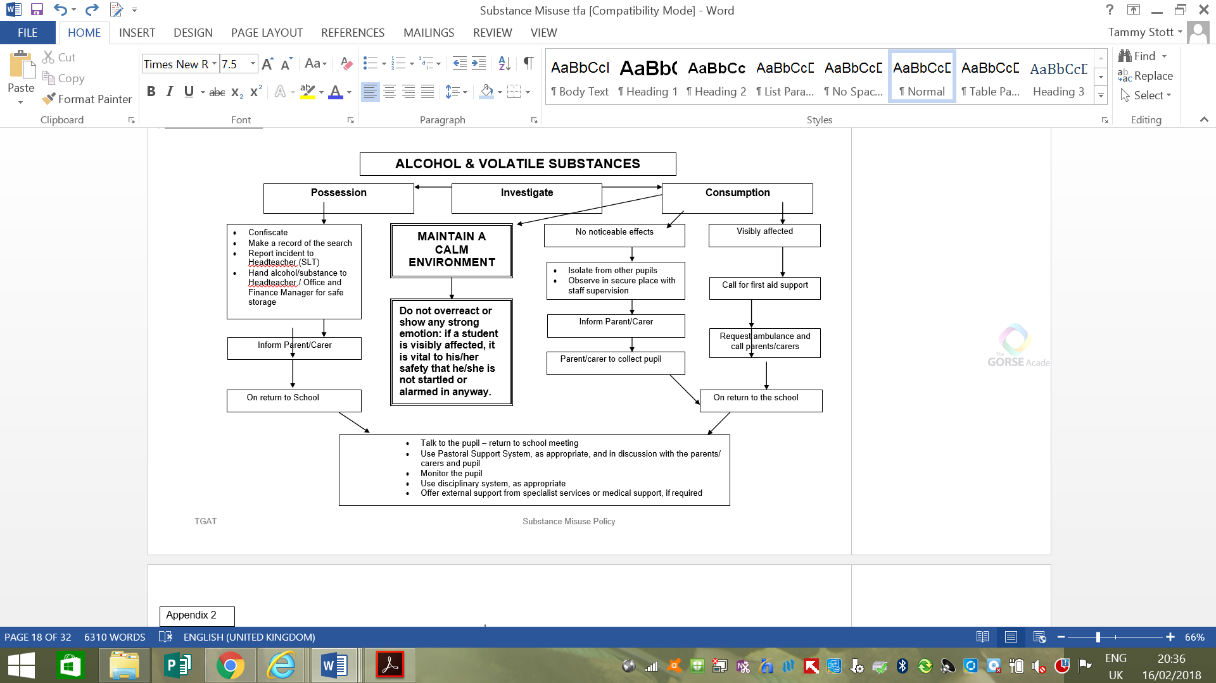

**Appendix 2 – Disclosure of Substance Misuse by a Pupil**

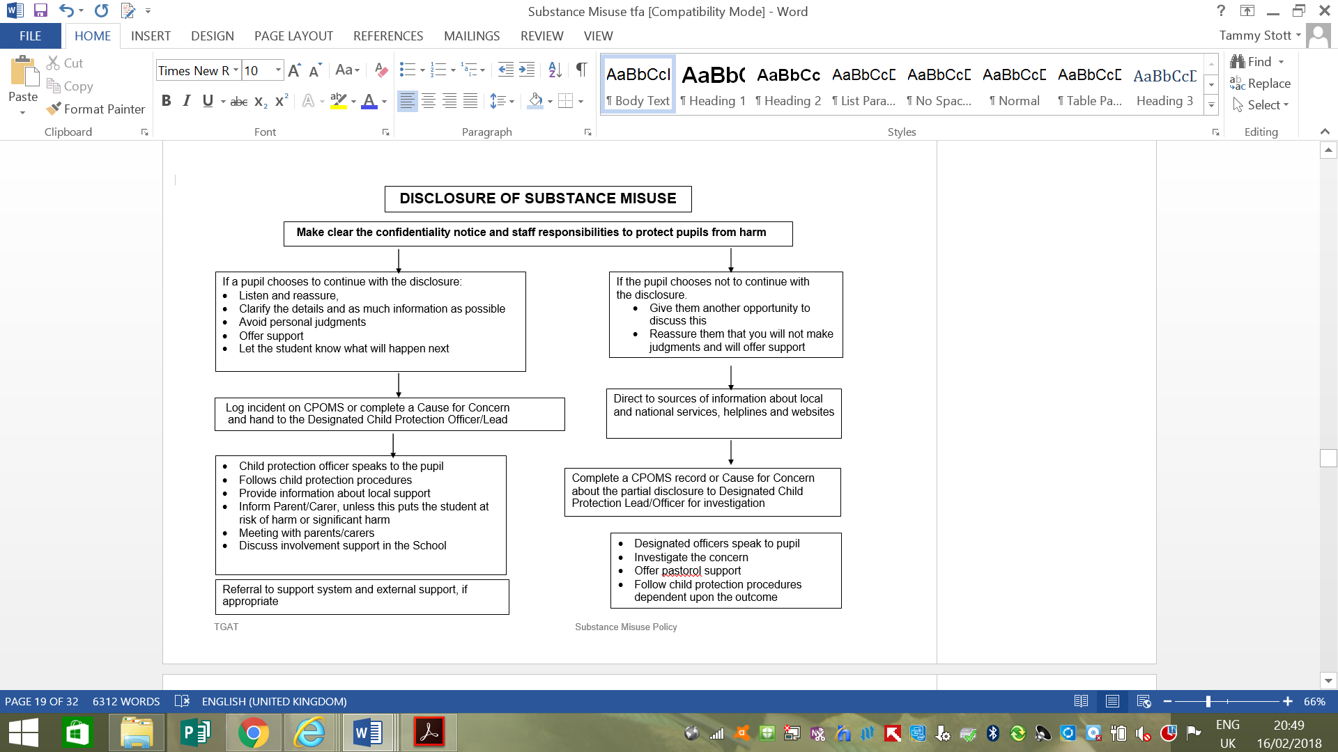

**Appendix 3 – Record of Substance Misuse Incident**

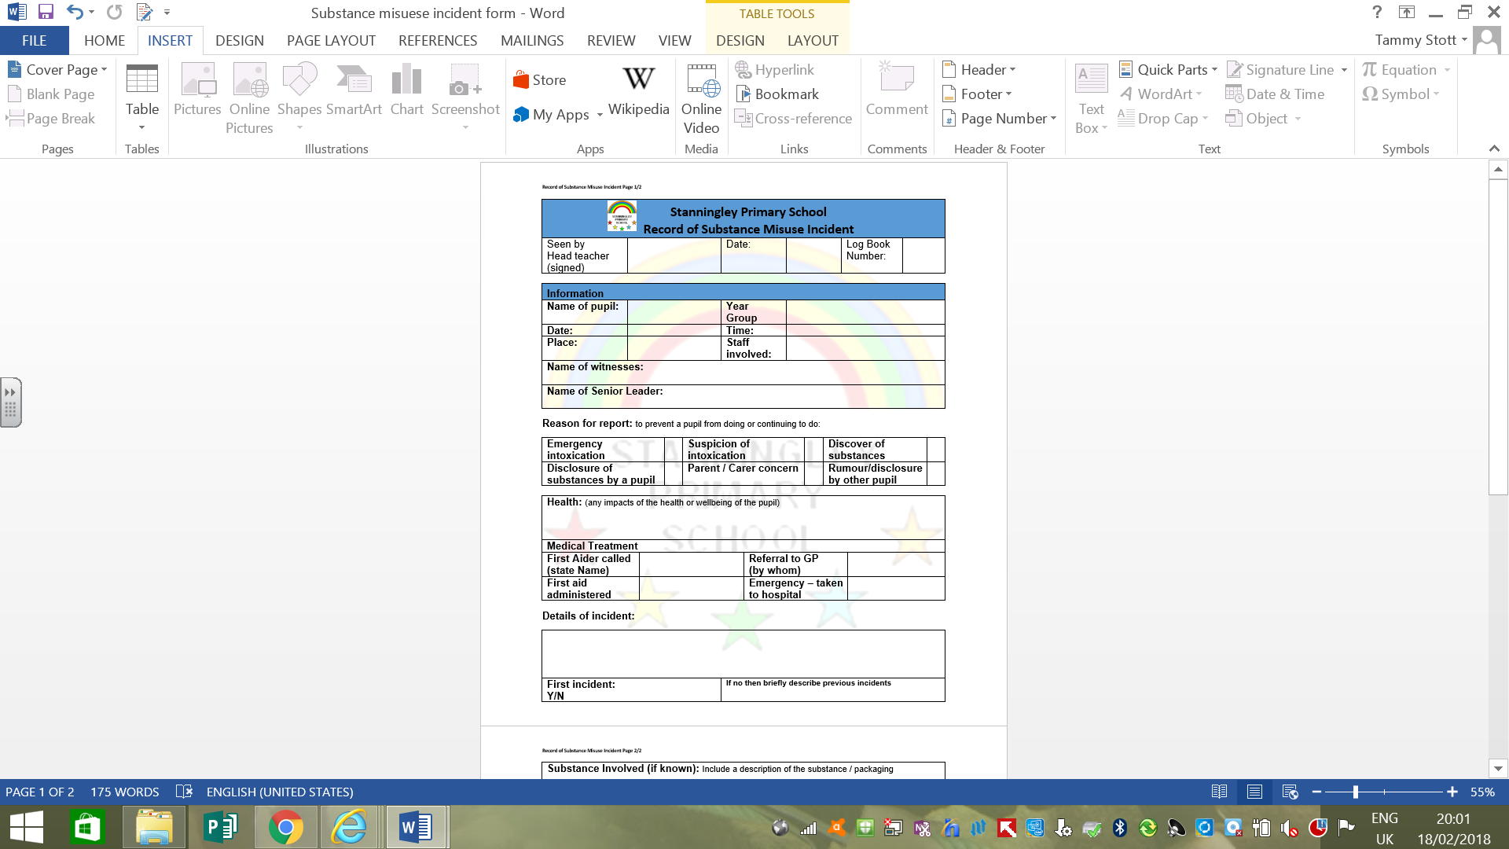

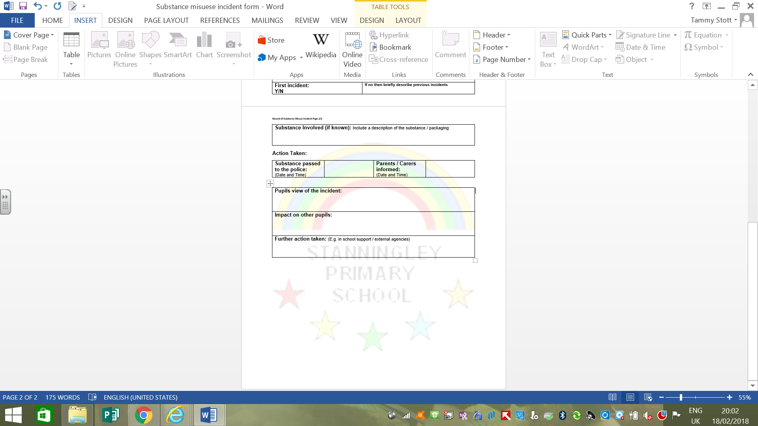

**Appendix 4 – Handling Substances and Paraphernalia**

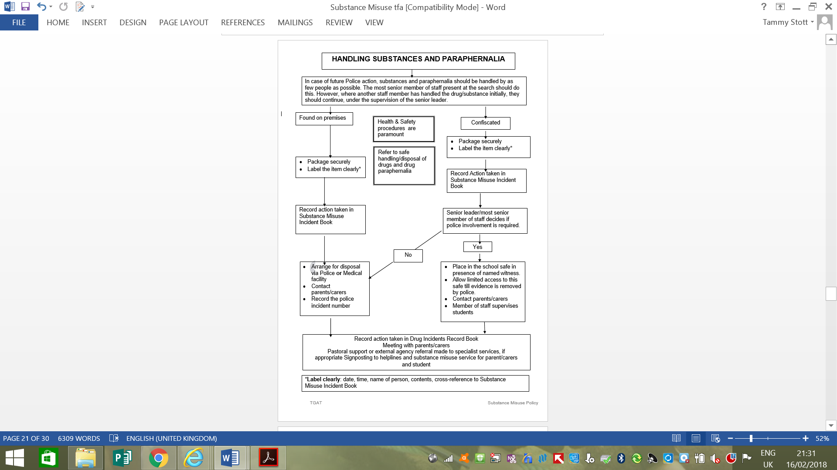

**Appendix 5 – Parents/Carers/Visitors (PCV) on school premises affected by substances**

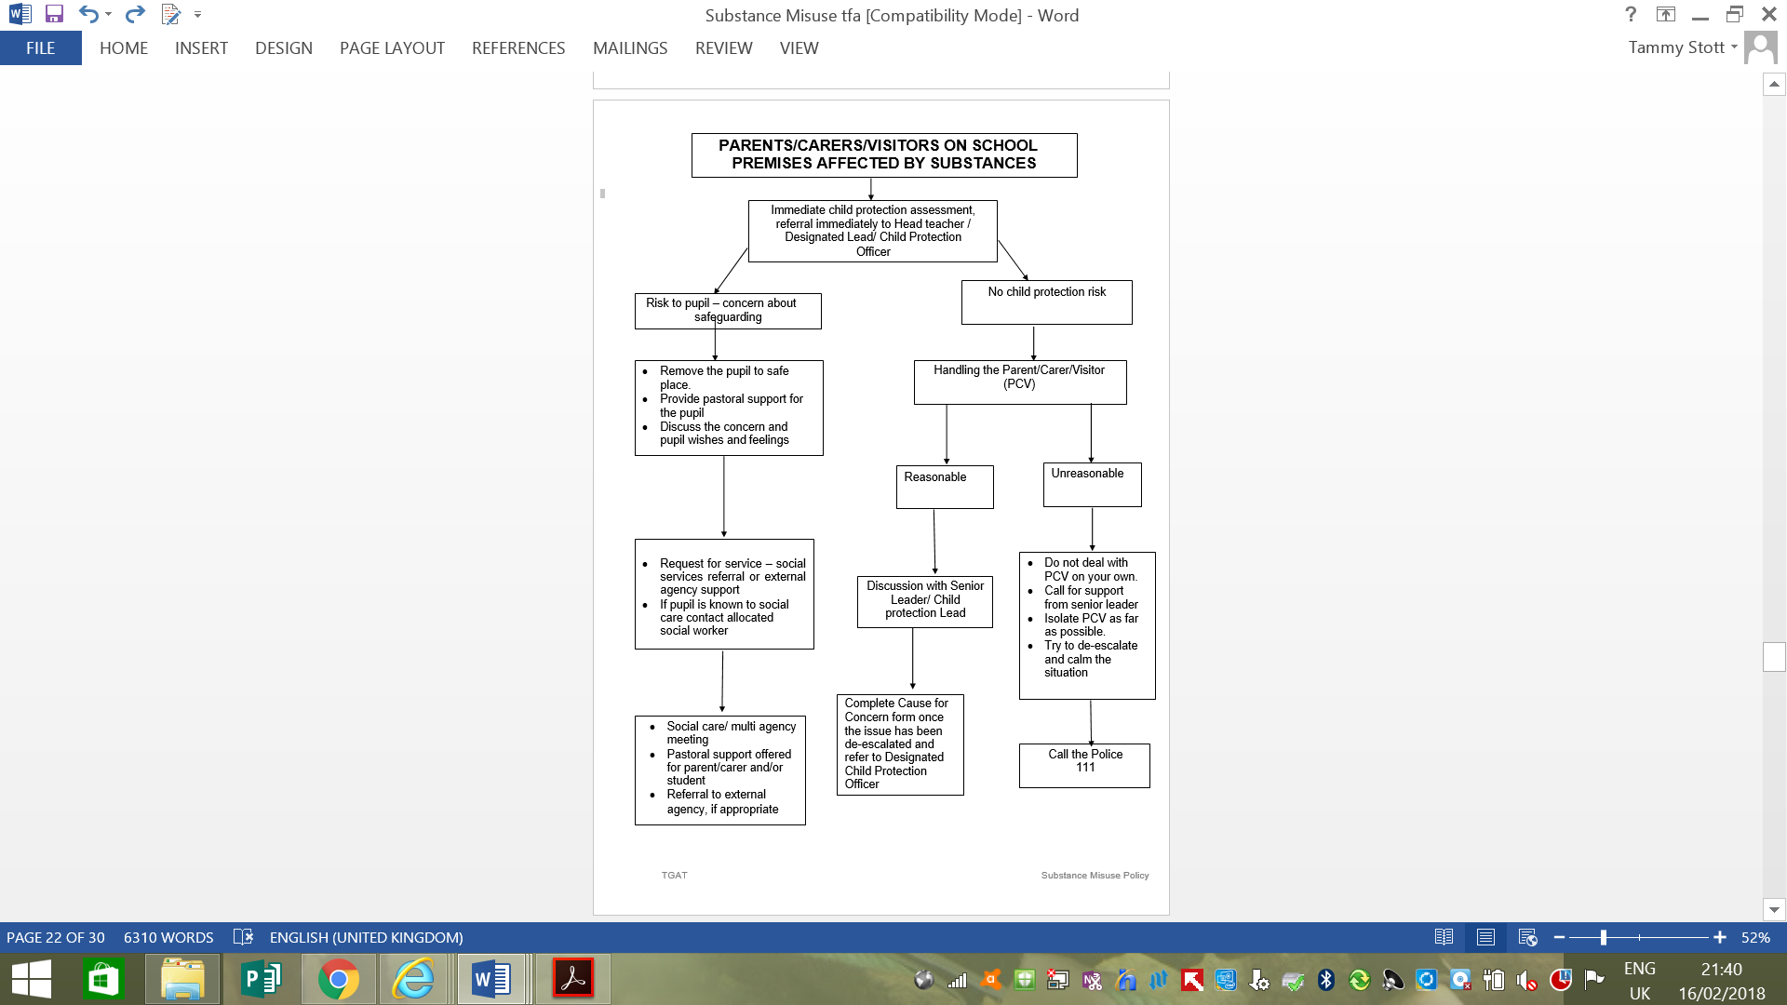

**Appendix 6 – Misuse of substances within the school**

