YEAR 1 | Autumn 1 | Autumn 2 | Spring 1 | Spring 2 | Summer 1 | Summer 2
YEAR 1 | 8 Weeks  4.9.24 – 25.10.24 | 7 Weeks  4.11.24 – 20.12.24 | 6 Weeks  6.1.25 – 14.2.25 | 6 Weeks  24.2.25 – 4.4.25 | 5 Weeks  22.4.25 – 23.5.25 | 7 Weeks  3.6.25 – 18.7.25
½ Term Class Topic / Theme | All about us!   | Castles and Dragons  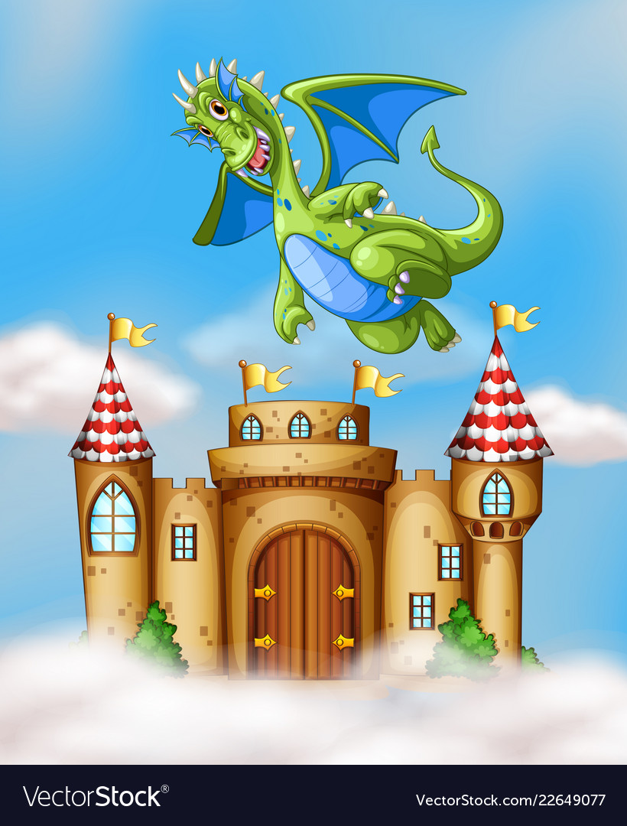 |   Superheroes | Toys  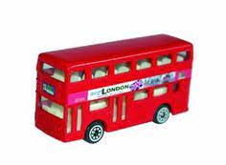 | 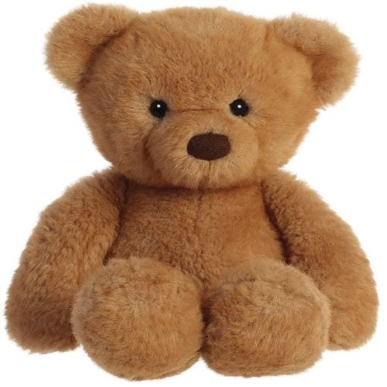  We’re going on a bear hunt… | 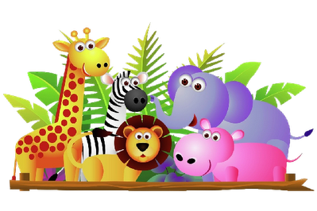  Dinosaurs and Sea Creatures
WOW activities | Grandparents Morning  Zoom call Kirkstall Toy Museum  Elmer Afternoon | Bonfire Activities  The Dragon Egg  Christmas performance | RSPCB bird watch  Superhero day! | DECORATE BEAR CUB  HEALTHY week  World Book Day 7.3.25 | Walk to Pudsey Gardens  Teddy Bear Picnic | VISIT - Yorkshire Wildlife Park ?  Harewood House ?  Church Visit
Class Text | Only One You  Nothing  Peepo  Elmer (T4W) | The Egg | Supertato | Lighthouse Keepers Lunch  Naughty Bus  Eric Carle (class author) | We’re Going on a Bear Hunt  Flower Identification books  Non-Fiction texts | Lost and found  Bear Hunt  Non-Fiction texts  Penguin / Animal fact files
Provision | Home corner | Castle | Superhero city | Vehicles | Picnic | Small World – Animals / sea life / dinosaurs
ENGLISH | I am special because…  Writing questions for our visitors.  . Describe Elmer  Responding / predicting Elmer  Retell Elmer using story map | Dragon Egg hook – predictions  How to look after a dragon (instructions) Instructions on how to cross the road  Retell & innovate Dragon Instructions  Diary of elf’s antics | Description of a superhero  Comic strip of Supertato  Explanation text of own version | Lighthouse Keeper’s Lunch – design and make a new healthy sandwich  Police recount ‘ed’ endings  Naughty Bus retell 1st person  Own Naughty Bus Book | Non fiction identification books  T4W Going on A Bear Hunt & innovate animal and places  Scavenger hunts | Poster for lost penguin  Animal poems/riddle ‘What am I?  Non-fiction chronological report on an animal
MATHS  Power Maths | Unit 1 - Wk 1, 2, 3 – Numbers to 10  Unit 2 – Wk 4, 5 – Part-whole within 10  Unit 3 – Wk 6, 7, – Addition and Subtraction within 10 (1)  Week 8 – assessment | Unit 4 – Wk 1, 2 – Addition and Subtraction within 10 (2)  Unit 5 - Wk 3, 4 – 2D and 3D Shapes  Unit 6 – Wk 5, 6 – Numbers to 20  Week 7 – assessment | Unit 7 – Wk 1, 2 – Addition within 20  Unit 8 - Wk 3, 4 – Subtraction within 20  Week 5 – assessment | Unit 9 – Wk 1, 2 – Numbers to 50  Unit 10 - Wk 3, 4 – Introducing length and height  Unit 11 – Wk 5 – Introducing weight and volume  Week 6– assessment | Unit 12 – Wk 1, 2 – Multiplication  Unit 13 – Wk 3, 4 – Division  Unit 14 – Wk – 5 Halves and quarters  Unit 15 – Wk 6 – Position and Direction  Week 6 – assessment | Unit 16 – Wk 1, 2, 3 – Numbers to 100  Unit 17 - Wk 4, 5 – Time  Unit 18 – Wk 6 – Money  Week 7 – assessment
SCIENCE | SEASONAL CHANGES –introduce our tree & have a photo  - seasonal walk / observe length of day  HUMANS  Know the name of the parts of the human body that can be seen.  Know which body part is connected to which sense.  SC1 observing closely, using simple equipment & performing simple tests exploring senses | SEASONAL CHANGES – Tree photo and observe  - seasonal walk / observe length of day  MATERIALS  -Distinguish between an object and the material from which it is made  -Identify and name a variety of everyday materials, including wood, plastic, glass, metal, water, and rock  SC1 - gathering and recording data to help in answering questions  asking simple questions and recognising that they can be answered in different ways | SEASONAL CHANGES – Tree photo and observe  MATERIALS  Describe the simple physical properties of a variety of everyday materials  -Compare and group together a variety of everyday materials on the basis of their simple physical properties.  SC1 - identifying and classifying  using their observations and ideas to suggest answers to questions | SEASONAL CHANGES – Tree photo and observe  - seasonal walk / observe length of day  PLANTS (HEALTH WEEK)  Know and name the petals, stem, leaves and root of a plant.  SC1 - observing closely  identifying and classifying | SEASONAL CHANGES – Tree photo and observe  - seasonal walk / observe length of day  PLANTS  Know and name the petals, stem, leaves and root of a plant.  Know and name the roots, trunk, branches and leaves of a tree  identify and name a variety of common wild and garden plants, including deciduous and evergreen trees  SC1 - gathering and recording data to help in answering questions  asking simple questions and recognising that they can be answered in different ways | SEASONAL CHANGES – Tree photo and observe  ANIMALS  identify and name a variety of common animals including fish, amphibians, reptiles, birds and mammals identify and name a variety of common animals that are carnivores, herbivores and omnivores  describe and compare the structure of a variety of common animals (fish, amphibians, reptiles, birds and mammals, including pets)  SC1 - gathering and recording data to help in answering questions  identifying and classifying
COMPUTING | Unit 1:1 Online safety and exploring purple mash.  Unit 1.2Grouping and sorting. | Unit 1.3 Pictograms  Unit 1.4 Lego builders | Unit 1.5 Maze explorers  Unit 1.6 Animated Storybooks | Unit 1.7 Coding | Unit 1.8 spreadsheets | Unit 1.9 Technology outside school
RE/CULTURES | C1.6 which books and stories are important | C1.5 Why are festivals important | F1.12 How and why do we care for others | Easter Story |  | C1.1 What des it mean to belong to a community or a belief
HISTORY | CHANGES WITHIN LIVING MEMORY | Bonfire Night  Story of the event and discussion about traditions.
  -Know the main differences between their school days and that of their grandparents.
  -Know what a number of older objects were used for.
  -Know that the toys their grandparents played with were different to their own
  -Organise a number of artefacts by age - timeline
  - Timeline themselves order of age
  LIVES OF SIGNIFICANT PEOPLE:
  Real Life Hero – Grace Darling
  -Name a famous person from the past and explain why they are famous
  LOCAL HSTORY
  -Know about a local famous figure (Pudsey Bear)
  -Know where the people and events they study fit within a chronological framework
  -Understand some of the ways in which we find out about the past - (videos, internet, photos, visit to Pudsey Park)
GEOGRAPHY |  | LOCATIONAL KNOWLEDGE:  NAME, LOCATE AND IDENTIFY CHARACTERISTICS OF THE FOUR COUNTRIES AND FLAGS OF THE UNITED KINGDOM AND ITS SURROUNDING SEAS  -Know the names of the four countries that make up the UK & the corresponding flags  - know the 7 continents and 5 oceans  - vocab – ocean, sea, |  |  | SKILLS + FIELDWORK  - Know and use the terminologies: left and right; below, next to  -Know own address and postcode (label Teddies for picnic)  - use simple fieldwork and observational skills to study the geography of their school and its grounds and the key human and physical features of its surrounding environment.  - vocab – city, town, house, shop, farm
DT |  | Moving Card  Design and make a product which moves.  Use own ideas to make something.  Describe how something works.  Explain what works well and not so well.  Explain how they want to make their product.  Choose appropriate resources and tools. |  |  | Structures  Making a shelter for a bear.
ART | Create own Elmer the Elephant  -Know how to cut, roll and coil materials  -Know the names of the primary and secondary colours.  -Describe what can be seen and give an opinion about the work of an artist Lubaina Himid -know how to create moods in art work  -Ask questions about a piece of art |  | Heroes and Villains  -know how to create moods in art work  -know how to show how people feel in paintings and drawings.  Pablo Picasso  -Ask questions about a piece of art | HEALTHY WEEK  Fruit and vegetable printing, repeating patterns |  | USE DRAWING, PAINTING AND SCULPTURE TO DEVELOP AND SHARE IDEAS, EXPERIENCES AND IMAGINATION  create animal sculptures  - look at skin textures, size and shape, patterns  ALEXANDER CALDER
PSHE  You, Me & PSHE Scheme of Work | Keeping safe and managing risk  Feeling safe | Identifying Society and Equality  Me and others | Mental Health and emotional well being  Feelings | Drugs alcohol and tobacco education  What do we put into and on our bodies. | Physical health and well being  Fun times | Sex and Relationship Education  Boys and girls and families  Careers, financial capability and economic wellbeing  My money
MINDMATE | Feeling good & being me  Recognise feelings  I can talk about how I am feeling | Friends & Family  Recognise how others show feelings & know how to respond  I know when my friends are feeling happy | Life Changes  New school/class  Making new friends  I understand that talking about my feelings can help | Strong emotions  Recognise what is fair/ unfair right/wrong  I know when someone is being unkind, including myself | Solving problems/  Making it better  Setting goals & targets  I can work & play well in a small group | Being the same, being different  Celebrating differences  I know the people in my class are all different
REAL PE | Core real PE Unit 1  Coordination: Footwork (FUNS Station 10)  Static Balance: One Leg (FUNS Station 1)  Personal Cog | Core real PE Unit 2  Dynamic Balance to Agility: Jumping and Landing (FUNS Station 6)  Static Balance: Seated (FUNS Station 2)  Social Cog | Core real PE Unit 3  Dynamic Balance: On a Line (FUNS Station 5)  Static Balance: Stance (FUNS Station 4)  Cognitive Cog | Core real PE Unit 6  Agility: Ball Chasing (FUNS Station 11)  Static Balance: Floor Work (FUNS Station 3)  Health & Fitness Cog | Core real PE Unit 5  Coordination: Sending and Receiving (FUNS Station 8)  Agility: Reaction/Response (FUNS Stat. 12)  Applying Physical Cog | Core real PE Unit 4  Coordination: Ball Skills (FUNS Station 9)  Counter Balance: With a Partner (FUNS Station 7)  Creative Cog
REAL PE | Activities leading to Games | Real Dance Unit 1 | Real Gym Unit 1  Gym Skill = Shape → Travel | CRICKET CHANCE TO SHINE | Activities leading to Games | Running, throwing and jumping (Sports Day)
MUSIC  Session delivered by Mrs Rivers (Artforms) | My body  Body percussion  Pulse and rhythm activities  Cup drumming  Games  Hey You! Rap (Music of black origin); Charanga  Harvest whole school performance with year 1 showcase | Castles and Dragons: Songs and compostitions, using tuned and untuned percussion.  Christmas- KS1 Nativity | Superhero (song)  Charanga Y1 topic ‘In the Groove’ (Charanga) original scheme. Performing and improvising using the piece. | Charanga Y1 topic ‘Round and Round’ – Original Scheme. Performing and improvising using the piece. | Ensemble work:  Tuned/untuned percussion. Composition and performance.  Teddy Bear songs -Teddy Bear Rock n Roll, The Bear went over the mountain | Charanga Y1 Unit 6: How does Music teach us about looking after our Planet?’  -Includes ‘In the Sea’ song. Explore sound and create a story.

