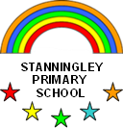  CLASS 4 | Autumn 1 |  | Autumn 2 | Spring 1 | Spring 2 |  | Summer 1 |  | Summer 2
 | 8 Weeks  Prepare for Harvest |  | 7 Weeks  Prepare for Christmas | 6 Weeks | 6 Weeks  PREPARE FOR EASTER |  | 5 Weeks |  | 7 Weeks
½ Term Class Topic / Theme | Respect & Pride  “I have a dream!” |  | Celebrations | Rivers & the  Water Cycle | Romans |  | Living Things |  | Victorian Childhood
ENGLISH  Assessed Genres   | Writing to Inform  - Explanation text  Paragraphs used to group related ideas.  Subheadings to label content.  Writing to Persuade  - School Council Election Letter  Use of 2nd Person  Planned repetition  Facts and statistics  Adjectives for positive description  Writing to persuade / entertain  - Black History  - Martin Luther King |  | Writing to Entertain  - Stories  - Descriptions  Detailed descriptions  Use paragraphs to organise in time sequence  Modifying adjectives, use adverbs and adverbials  - Prediction  - Speech  ALL THE ABOVE LINKED TO CLASS TEXT | Non – fiction  Rushing rivers (links to Geog)  - Non fiction information booklet about rivers  The story of the Green River  - Stories  - Retell extracts  Detailed descriptions  Use paragraphs to organise in time sequence | Writing to Inform  - Letter writing  Paragraphs used to group related ideas  Subheadings to label content  Writing to Entertain  Stories  Playscript  ALL THE ABOVE LINKED TO CLASS TEXT |  | Animal Poetry – link to Science  - Non fiction leaflets  Writing to Entertain  - Descriptions (Victorian Children)  THE ABOVE LINKED TO CLASS TEXT |  | Writing in role  Writing to Persuade (end to child labour)  - Letter  - Diary  Use of 2nd person  Planned repetition  Facts and statistics  Adjectives for positive description  ALL THE ABOVE LINKED TO CLASS TEXT
Class Text   | The Firework Maker’s Daughter  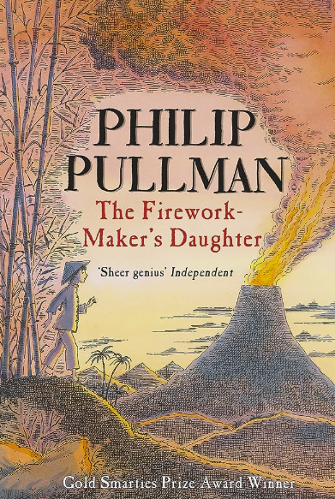 |  |  | I was there Boudicca – Hilary McKay  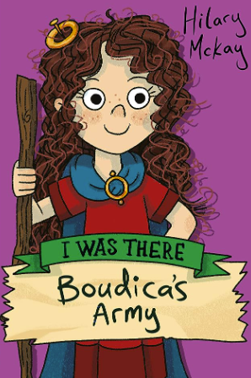 |  |  | Street Child – Berlie Doherty  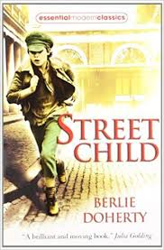
MATHS  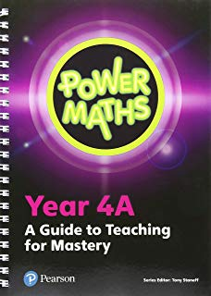 | Unit 1. Place value - 4-digit numbers (1) (8 Lessons)  Unit 2. Place value - 4-digit numbers (2) (8 Lessons)  Unit 3. Addition and subtraction (16 Lessons)  Unit 4. Area (5 Lessons)  Unit 5. Multiplication and division (1) (12 Lessons) |  |  | Unit 6. Multiplication and division (2) (16 Lessons)  Unit 7. Measure – Length & Perimeter (6 Lessons)  Unit 8. Fractions (1) (9 Lessons)  Unit 9. Fractions (2) (8 Lessons)  Unit 10. Decimals (1) (12 Lessons) |  |  | Unit 11. Decimals (2) (7 Lessons)  Unit 12. Money (6 Lessons)  Unit 13. Time (5 Lessons)  Unit 14. Geometry - angles and 2D shapes (8 Lessons)  Unit 15. Statistics (6 Lessons)  Unit 16. Geometry - position and direction (6 Lessons)
SCIENCE  Some units from - Switched on Science – Rising Stars   | What’s that sound?  N.C. SOUND (PHYSICS)  - Know how sound is made, associating some of them with vibrating  - Know how sound travels from a source to our ears  - Know the correlation between pitch and the object producing a sound  - Know the correlation between the volume of a sound and the strength of the vibrations that produced it  - Know what happens to a sound as it travels away from its source |  | Power it up!  N.C. ELECTRICITY (PHYSICS)  - Identify and name appliances that require electricity to function  - Construct a series circuit  - Identify and name the components in a series circuit (including cells, wires, bulbs, switches and buzzers)  - Predict and test whether a lamp will light within a circuit  - Know the function of a switch  - Know the difference between a conductor and an insulator; giving examples of each | Looking at states  N.C. STATES OF MATTER (CHEMISTRY)  - Know the temperature at which materials change state  - Know about and explore how some materials can change state  - Know the part played by evaporation and condensation in the water cycle | Teeth and Eating  N.C. ANIMALS INCLUDING HUMANS (BIOLOGY)  - Identify and name the parts of the human digestive system  - Know the functions of the organs in the human digestive system  - Identify and know the different types of human teeth  - Know the functions of different human teeth  - Use and construct food chains to identify producers, predators and prey |  | Living things  N.C. LIVING THINGS & THEIR HABITATS (BIOLOGY)  - Use classification keys to group, identify and name living things  - Know how changes to an environment could endanger living things  - Group materials based on their state of matter (solid, liquid, gas |  | Wow Science!  (WORKING SCIENTIFICALLY)  *Additional topic that goes beyond NC requirements*
COMPUTING  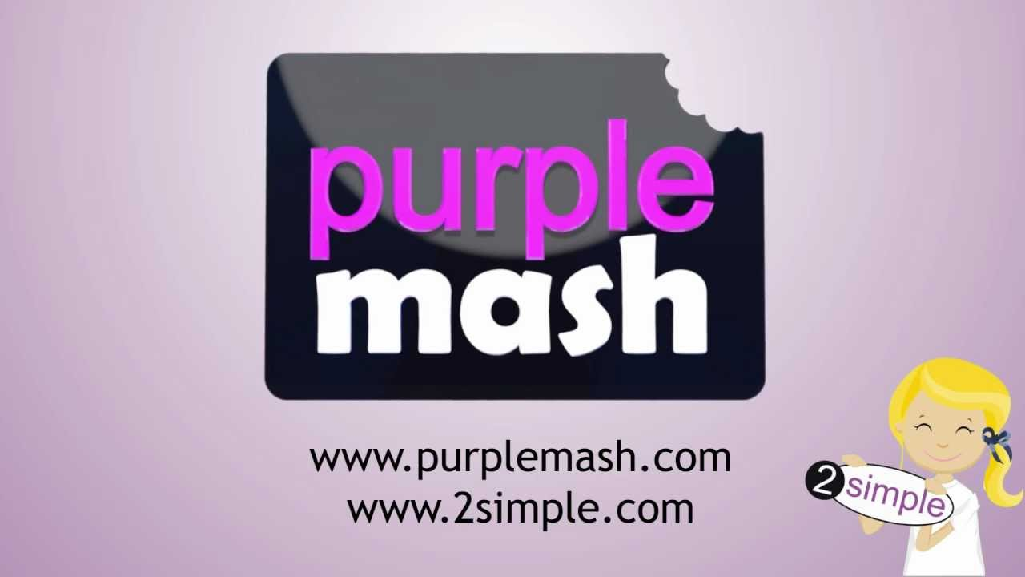 | Unit 4.1 = Coding  Main Programs – 2Code  N.C. Design, write and debug programs that accomplish specific goals, including controlling or simulating physical systems; solve problems by decomposing them into smaller parts |  | Unit 4.2 = Online  Safety (combined with Writing for Different Audiences)  Weeks – 2 Programs – Various  N.C. Use technology safely, respectfully and responsibly; recognise acceptable / unacceptable behaviour; identify a range of ways to report concerns about content and contact.  . | Unit 4.5 = Logo  Programs – Logo  N.C. Use sequence, selection and repetition in programs; work with variables and various forms of input and output.  Use logical reasoning to explain how some simple algorithms work and to detect and correct errors in algorithms and programs. | Unit 4.6 = Animation  Programs – 2Animate  N.C. Design and create a range of programs, systems and content that accomplish given goals. |  | Unit 4.7  Effective  Search  Weeks – 3 Programs –Browser  N.C. Use search technologies effectively,  appreciate how results are selected and ranked, and be discerning in evaluating digital content. | Unit 4.8  Hardware  Investigators  Weeks – 2  N.C. Understand computer networks, including  the Internet; how they can provide  multiple services, such as the World Wide  Web; and the opportunities they offer for communication and collaboration. | Unit 4.3  Spreadsheets  Programs – 2Calculate  N.C. Design and create a range of programs, systems and content that accomplish given goals.
RE/CULTURES  The Agreed Syllabus for RE in Calderdale, Kirklees and Leeds | What faiths and beliefs can be found in our country and community? (Core) |  |  | How do the lives of the Gurus inspire Sikh believers?  (Core) | What is the significance of Easter, Ascension and Pentecost? (Focus) |  | How do the Five Pillars of Islam help Muslims to live a good life? (Core)
HISTORY  Rising Stars Voyagers Scheme   | Black History Month  (Martin Luther King)  Possibility of covering the Summer 2 Mindmate lesson on discrimination |  | What was important to our local Victorians?  NC. Local History Study: A study of an aspect or theme in British history that extends knowledge beyond 1066  Link to Victorian Christmas  - ask perceptive questions, think critically, and weigh up historical evidence  - carry out a local history study  - study an aspect or theme in British history that  extends their chronological knowledge beyond 1066. |  | What happened when the Romans came?  N.C. The Roman Empire and its impact on Britain  - gain a coherent knowledge and understanding of Britain’s past and that of the wider world by knowing about the Roman Empire and its impact on Britain  - understand historical concepts and terms such as civilisation, empire, change etc.  - ask perceptive questions, think critically, weigh  evidence, sift arguments and develop perspective. |  | Is it better to be a child now than in the past?  N.C. A study of an aspect or theme in British history that extends knowledge beyond 1066  - be inspired to know more about the past, ask perceptive questions, think critically and weigh evidence  - understand historical concepts such as continuity and change, cause & consequence, similarity, difference & significance, and use them to make connections, draw contrasts, and create their own structured accounts  - study an aspect or theme in British history that  extends pupils’ chronological knowledge beyond 1066.
GEOGRAPHY  Rising Stars Voyagers Scheme | Can the Earth shake, rattle and roll?  N.C. Describe and understand key aspects of physical geography,  including volcanoes  RS =  - Describe and understand the key aspects of volcanoes and earthquakes  - Understand that the distribution of earthquakes and volcanoes follows a pattern  - Learn about the ‘Pacific Ring of Fire’. |  |  | How does water go round and round?  N.C. Describe and understand key aspects of physical geography,  including the water cycle  RS =  - Name and locate (some of) the UK’s most significant rivers and mountain environments  - Describe features of a river and a mountain environment in the UK  - Learn how rivers and mountains are formed  - Understand where rivers and mountains fit into the water cycle. |  |  |  |  | Can you come on a great American road trip?  N.C. Locate the world’s countries using maps, including North and South America  RS =  - Enhance their locational and place knowledge  - Focus on North and South America, concentrating on their environmental regions, key physical and human characteristics, countries and major cities  - Understand geographical similarities and differences through the study of a region in North and South America  - Use maps, atlases, globes and digital/computer mapping  - Learn to use the eight points of a compass.
DT  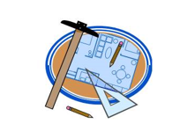 |  |  | Electrical Systems  Simple circuits and switches (including programming & control)  - Design  - Make  - Evaluate  - Technical knowledge | Structures  Shell structures  Early prep for Easter boxes  - Design  - Make  - Evaluate  - Technical knowledge | Food  Healthy and varied diet (including cooking and nutrition requirements)  - Understand & apply the principles of a healthy & varied diet  - Prepare & cook a variety of predominantly savoury dishes using a range of cooking techniques  - Understand seasonality, & know where & how a variety of ingredients are grown, reared, caught & processed  Cooking in the curriculum with DG
ART   | COLLAGE – Henri Matisse  - Know how to use shape and colour to figures and forms in movement |  |  |  | CLAY – POTTERY  (Roman Tile)  - Know how to use marks & lines to show texture in art.  - Know how to sculpt clay and other mouldable materials. (Make into flat tile)  - Know how to print onto different materials (Print from the tile) |  |  |  | DRAWING – Louise Bourgeois  INSECT  Using Sketchbooks – using photographs of nature butterflies to help create reflections
PSHE  You, Me & PSHE Scheme of Work   | Keeping safe and managing risk  Playing safe  SCHOOL ELECTIONS  NSPCC PANTS |  | Identity, society & equality  Democracy  **A lot of this will be covered in Aut.1. & linked to school council elections. |  | Drug, alcohol and tobacco education  Making choices |  | Sex and relationship education  Growing up and changing |  | Physical health & wellbeing  What is important to me?
MINDMATE   | Feeling good & being me  Feelings - Intensity  I can use a range a words to describe my feelings |  | Friends & Family  Skills to maintain & keep positive relationships  I can describe a healthy relationship | Life Changes  Positive & negative effects on emotional wellbeing & mental health  I am learning to accept that I will feel a wide range of emotions depending on the situation | Strong emotions  Resisting pressure  I can stand up for myself without hurting others |  | Being the same, being different  Know actions affect themselves & others  I know that discrimination can hurt people’s feelings |  | Solving problems/  Making it better  Coping with difficult situations  I can cope in difficult situations
PE   | Core real PE Unit 1  Coordination: Footwork (FUNS Station 10)  Static Balance: One Leg (FUNS Station 1)  Personal Cog  |  | Core real PE Unit 2  Dynamic Balance to Agility: Jumping and Landing (FUNS Station 6)  Static Balance: Seated (FUNS Station 2)  Social Cog | Core real PE Unit 3  Skill – Dynamic Balance: On a Line (FUNS Station 5)  Cool Down – Coordination: Ball Skills (FUNS Station 9)  Cognitive Cog  Real Gym Unit 1 *Combine Unit  Gym Skill = Shape → Rotation | Core real PE Unit 6  Skill – Agility: Ball Chasing (FUNS Station 11)  Cool Down – Static Balance: Stance (FUNS Station 4)  Health & Fitness Cog |  | Core real PE Unit 4  Skill – Coordination: Sending and Receiving (FUNS Station 8)  Cool Down – Counter Balance: With a Partner (FUNS Station 7)  Creative Cog |  | Core real PE Unit 5  Skill – Agility: Reaction/Response (FUNS Station 12)  Cool Down – Static Balance: Floor Work (FUNS Station 3)  Applying Physical Cog
PE (Session 2) | Striking and fielding  Yorkshire Cricket  Schools Support Programme | Real Dance Unit 1 |  | Real Gym Unit 2 |  | Developing skills and knowledge in  relation to Invasion Games | Developing skills and knowledge in relation to  Athletics |  | Developing skills and knowledge in relation  to Net and wall  (Sports Day)
SPANISH   | - Revision of colours, numbers, greetings and classroom instructions from last year  - Parts of the body  - Adjectives  - It has (Tiene) |  | - Zoo animals  - Simple descriptions  - Revision of colours and adjectives  - Gender  - Vowels in Spanish  - Storytelling in Spanish (A visit to the zoo)  - Is (es)  - Christmas: make a mini-book about Christmas. | - Family  - I have (tengo)  - Revision numbers, days of the week and months. | - Pets  - Revision of colours and adjectives.  - Revision of “I have /  I don’t have” (Tengo/no tengo)  - Role play speaking about pets and family. |  | - Hobbies  - I like/I don’t like (Me gusta/ no me gusta)  - Revision of days of the week.  - Role play speaking about hobbies.  - Do you like…? (¿Te gusta…?)  - Numbers up to 30 |  | - Means of transport  - The date  - Weather  - Clothes.
MUSIC  Session delivered by Mrs Rivers (Art Forms)   | Y4 Unit 5 (Charanga) ‘How does Music shape our way of Life?’ – learning about the history of Spirituals, such as ‘Train is a-coming’.  Connecting notes and feelings.  Harvest whole school performance with year 4 showcase |  | Victorians  ‘Two Queens’ song, about Queen Victoria and Queen Elizabeth 1  Classroom Jazz 1, (Charanga)  Christmas- KS2 Nativity | Ensemble work:Tuned/untuned percussion. Composition and performance.  The Watercycle  ‘Watercycle Song’ as a class ensemble performance. | Romans: ‘Just Like a Roman’ (Sing Up), Roman Rap  Benjamin Britten ‘Storm’ from the Peter Grimes opera. BBC Ten Pieces. |  | Whole class Recorder: Following the ‘Red Hot Recorder ‘ and ‘Charanga’ schemes. |  | Whole class Recorder: Following the ‘Red Hot Recorder ‘ and ‘Charanga’ schemes.  Ensemble work – including tuned/untuned
VISIT / VISITOR |  |  |  | Nell Bank activity centre – Rivers workshop |  |  | Victorian Day at St Thomas’

