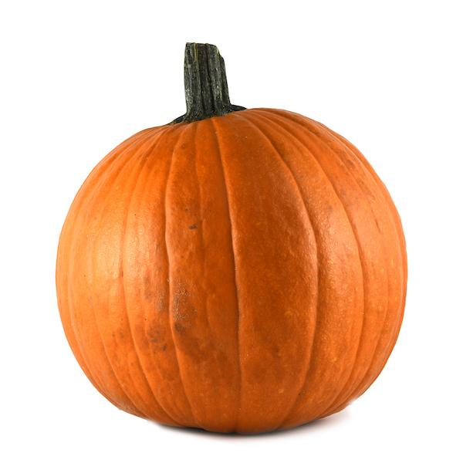

Teachers
Mrs McDowall: Monday and Tuesday
Mrs Hayward: Wednesday, Thursday, Friday
Teaching Assistants
Mrs Lofthouse
Our theme this half-term is ‘Dragons and Castles’
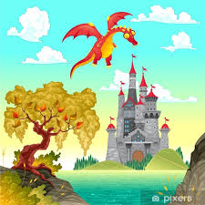

Mrs Abram (Mornings)

WOW! Look at what we found in our classroom! We came in during the holidays and found this….we wonder what it can be?
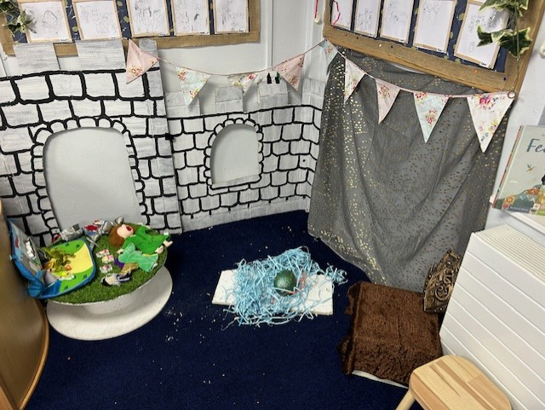
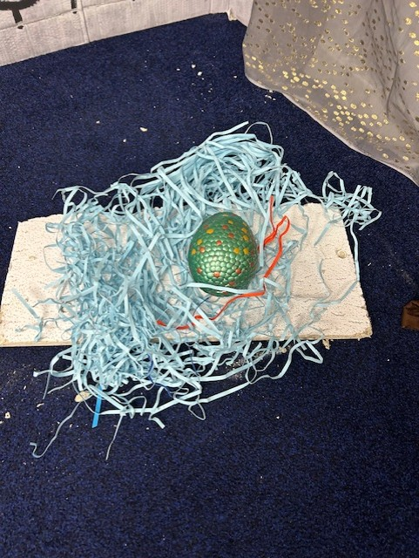
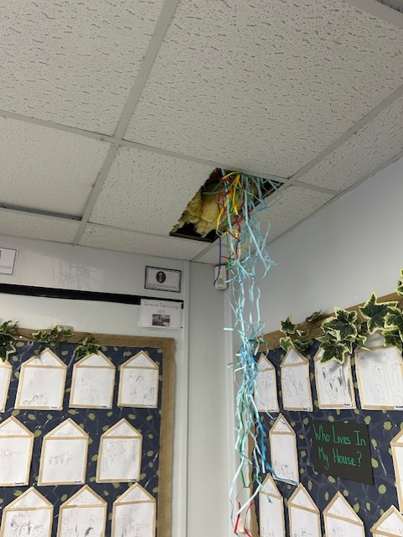

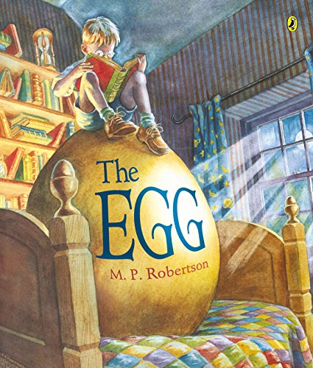  English  We will be using our imagination to ask questions about the egg that’s appeared in our classroom, thinking about our use of a question mark. We will also be trying really hard to put finger spaces in between words, sit our writing on the line and start a sentence with a capital letter. We will move onto looking at instructions for ‘How to trap a dragon’ and we will be learning a text off by heart to help us write our own! |   Maths  The children have really embraced their ‘power maths’ books and worked really hard in maths last half-term. This half-term we will still be focusing on addition and subtraction within 10.  We will be…  - Writing number sentences (eg 3+2=5)  - Fact families (5+3=8, 3+5=8, 8=5+3, 8=3+5)  - Number bonds/missing numbers (4 + _ = 10)  - Learning the +, = and – symbol    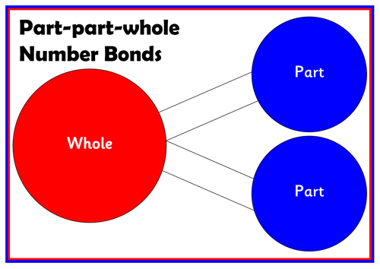  These are models we use in class to support the children’s learning…  Part-part whole  Tens frame
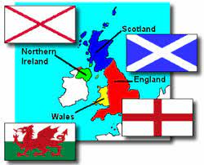
Geography
We will starting by learning the 4 countries of the UK (England, Wales, Scotland and Northern Ireland) and their corresponding flags. Then we will be looking at the 7 continents and 5 oceans of the World.
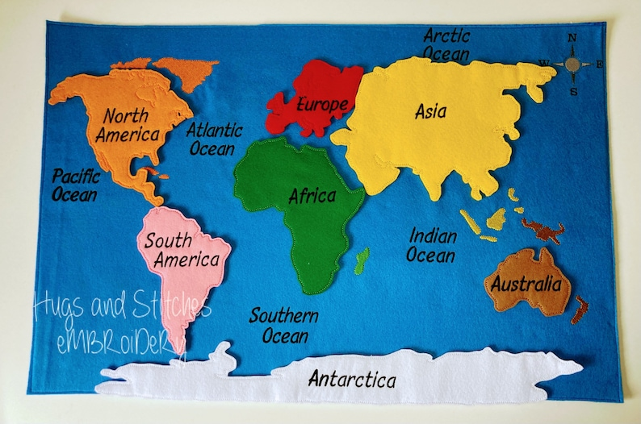
We will be using songs and rhymes to help the children remember. We will share these with you as we learn them.
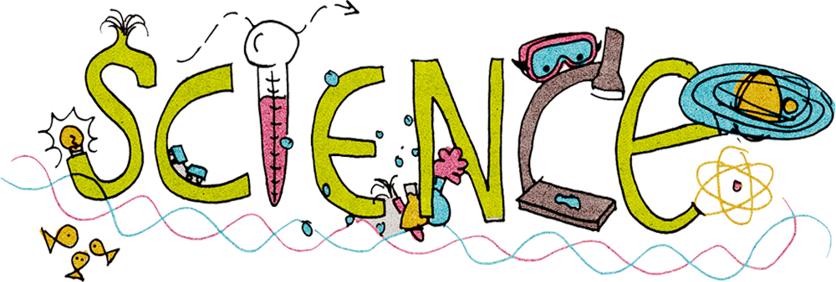    We will be looking at different kinds of materials. The children will be labelling objects around school to show which material they are made out of. Then we find out materials would be the best to design a bed for a dragon by completing some simple tests. | 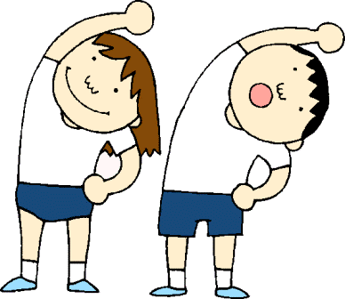  PE  Indoor PE- Thursday  Outdoor PE- Tuesday  Please ensure your child comes into school wearing the correct kit. Plain black bottoms (no logos), plain white round neck t-shirt, school jumper if needed and suitable footwear. Please make sure children can fasten their own shoes independently and that all earrings are removed.
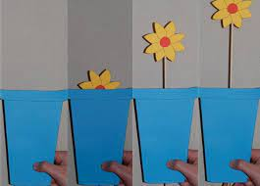  DT  As we move towards Christmas this half-term we will be using all that we’ve learnt in DT to make MOVING CHRISTMAS CARDS! Wow!  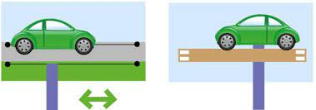  The children will choose if they include a lever, a slider or a rotating wheel. We will be using scissors and paper fasteners and describing how our card moves.   | Home Learning  Spellings will be given out on a Wednesday and then tested on the following Tuesday. The spellings will all be words taught that week in phonics. They will be stuck in homework books.  Learn By Heart are maths facts that need to be learnt by heart. These will also be sent home on a Wednesday and tested the following Tuesday.  Group Reading Books will be collected in on a Tuesday and new group reading books will be sent home Wednesday Please try and do THREE reads at home.  WEDNESDAYS – spelling and learn by heart books sent home  TUESDAYS – spelling and learn by heart test.  **CHILDREN WILL NEED SPELLING AND LEARN BY HEART BOOKS IN SCHOOL ON A TUESDAY (THEY’LL THEN BE SENT BACK HOME ON A WEDNESDAY WITH NEW SPELLINGS AND LEARNING BY HEARTS IN) **
PEACE WEEK / ANTIBULLYING WEEK
On the week of 11th November it is the ANTI-BULLYING WEEK 2024. In school our focused ‘PEACE WEEK’ addresses the emotional work surrounding this. Throughout the week, the children will take part in circle time sessions and activities that allow them to explore situations, feelings and give them strategies for dealing with social situations. It will begin with ODD SOCKS DAY on TUESDAY 12th NOVEMBER where the children celebrate how everyone is different and unique.
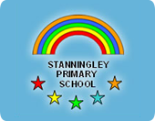
School Website
We will update the class page regularly with examples of our learning and experiences in class one. You can check this with your child as it will give you a really good insight into what they are doing at school everyday, what things they have been learning and any special events that have happened.
www.stanningleyprimary.com
SPECIAL DATES:
Parents’ Evening- Wednesday 13th and Thursday 14th November (please make sure you have booked your session)
Peace week – WB Monday 11th November
Children in need- Friday 15th November
Non-uniform day (bring a colour gift)- Wednesday 4th December
Christmas Carols and fair in the Playgound – Wednesday 11th December
Christmas Nativity Year 1 and 2- Monday 16th December 1.30pm
Christmas service at the church and Christmas lunch – Wednesday 18th December
Christmas party – Thursday 19th December
Pantomime in school hall – Friday 20th December
Should you have any queries or questions, please do not hesitate to speak with a member of the year 1 team. You can always call the school office and a member of staff will call you back, or alternatively you can email the school office at office@stanningleyprimary.com. These emails will be passed to the team and someone will get back to you as soon as possible.
We are looking forward to another great half-term!
Mrs Hayward, Mrs McDowall, Mrs Lofthouse and Mrs Abram

