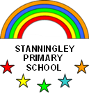

Year 2

Wrap & Coleslaw

Year Two have enjoyed making a Healthy Wrap & Coleslaw

The children learnt all about where food comes from, how to keep our body’s healthy. As well as learning to use a range of techniques to chop, peel & grate different food ingredients.

