AUTUMN 1 2024
SUBJECT | WEEK 1  4.9.24  (3 days) | WEEK 2  9.9.24 | WEEK 3  16.9.24 | WEEK 4  23.9.24 | WEEK 5  30.9.24 | WEEK 6  7.10.24 | WEEK 7  14.10.24 | WEEK 8  21.10.24
READING   | Understanding an extract from a non-fiction text  Context: Volcanoes  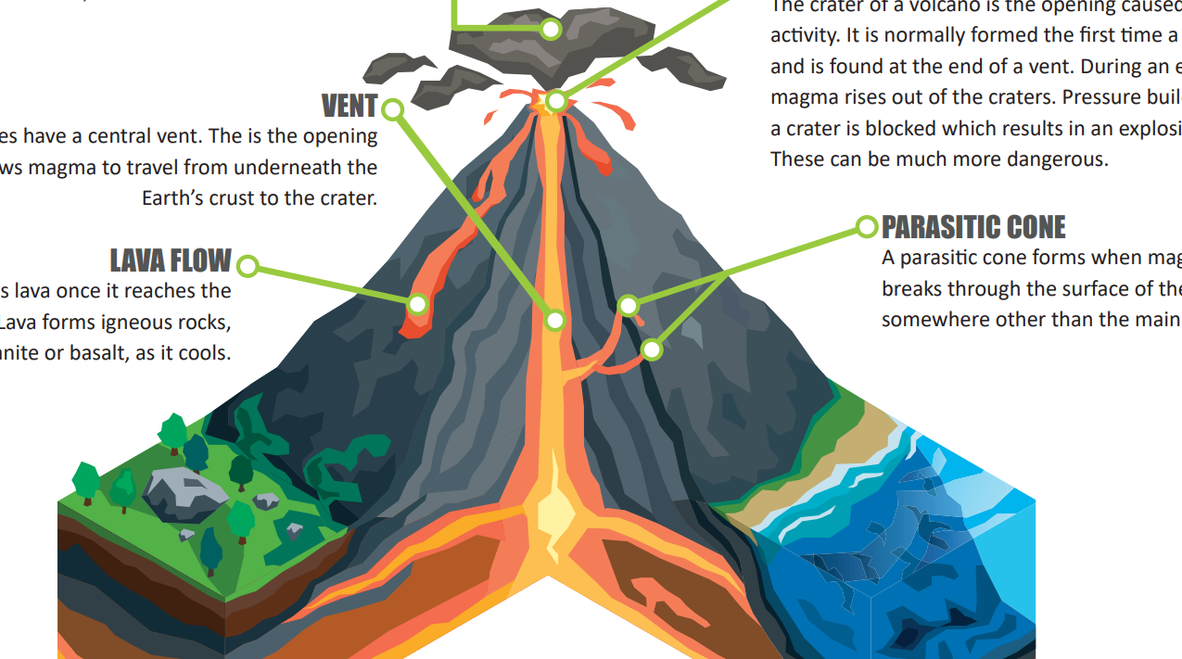 | Understanding an extract from a non-fiction text  Context: Volcanoes  Introduce class novel: “The Firework Maker’s Daughter”  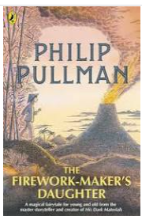 | Using clues to understand an unfamiliar fictional text  Context:  The opening paragraphs of “Wonder” by R.J Palacio  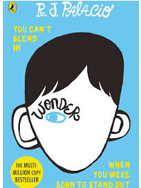 | Understanding an extract from a fictional text  Context: Chapter 1 of class novel: “The Firework Maker’s Daughter” | Understanding an extract from a fictional text  Context: Chapter 1 of class novel: “The Firework Maker’s Daughter” | Understanding an extract from a non-fiction text  Context: Black History | Assessment week | Understanding an extract from a fictional text  Context: Chapter 3 of class novel: “The Firework Maker’s Daughter”
WRITING    INCLUDING GENRE(S) | Writing to inform  Write about themselves.  Family, hobbies, likes, dislikes.  Subheadings &  Paragraphs. | Writing to inform  Writing about expectations in school.  - Class rules  - School day  - Daily mile | Writing to persuade  Write a letter to support application to school council. | Writing to persuade  Write a letter to support application to school council. | Black History  Martin Luther King  “I have a dream.”  Who is MLK?  Look at speech, collect concepts associated with speech. | Black History  Martin Luther King  “I have a dream.”  Who is MLK?  Look at speech, collect concepts associated with speech. | Black History  Martin Luther King  Writing to persuade / entertain  Own poem I have a dream. | ASSESSED WRITING
SPELLING  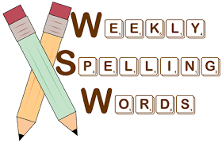 | Commonly misspelt words | Commonly misspelt words | Endings which sound like /ʃən/, spelt –tion  Words from the Year 4 statutory list | Endings which sound like /ʃən/, spelt–sion  Words from the Year 4 statutory list | Endings which sound like /ʃən/, spelt–ssion  Words from the Year 4 statutory list | Endings which sound like /ʃən/, spelt–cian  Words from the Year 4 statutory list | Assessment | Words from the Year 4 statutory
GRAMMAR AND PUNCTUATION  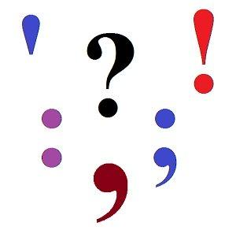 | Sentence structure – correct punctuation between independent clauses | Sentence structure – introducing homework sentence tasks | Sentence structure – correct punctuation between independent clauses | Fronted adverbials with commas | Sentence structure – correct punctuation between independent clauses with fronted adverbials | Expanded noun phrases | Assessment | Expanded noun phrases
MATHS  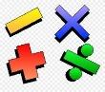 | Unit 1 – Place Value – 4 digit numbers (1) | Unit 1 – Place Value – 4 digit numbers (1) | Unit 1 – Place Value – 4 digit numbers (1) | Unit 2 – Place Value – 4 digit numbers (2) | Unit 2 – Place Value – 4 digit numbers (2) | Unit 3 – Addition and Subtraction | Unit 3 – Addition and Subtraction | Assessment
LEARN BY HEARTS   | N/A | Tables: 2x 5x 10x | Tables: 2x 5x 10x | Tables: 3x4x | Tables: 3x4x | Tables: 3x6x | Tables: 3x6x | Tables: 4x7x
SCIENCE - Sound   |  | Sound Walk  NC - To identify how sounds are made, associating some of them with something vibrating.  LO - To ask and answer questions about the sounds that can be heard and to begin to consider how sounds are made. | Good Vibrations  NC – To identify how sounds are made, associating some of them with something vibrating.  To recognise that vibrations from sounds travel through a medium to the ear.  To recognise that sounds get fainter as the distance from the sound source increases.  LO - To explain that sounds are made when an object vibrates and to begin to understand that we hear sounds when the vibrations travel from a source through a medium to our ears.  To use this knowledge to recognise why sounds get fainter when you are further from the source of the sound. | Pitch and Volume  NC – To find patterns between the pitch of a sound and features of the object that produced it.  To find patterns between the volume of a sound and the strength of the vibrations that produced it.  LO - To notice patterns between the pitch and volume of a sound and the features of the object that produced it. To use understanding of pitch and volume to answer questions about soundwaves | Pardon?  NC - To identify how sounds are made, associating some of them with something vibrating.  To recognise that vibrations from sounds travel through a medium to the ear.  LO - To use what they know about the world to ask and answer questions about the hearing of humans and other animals. To understand that sound travels slower than light | Sssshhhhhhh!  NC – To recognise that vibrations from sounds travel through a medium to the ear.  To recognise that sounds get fainter as the distance from the sound source increases.  LO - To investigate sound-proofing materials by planning and conducting a fair test, considering all the variables and how to record the results. | The Rock Star Challenge  NC – All previous weeks.  LO - To answer questions about the results of the investigation into sound reduction and to demonstrate an understanding of sound, including how it is made and how it travels.
COMPUTING   | Introduce expectations for Y4 Computing and check access to Chrome books and Purple Mash | Coding  Design, Code, Test and Debug • To review coding vocabulary and knowledge. • To create a simple computer program. | IF Statements • To begin to understand selection in computer programming. • To understand how an IF statement works | Co-ordinates • To understand how to use coordinates in computer programming. • To understand how an IF statement works. | Repeat Until and IF/ELSE Statements • To understand the Repeat until command. • To begin to understand selection in computer programming. • To understand how an IF/ELSE statement works. | Number Variables • To understand what a variable is in programming. • To use a number variable | Making a Playable Game • To review vocabulary and concepts learnt in Year 4 Coding. • To create a playable game.
HISTORY/  GEOGRAPHY  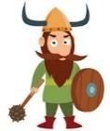 |  | Geography – Volcanoes and Earthquakes  WHAT IS HAPPENING WHEN THE EARTH SHAKES?  To have an understanding of the causes, outcomes & locations of earth quakes.  Structure of Volcanoes: in Reading lesson | WHAT IS HAPPENING WHEN THE EARTH SHAKES? (Continued)  To have an understanding of the causes, outcomes & locations of earth quakes.  Structure of Volcanoes: in Reading lesson | DOES THE EARTH SHAKE, RATTLE & ROLL ALL OVER?  To understand list of hazards of the distribution of earthquakes & volcanoes and to know where the worlds most active earthquake & volcanic zone is today. | History - Martin Luther King (through English lessons)  Geography  HOW & WHY DO PEOPLE LIVE WHERE THE EARTH SHAKES, RATTLES & ROLLS?  To discuss why people live in the vicinity of volcanoes, & what measures can be taken to make life safer in earthquake zones. | History - Martin Luther King (through English lessons)  Geography  HOW DISASTROUS HAVE RECENT EARTHQUAKES &/OR VOLCANIC ERUPTIONS BEEN?  To provide an opportunity to investigate recent earthquakes & volcanic eruptions & associated issues. | Prepare for Harvest celebration | Harvest celebration
RE –
What faiths and beliefs can be found in our country and community?


SPANISH   |  | Revision of greetings,  Name and age numbers 1 - 10Numbers 1 - 10 Numbers 10 - 31 | Parts of the body | Parts of the body | Adjectives | Adjectives | It has (Tiene) | RECAP ALL
MUSIC   | Pulse and rhythm activities:  Learn ‘Apple Tree’ and pass an object around the circle to the pulse.  Revise songs we know: Up the Ladder, O Susanna (tapping the pulse).  Circle games (‘Let’s all play my drum’, Rainstorm) | Pulse and rhythm activities:  Revision of rhythm patterns: Ta/Ti-ti/Sh/Ta-2  Partner work: Simple Kodaly songs with easy patterns. | Pulse and rhythm activities:  Revision of rhythm patterns: Ta/Ti-ti/Sh/Ta-2  Learn to sing ‘Across the Fields’ (trad. N American) for our Harvest festival. | Pulse and rhythm activities:  Revision of rhythm patterns: Ta/Ti-ti/Sh/Ta-2  Practise ‘Across the Fields’ (trad. N American) for our Harvest festival  Learn ‘Marching to the Beat- The Harvest of the whole world’ from the Harvest Sparkyard collection.. | Pulse and rhythm activities:  Rhythm Round-up Level 2 with improvisations  Charanga, New Model Curriculm – Listen to the ‘Hoe Down’ song and discuss what it’s about. Think of some actions to match the words.  Songs for the season: Creepy Castle | Pulse and rhythm activities: Tap the pulse along to Copland’s ‘Hoe Down’ and talk about how the music is linked to the song we are learning.  Charanga, New Model Curriculm – Listen to the ‘Hoe Down’ song. Practise the song and actions.  Songs for the season: Creepy Castle | Practise ‘Across the Fields’ (trad. N American) for our Harvest festival | Practise and sing the song in the Harvest assembly
PE  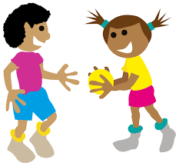 |  | Core real PE Unit 1  Coordination: Footwork (FUNS Station 10)  Static Balance: One Leg (FUNS Station 1)  Personal Cog  | Core real PE Unit 1  Coordination: Footwork (FUNS Station 10)  Static Balance: One Leg (FUNS Station 1)  Personal Cog | Core real PE Unit 1  Coordination: Footwork (FUNS Station 10)  Static Balance: One Leg (FUNS Station 1)  Personal Cog | Core real PE Unit 1  Coordination: Footwork (FUNS Station 10)  Static Balance: One Leg (FUNS Station 1)  Personal Cog | Core real PE Unit 1  Coordination: Footwork (FUNS Station 10)  Static Balance: One Leg (FUNS Station 1)  Personal Cog | Core real PE Unit 1  Coordination: Footwork (FUNS Station 10)  Static Balance: One Leg (FUNS Station 1)  Personal Cog | Recap a week children need more support in and ASSESSMENT
 |  | Cricket with Jamie | Cricket with Jamie | Cricket with Jamie | Cricket with Jamie | Cricket with Jamie | Cricket with Jamie | Cricket with Jamie
PSHE   |  | Pupils learn how to be safe in their computer gaming habits  Pupils  - know about the age classification system and understand why some games are not appropriate for children to play  - can evaluate whether a computer game is suitable for them to play and explain why  - are able to share opinions about computer games | Pupils learn how to be safe in their computer gaming habits  Pupils  - know about the age classification system and understand why some games are not appropriate for children to play  - can evaluate whether a computer game is suitable for them to play and explain why  - are able to share opinions about computer games | Pupils learn about keeping safe near roads, rail, water, building sites and around fireworks  Pupils  - can identify and assess the level of risk of different activities in the local environment  - recognise that in some situations there may pressure to behave in a way that doesn’t feel safe  can identify some ways to respond to unhelpful pressure | Pupils learn about keeping safe near roads, rail, water, building sites and around fireworks  Pupils  - can identify and assess the level of risk of different activities in the local environment  - recognise that in some situations there may pressure to behave in a way that doesn’t feel safe  can identify some ways to respond to unhelpful pressure | Pupils learn about what to do in an emergency and basic emergency first aid procedures  Pupils  - are able to assess what to do in an emergency  - can carry out some simple first aid procedures for different needs | Pupils learn about what to do in an emergency and basic emergency first aid procedures  Pupils  - are able to assess what to do in an emergency  - can carry out some simple first aid procedures for different needs
MINDMATE   | Feeling good and being me  Feelings – Intensity  I can use a range of words to describe my feelings.
ART/DT  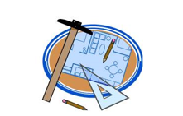  INCLUDING ARTISTS  WHERE APPROPRIATE | Art – Collage  Refresh cutting skills | Introduce “The Snail” by Henri Matisse  Learn about the life and work of Matisse. | Introduce collage.  Look at other artists who use collage | Make a collage inspired by “The Snail”.  Using shape and colour to represent figures and forms in movement, | Make a collage inspired by The Cut Outs – Matisse figures in movement  Using shape and colour to represent figures and forms in movement. | Make a collage inspired by The Cut Outs – Matisse figures in movement. Complete work.  Using shape and colour to represent figures and forms in movement.

