|  |  |  |
| --- | --- | --- |
| **Year 1 - PSHE** | | |
| **Autumn 1** | **Spring 1** | **Summer 1** |
| **Physical health and wellbeing**  **Fun times** | **Identity, society and equality**  **Me and others** | **Mental health and emotional wellbeing**  **Feelings** |
| **Autumn 2** | **Spring 2** | **Summer 2** |
| **Keeping safe and managing risk**  **Feeling safe**  C:\Users\sally martin\AppData\Local\Microsoft\Windows\Temporary Internet Files\Content.IE5\92VM23LK\warning-children-crossing-16353-large[1].png | **Drug, alcohol and tobacco education**  **What do we put into and on to bodies?**  sunscreen | **Careers, financial capability and economic wellbeing**  **My money**  money |

|  |  |  |
| --- | --- | --- |
| **Year 2 - PSHE** | | |
| **Autumn 1** | **Spring** | **Summer 1** |
| **Physical health and wellbeing**  **What keeps me healthy?**  C:\Documents and Settings\SALLY MARTIN\Local Settings\Temporary Internet Files\Content.IE5\B1IOHWMC\MM900365300[1].gifMP900431788[1]  fruit veg | **Sex and relationship education**  **Boys and girls, families**  hug | **Keeping safe and managing risk**  **Indoors and outdoors**  MP900422690[1] |
| **Autumn 2** | **Summer 2** |
| **Mental health and emotional wellbeing**  **Friendship**  MC900436043[1] | **Drug, alcohol and tobacco education**  **Medicines and me**  medicine |

|  |  |  |
| --- | --- | --- |
| **Year 3 - PSHE** | | |
| **Autumn 1** | **Spring 1** | **Summer 1** |
| **Drug, alcohol and tobacco education**  **Tobacco is a drug**  Description: cigarette | **Mental health and emotional wellbeing**  **Strengths and challenges**  Image result for achievements | **Careers, financial capability and economic wellbeing**  **Saving, spending and budgeting**    piggybank |
| **Autumn 2** | **Spring 2** | **Summer 2** |
| **Keeping safe and managing risk  Bullying – see it, say it, stop it**  http://www.advancedbkj.com/wp-content/uploads/2654460_370.jpg | **Identity, society and equality**  **Celebrating difference**  racism | **Physical health and wellbeing**  **What helps me choose?**  C:\Users\sally martin\AppData\Local\Microsoft\Windows\Temporary Internet Files\Content.IE5\2WFAUCLP\Question-Guy[1].png |

|  |  |  |
| --- | --- | --- |
| **Year 4 - PSHE** | | |
| **Autumn 1** | **Spring 1** | **Summer** |
| **Identity, society and equality**  **Democracy**  House_of_Commons_logoIslington+Town+Hall | **Physical health and wellbeing**  **What’s important to me?**  C:\Users\sally martin\AppData\Local\Microsoft\Windows\Temporary Internet Files\Content.IE5\NYRPN9VP\yawn[1].gif | **Sex and relationship education**  **Growing up and changing** |
| **Autumn 2** | **Spring 2** |
| **Drug, alcohol and tobacco education**  **Making choices**  C:\Users\sally martin\AppData\Local\Microsoft\Windows\Temporary Internet Files\Content.IE5\2WFAUCLP\120px-Blue_cup_of_coffee.svg[1].pngDescription: cigarette | **Keeping safe and managing risk**  computer games**Playing safe**  MC900150441[1] |

|  |  |  |
| --- | --- | --- |
| **Year 5 - PSHE** | | |
| **Autumn 1** | **Spring 1** | **Summer 1** |
| **Physical health and wellbeing**  **In the media**  C:\Documents and Settings\SALLY MARTIN\Local Settings\Temporary Internet Files\Content.IE5\RSS82HTW\MC900240859[1].wmf | **Keeping safe and managing risk**  **When things go wrong**  C:\Users\sally martin\AppData\Local\Microsoft\Windows\Temporary Internet Files\Content.IE5\P1HZOB3H\cyber-bullying-270x293[1].jpg | **Mental health and emotional wellbeing**  C:\Documents and Settings\SALLY MARTIN\Local Settings\Temporary Internet Files\Content.IE5\OEHPO6VY\MC900078628[1].wmf**Dealing with feelings** |
| **Autumn 2** | **Spring 2** | **Summer 2** |
| **Identity, society and equality**  **Stereotypes, discrimination and prejudice  (including tackling homophobia)** | **Drug, alcohol and tobacco education**  Description: teenager-peer-pressure**Different influences** | **Careers, financial capability and economic wellbeing**  **Borrowing and earning money** |

friends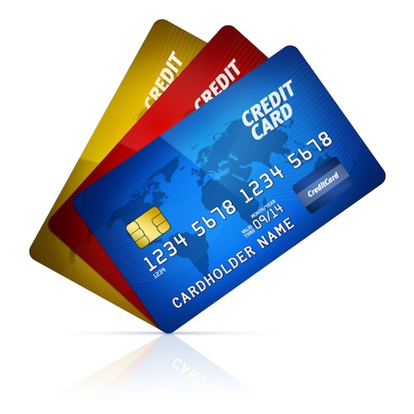

|  |  |  |
| --- | --- | --- |
| **Year 6 - PSHE** | | |
| **Autumn** | **Spring 1** | **Summer 1** |
| **Sex and relationships education**  **Healthy relationships / How a baby is made**  C:\Documents and Settings\SALLY MARTIN\Local Settings\Temporary Internet Files\Content.IE5\OEHPO6VY\MC900078796[1].wmf | **Drug, alcohol and tobacco education**  **Weighing up risk**  MP900442439[1] | **Mental health and emotional wellbeing**  **Healthy minds** |
| **Spring 2** | **Summer 2** |
| **Identity, society and equality**  **Human rights** | **Keeping safe and managing risk**  **Keeping safe - out and about**  crime_gangs |