**Year 6 Sizzling stir fry**

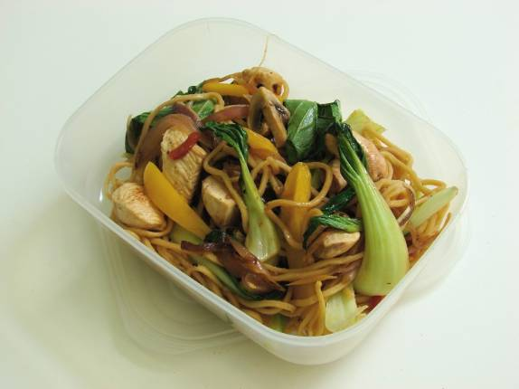  
Ingredients  
100g noodles1 x chicken breast or Quorn  
½ red chilli  
1 clove garlic   
1cm fresh ginger   
½ red onion

2 carrots   
1 bok choi   
1/2 yellow pepper  
3 mushrooms1x10ml spoon oil  
1x10ml spoon soy sauce (reduced salt)Equipment  
Chopping boards, knives, garlic press, grater, wok or frying-pan, wooden spoon, saucepan, colander, measuring spoon, serving dish, weighing scales.Method1. Cook the noodles in boiling water. Check the packet for details.2. While the noodles are cooking, remove any skin from the chicken and cut into strips, ideally on a red board. Thoroughly wash and dry hands after touching raw chicken. Place in the fridge, covered, until needed.  
3. Prepare the vegetables with a fresh knife on a clean chopping board:

* peel and crush the garlic;
* peel & slice carrots into strips
* de-seed and slice the chilli;
* peel and slice the ginger;
* slice the onion, pepper and mushrooms;
* shred the bok choi.

4. Heat the oil in the wok or frying pan.  
5. Add the onion, garlic, chilli and ginger. Allow to cook for 1 minute.  
6. Add the chicken and stir-fry for 3-4 minutes. Check that the chicken is cooked.  
7. Add the remaining vegetables and soy sauce and continue to cook for a further 2 minutes.8. Drain the boiling hot water away from the noodles into a colander in the sink9. Stir in the cooked noodles and cook for 2 minutes until hot.10. Serve.  
**Top tips**

* Use noodles that have already been cooked.
* Vary the vegetables – leeks, courgettes and carrots all work well.
* Go for tofu instead of chicken for a vegetarian alternative.
* Other types of meat could be used, e.g. thin strips of beef or turkey.
* Mix in ready cooked noodles or rice for a quick main meal.

**Food skills**

* Weigh.
* Measure.
* Crush.
* Slice and shred.
* Stir fry.
* Stir.
* Simmer and boil.
* Drain.