**Year 3 Quiche**

**Ingredients**

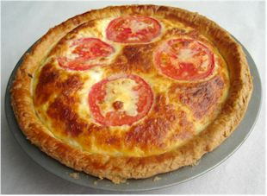  
**Short crust pastry**

100g plain flour

50g butter or baking fat/block

2-3 x 15ml spoons water

**Filling**

2 eggs, large

125ml semi-skimmed milk

50g reduced fat cheddar cheese

1 tomato

2 rashers bacon (or 3 mushrooms and 1x5ml spoon oil)

**Equipment**

20cm flan ring, baking tray or sandwich tin, sieve, mixing bowl, palette knife or mixing spoon, rolling pin, flour dredger, measuring spoons, chopping board, knife, frying pan, fish slice, measuring jug, grater, fork.

**Method**

1. Preheat the oven to 170ºC or gas mark 4.
2. Grease a flan ring and baking sheet or a sandwich tin.
3. Make up the shortcrust pastry:
   * sift the flour into a bowl;
   * cut the fat into cubes and add to the flour;
   * rub the fat into the flour until the mixture resembles breadcrumbs;
   * add the water a spoonful at a time and mix until the dough comes together.
4. Roll out the pastry, on a flowered surface, and line the flan ring/sandwich tin.
5. Prick the bottom of the pastry with a fork.
6. Grill the bacon until crispy and slice (fry the mushrooms in the oil for 2-3 minutes).
7. Place the bacon/mushrooms around the pastry base.
8. Grate the cheese and whisk with the eggs and milk.
9. Pour the egg mixture over the pastry base.
10. Slice the tomatoes and place on top.
11. Bake for 25-30 minutes, until golden brown and firm.

**Top tips**

* Add canned tuna or smoked salmon bits and chopped cooked asparagus for a fancy dinner.
* Change the cheddar for goats’ cheese and add sliced red pepper instead of bacon for a veggie quiche.
* To make it healthier you can choose reduced salt bacon and reduced fat cheese.

**Food skills**

* Weigh.
* Measure.
* Sift.
* Cut and slice.
* Rub in.
* Mix.
* Roll out.
* Grill.
* Grate.
* Bake.