**Year 4 Pasta bolognaise**

Ingredients

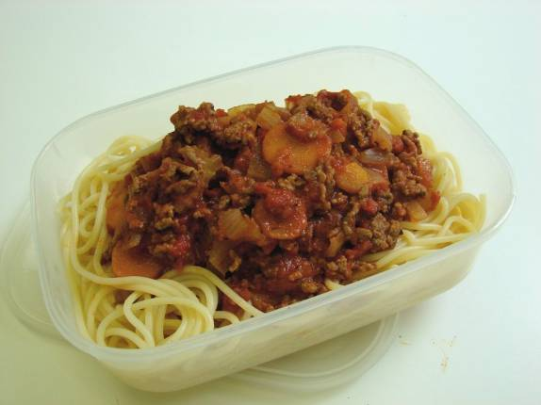1 onion1 clove garlic1 carrot1 celery stick1 x 15ml oil250g minced beef400g canned chopped tomatoes1 x 15ml spoon tomato puree100ml water1 x 5ml spoon mixed herbsBlack pepper150g Pasta

Equipment

Weighing scales, chopping board, knife, garlic press, peeler, 2 saucepans, wooden spoon, measuring spoons, measuring jug, colander.

Method

1. Prepare the vegetables:

* Peel and chop the onion;
* Peel and crush the garlic;
* Peel and slice the carrot;
* Finely slice the celery.

2. Fry the onion, garlic, carrot and celery in the oil.3. Add the meat and cook until the mince is lightly browned. 4. Add the tomatoes, tomato puree, mixed herbs and water and mix all the ingredients together. Then add a few twists of black pepper.5. Bring to the boil, then simmer for 20 minutes.6. Meanwhile place the spaghetti in a separate saucepan of boiling water. Cook for 10 - 12 minutes or until the spaghetti is al dente (tender).7. Drain the boiling water away from the spaghetti into a colander in the sink.8. To serve pour some of the bolognaise sauce over the spaghetti.

**Top tips**

* Try serving your spaghetti bolognaise with parmesan cheese and fresh basil.
* For a vegetarian option swap the minced beef for veggie mince or lentils.

**Food skills**

* Weigh.
* Measure.
* Peel.
* Chop and slice.
* Fry.
* Stir.
* Boil and simmer.
* Drain.