**Tuna pasta bake**

Ingredients

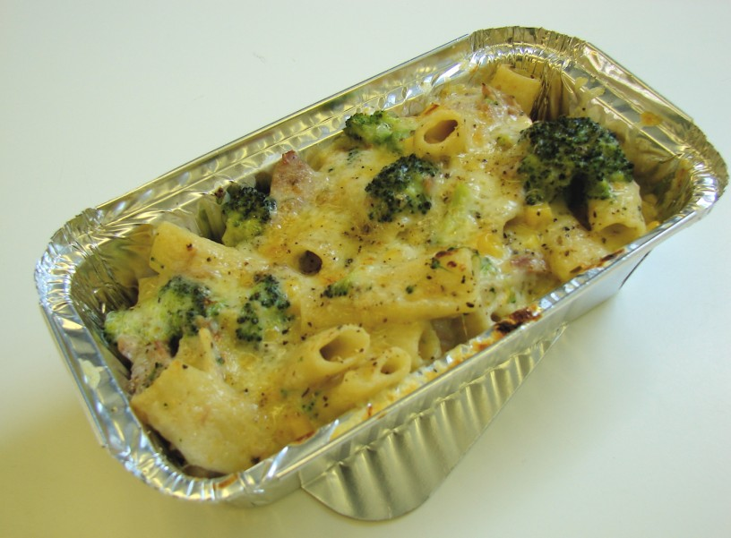100g Pasta40g cheese100g broccoli100g canned tuna (in water) drained25g butter or soft spread

25g plain flour250ml semi-skimmed milk1x5ml spoon dried oregano

50g sweetcorn (canned or frozen)Black pepper

Peppers chopped

Onion chopped**Equipment**Two saucepans, weighing scales, grater, chopping board, knife, colander, measuring jug, wooden spoon, measuring spoons, whisk, ovenproof dish or foil tray.**Method**

1. Bring a saucepan of water to the boil, and then add the pasta. Simmer for about 10-12 minutes, until *al dente*.
2. Grate the cheese and cut the broccoli into small pieces.
3. While the pasta is cooking, make the sauce:

* Place the fat, flour and milk into a small saucepan;
* Bring the sauce to a simmer, whisking it all the time until it has thickened;
* Reduce the heat, stir in the oregano, and allow to simmer for 2 minutes.

1. During the last 2 minutes of the pasta boiling, add the sweetcorn and broccoli to the saucepan.
2. Preheat the grill.
3. Drain the boiling hot water away from the pasta and vegetables into a colander in the sink.
4. Pour the drained pasta and vegetables into the sauce.
5. Stir in the canned tuna.
6. Pour the mixture into an ovenproof dish or foil tray.
7. Sprinkle the cheese over the top, and add a few twists of black pepper.
8. Place under a hot grill until the cheese is bubbling and golden brown.

**Top tips**

* Try different varieties of pasta shapes, such as macaroni or shells.
* Use different types of vegetables, like leeks, peppers and mushrooms.
* Add a spoon of pesto, mustard or tomato puree to the sauce for extra flavour.

**Food skills**

* Weigh.
* Measure.
* Boil and simmer.
* Grate.
* Chop.
* Whisk.
* Drain.
* Grill.